In Honor of the Holy Virgin Mary
and to celebrate our Church’s Name Day 2023
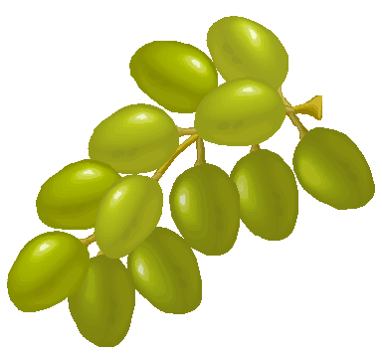

For Grape BLESSING
We thank the following parishioners who made donations:
As of 8/11/23

Donated by: In Memory of:
Albright Bruce & Carolyn Harry & Queenie Kachadourian
Asadoorian Hovannes & Family Megurditch Asadoorian, Eliza Alyanakian & Herman Carson
Badalian Mary Loved Ones
Balian Rita Simonian Marie Simonian
Balian Marie Marie Simonian, Arabian, Missirian , Krikorian & Gabriel
Barsoumian Vergine Parents: Yenovk and Elissa Barsoumian
Bandazian Bedros Khoren & Virginia Bandazian
Berberian Brenda Stephen & Jean Berberian
Bodurian Ellen & Ed & family Abraham & Elise Bodurian
Bozadjian Araxi Zvart & Arpi Yegavian
Derderian Harry & Ani Mary Derderian and Markrid Jindian
Dersookian Mirra & Michael Loved Ones
Dilanian Hayro & Ani Hrant Dink
Ghazarian Anahid Alyanakian, Carson, Parounagian, Hisarlian & Michigian families
Ghazarian Hasmig Mary Kalemkiarian
Ghazarian Kevork Maria Ghazarian
Hakopian Ema and Souren Hirig Hakopian, Lucig Hakopian, Zorig Hakopian
Ghokaz Yepremian, Zoya Yepremian, Sako Yepremian
All the deceased members Der Hakopian family

Hebert Arda Sirop & Selma Kanderian
Istepanian Rita Mary Banous
Diramayr Kalayjian Anahid Archpriest Der Vertanes Kalayjian
Kapikian Catherine Carl Kapikian
Khanbabian Yolande Orbel Khanbabian
Khrimian Ashot & Susanna Bilbulian Parents
Kolenick Nancy Serarpe & Onnig Halajian
Kooyoomjian Dr.& Mrs. Kachig Jack Harotune & Mary Kooyoomjian & Thomas V. & Theresa Doris Smith Kumkumian John and Katheleen Loved ones
Koudoussian Rita Marie Missirian & Marie Gabriel
Krikorian Helen Mariam Morookian
Krikorian Jacqueline George & Margaret Krikorian
Mulvihill Jellalian Christina & Jason Haig Ellian & Jack and Barbara Telalian
Nishanian Anahid Jerair Nishanian
Pickering Lola Loved Ones
Permian Avak and Elma Sarem and Levon Yepremian
Roxanne Paul Loved Ones
Sahakyan Shoghig & Raffi Nubar Sahakyan, Missak Missirian & Yervant Missirian
Sahr Arpi & David Maryam Zartaryan
Sardarbekians Angele Hamo & Hovig Sardarbegians
Sarkissian Nellie Roubina Faulkner
Semerjian Hratch Diruhi Semerjian
Shahinian Dean Esq. Rev.Fr.Vahan & Yeretzgin Zarouhi Jelalian
Shahverdian Armineh Ashot & Kitoosh Paul, Antanes & Naytstoon Shahverdian
Sivaslian Seta Arshavir & Anjel Hovannesian
Teymouri Aida Aghavni Aleksanian & Hrand Mailian
Vartanian sisters Parents Marie and Garbis Vartanian.
Zulikian Nurhan & Lisa Marie, Bogos & Yeranuhi Zulik

Donated by: In Honor of:
Asadoorian Hovannes & Family Anahid Ghazarian , Nadya Carson, Elmas Asadoorian & Kevork Ghazarian
Balian Rita Simonian Marie Balian
Ghazarian Taleen Anahid Ghazarian
Kolenick Nancy Araxe Cherishian
Koudoussian Rita Aunt Marie Balian
Mulvihill Jellalian Christina & Jason Sue Ellian & Clara Andonian
Sardarbekians Angele Holy Virgin Mary

