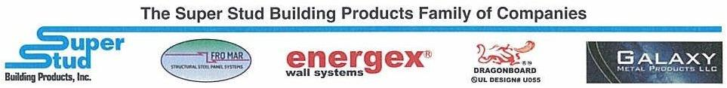
Building Products, Inc. www.buysuperstud.com

2960 Woodbridge Avenue, Edison, NJ 08837 Tel. 732-662-6200 Fax. 732-548-6036
Production Laborer
Since 1973, Super Stud Building Products, Inc. has been a proud manufacturer of the industry’s most diverse offerings of cold-formed steel framing components and accessories for use in the construction of commercial, institutional and residential structures.
Position Summary
SuperStud is looking for motivated and reliable production candidates to add to our Production Team. You will have the opportunity to be part of a fast pace and growing company. We are looking for candidates with a strong work ethic, positive attitude and a willingness to learn. You will be responsible for direct labor tasks related to the assembly of our steel products.

Reports to: Production Supervisor

Job Function
- Execute daily work instructions received from Supervisor in a timely manner
- Work effectively to meet or exceed productivity goals while maintaining high quality standards
- Operate manual material handling equipment
- Lift and carry merchandise as needed
- Inspect merchandise upon delivery to identify any damages
- Load and unload merchandise
- Maintain the work area to be clean, safe and organized

Qualifications
- HS Diploma or equivalent
- Prior experience working in a production/warehouse environment a plus
- Motivated and able to follow instructions.
- Able and willing to work outside and in all weather conditions.
- Excellent integrity, good moral, strong character and takes initiative
- Excellent interpersonal skills to interact with people from all levels and departments.
- Ability to communicate effectively in English. Bi-lingual, desired.
- basic math background and aptitude.
- High attention to detail.
- Proof of US citizenship or legal resident alien status by completing Federal Form I-9 in compliance with the Immigration Reform and Control Act of 1986.

We offer an attractive benefits package

