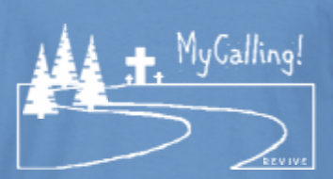

Parents and Youth,
I am so glad you are interested in Winter MyCalling!

We arrive on Friday Night at YUMC, we spend the night preparing for service then settle down to sleep at YUMC.
Saturday morning we wake up to a hearty breakfast and head off to worksites for the day. We come back together for an afternoon and evening of games, dinner, worship and more games.
You can stay over Saturday or leave after worship.

This is a great event to invite friends to join!
The cost is just $50. This covers your food (Friday snack, Saturday breakfast, lunch, dinner and Sunday breakfast)

To sign up, go to yardleyumcyouth.org/events. Once you are signed up, I will send you a packet with more information.

I hope you will join us for this fun weekend of serving and growing!

Blessings,
Denise

Schedule:
Friday 7 pm Registration Opens
7:30 pm Welcome and Intro to weekend
Worship service begins
9:30 pm Post worship meet in Crews, prepare for mission day
11 pm Lights Out
SATURDAY 8 am Wake up, Breakfast
9:00 am - 3:30 pm Worksites
12:30 pm Lunch
4pm-6pm Free Time, Snacks, Showers Available
6:30 pm Dinner, Worship at 7:30
9 pm Christians and Romans, game time, etc (or you are welcome to leave)
SUNDAY 8am Wake Up & Breakfast
9am Worship

