A Brief Introduction To Improving Document Accessibility Using Common Tools
By: Donna Lewis, CPACC (Certified Professional in Accessibility Core Competencies)
In an ideal world all documents should be “born accessible.” What does that statement really mean? A document is accessible if it allows people with diverse abilities to perceive, navigate, and interact with its information. So, a born accessible document is one that is accessible by design and has not required modifications to add in accessible elements after its initial development.

Building In Accessibility From The Start
Creating born accessible content begins with the source application. The source application is the one that is used to develop the content—the information contained in a document or webpage—from the first letter, number, or symbol typed. Examples of source applications include Microsoft Office Suite programs, Pages, Google Docs and Sheets, Libre Office programs, and many more. As you can probably tell from this list, “document” means more that just a Microsoft Word file; it can also refer to a presentation or spreadsheet. Even if we plan to distribute the content as a PDF file, using the source application to build the materials accessibly from the start is crucial to success.
This article will introduce some of the features of Microsoft Word that create accessible content. While we cannot cover every accessibility element available in Word, the focus will be on features that correct many of the most common accessibility errors and demonstrate ways of assessing your document’s accessibility.

Using Word’s Tools To Create Accessible Content

Headings
Headings in documents do many things. They organize information, showing readers how the information is related. They also help when a user skims the content to find areas of interest. And they allow screen readers—assistive technology that reads aloud text—to present the information architecture of the document to the screen reader user, providing an alternative way to effectively skim the document and move quickly to points of interest.
Accessible headings are not text in a large, bold font applied manually. An accessible heading is applied using the appropriate heading style from Word’s Home Ribbon. To properly format text as a heading:
- Select the text.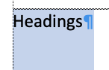
- Click the Styles button in the Home Ribbon or scroll the list of styles if the Styles Menu is open.
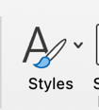
-or-
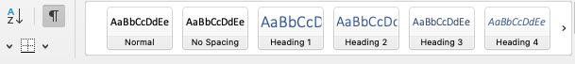
- Click the style button representing the heading level needed for the selected text.

Alternative (Alt) Text Descriptions
Images within documents require alternative (alt) text descriptions. Alt text provides screen reader users the ability to understand the meaning of an image. When screen readers encounter images, they announce that a graphic is present in the document. Without an alt text description, the screen reader user is left wondering if valuable information was present in the graphic that, if they are blind, they have no way of perceiving. Descriptive, concise, meaningful alternative text descriptions allow the screen reader to announce the image’s information in a perceivable way.
Add alt text descriptions by
- Selecting the image.
- Right click the selected image, and from the resulting menu, choose Edit Alt Text.
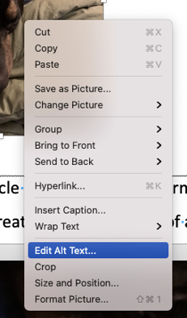
- This opens the Alt Text Pane along the right of the window.
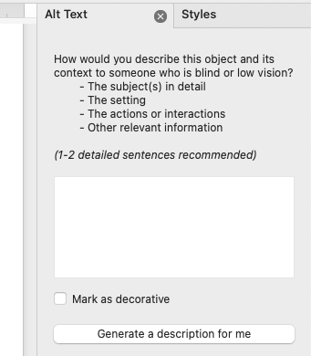
- In the text box, enter a meaningful description of the image and its context within the document. If the image is present only for visual interest, click the Mark as decorative option and type, “decorative,” in the textbox. Word currently has a bug that causes some screen readers to not recognize the checkmarked Mark As Decorative option. Adding “decorative” to the text box allows screen reader users to understand the image offers no real information.
Clicking the Generate a description for me button triggers Word to automatically provide a description. Although the technology is improving, often these automated descriptions do not provide a sufficient description.

Bulleted Or Numbered Lists
Create bulleted or numbered lists accessibly using Word’s specific tools for this task located on the Home Ribbon. If you create these lists manually by, for instance, typing a number then tabbing before entering the list item text, the list will not be properly encoded to optimize screen reader access.
To create a bulleted or numbered list
- Enter the text for the list item.
- Select the item text.
- Click the appropriate list button on the Home Ribbon.
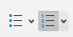

Verify A Document’s Accessibility In The Source Application
Most source applications have built-in tools that are useful to check documents’ accessibility. To use Microsoft Word’s Accessibility Checker,
- Click the Review Ribbon Option.
- From the Review Ribbon, click the Check Accessibility button.
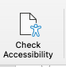
- Word will run its automated accessibility checker and open a panel to display the results.
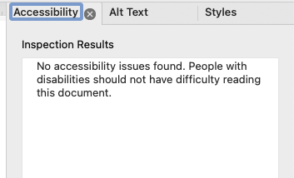
Any accessibility issues or areas needing manual checks will be listed in the panel, along with suggested fixes and additional information.

Understanding The Importance of Accessibility Elements
Born accessible documents have accessibility elements built in from the creation of the document in a source application. Once these elements are applied, the document can be converted from the source document into another format, such as PDF, for instance, and retain the accessibility features. Accessible PDFs are much easier to create from a document that is already accessible rather than having to add all the required elements by editing it in Adobe Acrobat.
Source applications have many more accessibility features that we could not demonstrate in this article. However, using the techniques described here will prevent some of the most common accessibility errors.

