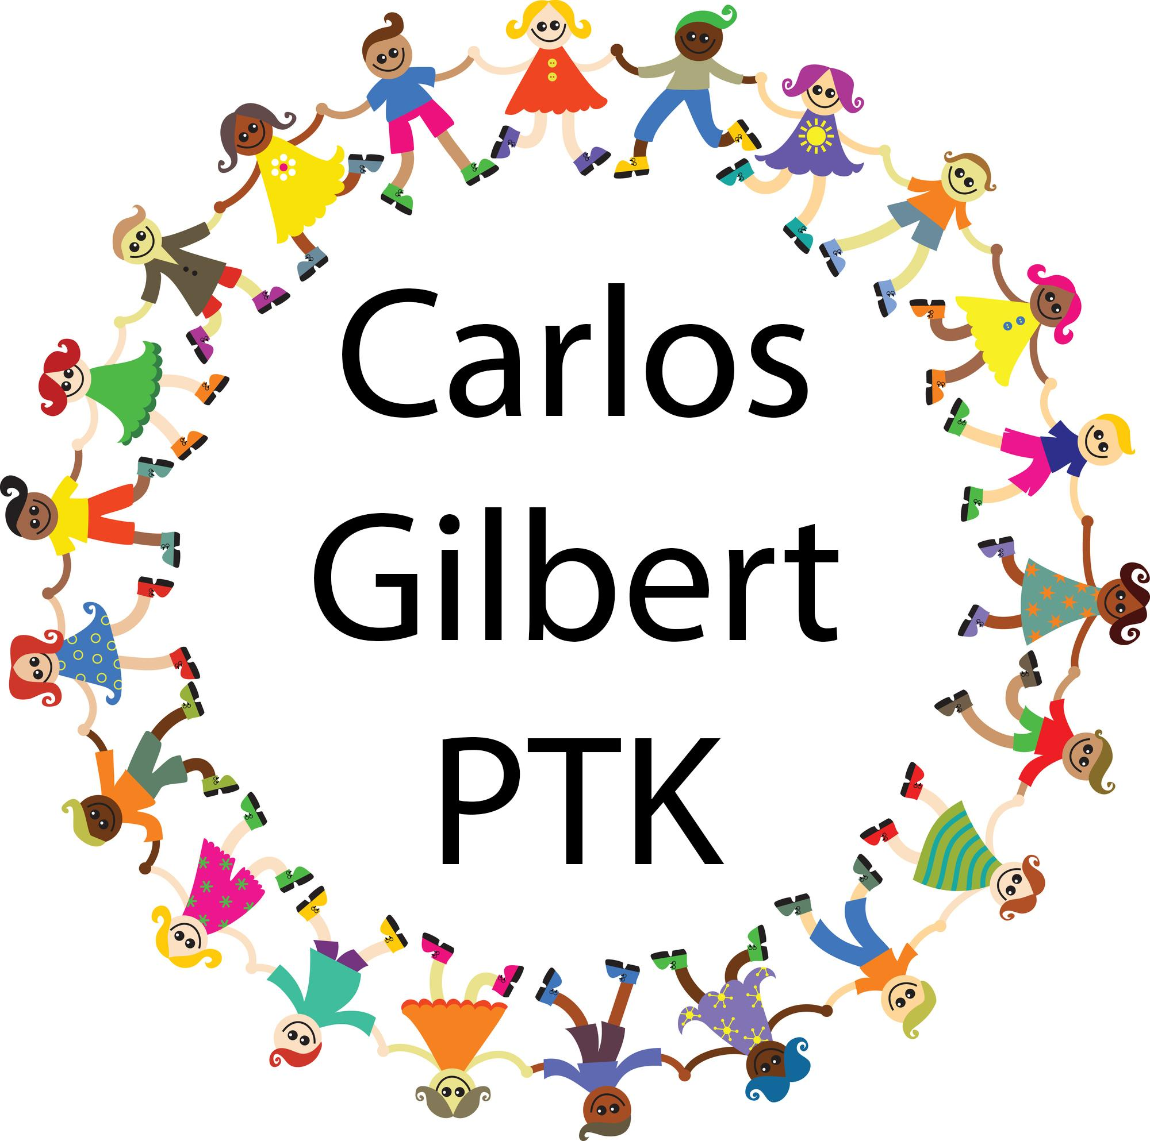**The Carlos Gilbert PTK is Looking for Room Reps**

**Interested in becoming a Room Rep?** Contact Erika at erika@carlosgilbertptk.com

**What is a Room Rep?**

* A Room Rep is a parent or guardian volunteer who lets the parents in their child's classroom know what is going on at Carlos Gilbert Elementary.

**What does a Room Rep do?**

* Sends email or texts to other parents in their classroom about fundraisers and school-wide events like the big Halloween Carnival
* Helps the teacher with class parties by delivering pizzas and drinks
* Chaperones a field trip or two
* Organizes end-of-year gifts of appreciation for the teacher

**How much time does being a Room Rep require?**

* A room rep will send a half dozen or so email messages leading up to Halloween Carnival in October. The messages will be about selling raffle tickets and asking other parents to volunteer to help with Halloween Carnival.
* Depending on your class, you might take the time to chaperone a field trip or two. This is optional, but a fun reason to play hooky.
* At the end of the year, you might spend a morning picking up 10 pizzas or watermelons and carrying them to a classroom for a party.
* At the end of the year, you'll spend a week asking parents to pitch in for a gift for the teacher and then go out and buy the gift and deliver it to the teacher's classroom.
* Some Room Reps organize out-of-school get-togethers for families at local parks. It is up to you if you’d like to do things like that.

**How does a Room Rep know what to do and when?**

* The PTK will send you example email messages to send out to your classroom's parent mailing list and let you know when you should send them.
* The PTK and / or the teacher will let you know when and what type of party the kids want.
* Your teacher will let you know when they have field trips they might need help with.
* The PTK will send you a message toward the end of the school year to let you know about when teacher appreciation week is.

**What is the PTK?**

The Carlos Gilbert PTK (Parents! Teachers! Kids!) welcomes you to the 2023-2024 school year at Carlos Gilbert Elementary, where a great school is a community project! This amazing school community has provided more than three generations of Santa Fe families a high quality education since 1942. The PTK is here to support our staff and families, and we'd love to have you on our team. Every parent, guardian, staff member, and kid in the Carlos Gilbert community is automatically a member of the PTK. We don’t charge dues, and we don’t require a minimum commitment. We welcome and appreciate all levels of participation and support.

The purpose of the PTK is to support, encourage, and enrich the educational, creative, and social experience of Carlos Gilbert Elementary School. We keep our school community connected and informed through weekly e-blasts, social media, and our website. We work together to make programs available to our children in the school through various fundraisers. Traditionally, the PTK funds an enrichment program, such as theatre, dance, or cooking, for each grade. The PTK also provides every teacher a stipend each semester for classroom materials, gives every club and team a yearly stipend, pays teachers to tutor students in need of extra assistance, facilitates school events, and supports other programs and activities as needed.

**Interested in becoming a Room Rep?** Contact Erika at erika@carlosgilbertptk.com