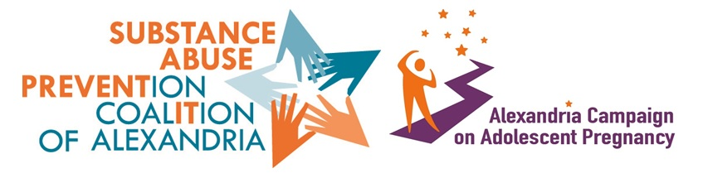
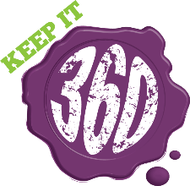
Healthy Minds Art Contest Entry Form
First and last name(s) of student(s) entering the contest:

Title of Entry:

Email:

Phone Number:

Please provide a brief bio of the artist(s):

Please describe the form of art used for this entry:

How does this entry relate to mental health topics experienced by teens? What inspired you to enter this contest?

How did you hear about this contest?

Please email completed entry forms with contest submissions by May 10 at 11:59 p.m. to Emma.Beall@alexandriava.gov and Joy.Kone@alexandriava.gov with the subject line: Mental Health Art Contest Submission.

