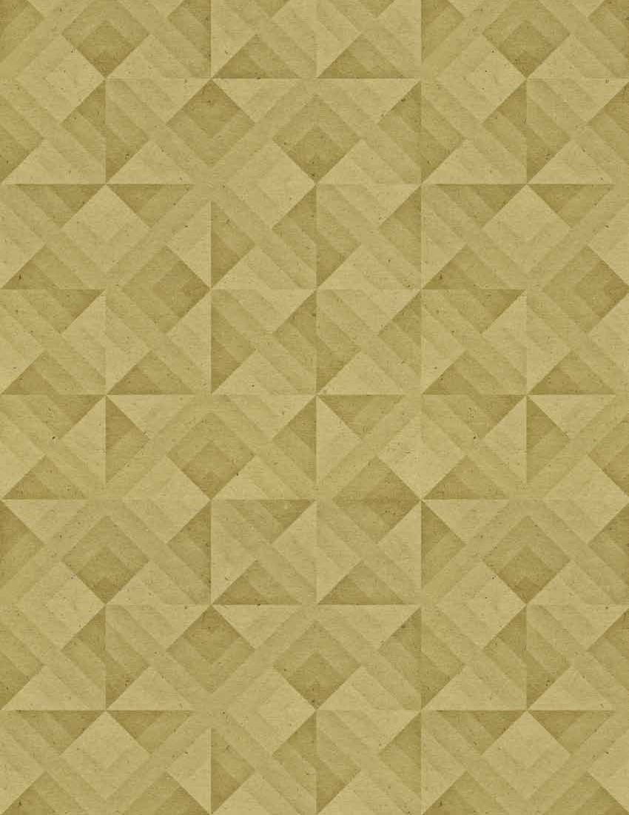
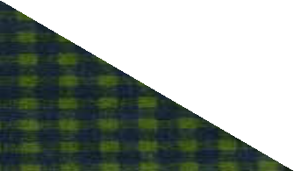




J

Call for Papers

GrandFamilies: The Contemporary Journal of Research, Practice and Policy

Submission Deadline: November 1, 2025

Grandfamilies: The Contemporary Journal of Research, Practice and Policy, an online peer review journal has expanded its focus from grandparents raising grandchildren to encompass all kinship care families. This change, made with input from our Advisory Board, allows Grandfamilies to more effectively represent the realities of kinship care, both within the United States and in international settings. GrandFamilies: The Contemporary Journal of Research, Practice and Policy continues to provide a forum for quality, evidence-based research with sound scholarship, knowledge, skills and best practices from the field for scholars, clinicians, policymakers, educators, program administrators, and family advocates.

Authors are invited to submit manuscripts presenting exemplary and innovative approaches of practice and model programming to best support kinship care families, analysis of primary or secondary data on emerging issues involving caregivers and the children in their care, and the effects of public policy on the well-being of grandfamilies. International authors with work that extends global knowledge and understanding about custodial grandparents are strongly encouraged to submit.

Manuscript Formats:
Full Articles (25-page max, double-spaced)
Research Briefs (15-page max, double-spaced)
Practice Briefs (15-page max, double-spaced)
Policy Briefs (15-page max, double-spaced)
Manuscripts that go over the page limit may not be reviewed. Page limits include references, tables and figures.

All manuscripts should follow the electronic publication format found in the APA Style
Guide (7th ed) at http://www.apastyle.org/. Authors must acknowledge that the submitted content has not been published in other peer-review journals or online open access sources.

Completed manuscripts should be sent via the journal website at:
http://scholarworks.wmich.edu/grandfamilies/

Send questions about manuscript submissions to Deborah Langosch, Co-Executive Editor of GrandFamilies at drlangosch@gmail.com.

Affiliated with the
National Research Center on
Grandparents Raising Grandchildren
http://www.wmich.edu/grandparenting/

