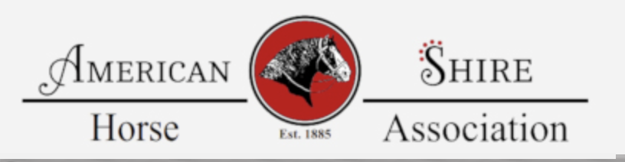

American Shire Horse Youth Ambassador Program

The American Shire Horse Association would like to start a Shire Horse Youth Ambassador Program. Participants should be between the ages of 14 - 18 as of January 1st of the current year. Participants will be given the opportunity to help promote the Shire horse through activities like horse shows and events in the Midwest. The chosen youth ambassador should be able to attend the National Shire Show August 16-18, 2026 to hand out awards. To be considered for the program please fill out the application and return by June 1, 2026.

Name_______________________________________________________________________Address_____________________________________________________________________City__________________________________________State_________Zip_______________ Email (if available): ______________________________
Phone: ___________________________ Age_____________
T-shirt Size: ___________________________
Please tell us about your involvement with Shire Horses:
____________________________________________________________________________________________________________________________________________________________________________________________________________________________________________________________________________________________________________________________________________________________________________________________Please list any clubs/groups, organizations, activities you have participated in: ____________________________________________________________________________________________________________________________________________________________________________________________________________________________________Please attach a paragraph about why you would like to be a Shire Horse Ambassador. Return to : membership@shirehorse.org

