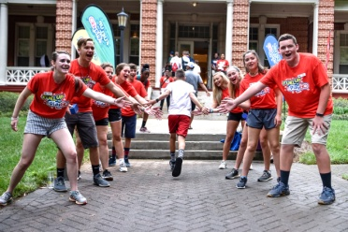
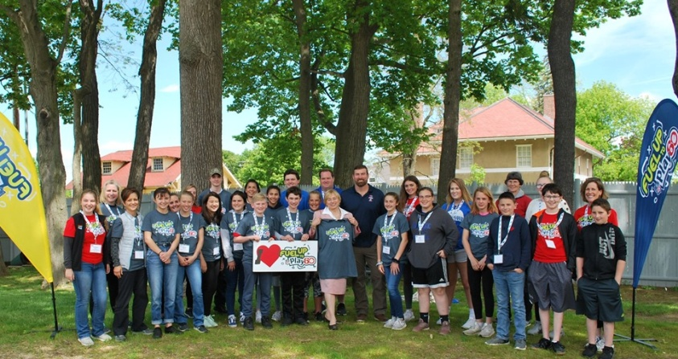
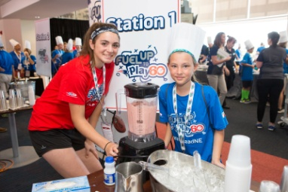
Eat Healthy. Get Active. Make a Difference!

Picture your school celebrating a year of healthy success!
Let Fuel Up to Play 60 make a positive impact on your wellness program!

Great things happen when your school is a part of Fuel Up to Play 60 - Empowered youth who eat healthier, move more, and inspire their school and community to do the same. Fuel Up to Play 60 uplifts students as agents of change, helps build a culture of wellness in schools and offers:
- A Playbook with school-tested healthy eating and physical activity projects
- Funds to jumpstart healthy school improvements –up to $4,000 per year
- Recognition and rewards for participants
- NFL excitement
- Educator resources
- Student leadership opportunities
- Student Ambassador Summits – national and regional
- Best-in-class tools for schools
- Special campaigns and challenges
- FUN FOR ALL!!!
You can register as a Fuel Up to Play 60 Program Advisor for your school, opening the door to healthy opportunities for your students. Visit www.FuelUptoPlay60.com to learn how this FREE program can get students involved in your school wellness program today. Contact School Programs Manager – Fuel Up to Play 60 Program Coordinator Katie Hoffmann, catherine@drinkmainemilk.org, for more information.
Funding Available for the 2020-21 School Year!
Online Application Open February 26, 2020 - April 8, 2020

https://www.fueluptoplay60.com/funding/general-information

