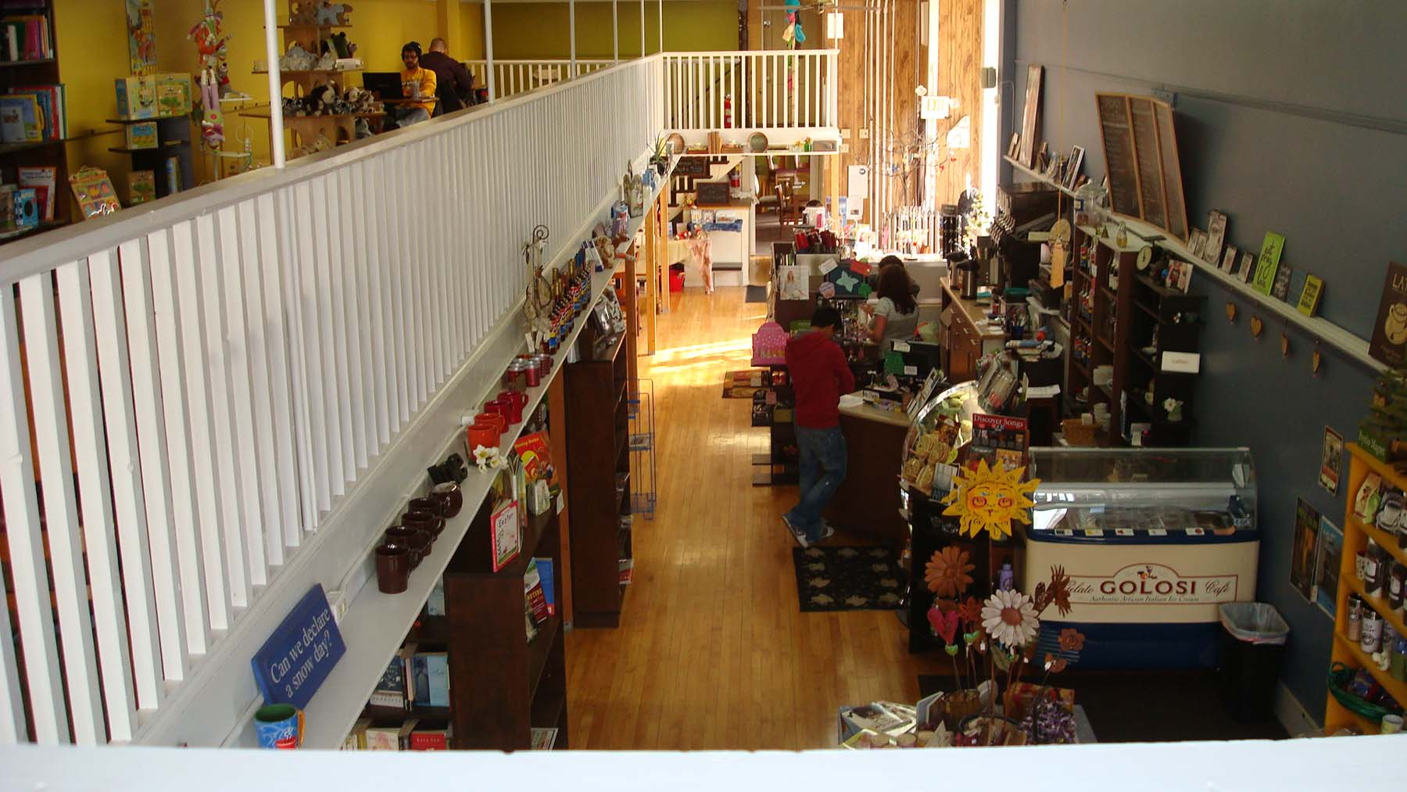

Downtown District & Businesses: Corona Virus Response

Ideas & Resources

March 16

Wisconsin Main Street

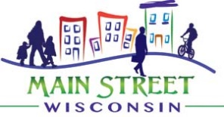

District & Business Sustainability
Wisconsin Main Street and WEDC appreciate the significant uncertainty and concern facing our district organizations, small businesses and civic and cultural institutions in the face of the current pandemic. This document is designed to serve as a repository of ideas, tips and best practices compiled from local, state and national resources to allow our downtown districts and local businesses to survive and thrive in light of current and rapidly changing circumstances.
“Persistence and resilience only come from having been given the chance to work through difficult problems.” ~Gever Tulley
This guidebook includes high-level information on the Coronavirus, links to resources for specific technical resources, and best practices and ideas for marketing, communications, outreach and business and event planning during the upcoming period of economic and social change.

We hope that you find this resource useful and look forward to working with each of you in the next several weeks and beyond as we strive to make our downtowns the thriving and vibrant commercial centers of Wisconsin communities.

Table of Contents:

- What we know (About Coronavirus)
- General Business Best Practices & Resources (Legal, HR, etc.)
- Organization Strategies (Downtown Organizations)
- Business Strategies
- Example Marketing Materials
- Additional Resources

- What we know (About Coronavirus)
Since other states and countries have been at the forefront of this pandemic, we can gain some useful information from their experiences.
- Retailers in the Seattle area report declines of 20-90% depending on type/location during first week of closures, and most are limiting hours or temporarily closing moving forward. Hotel occupancies have dropped to 30% in the metro (versus standard 85% this time of year).
  - Businesses relying on students or workers are likely to be harder hit. Businesses in residential areas seem to be doing better – people are still looking to get out but close to home
  - Businesses relying on long-distance tourism activity or group gatherings (conferences, concerts) will be significantly impacted.
  - Businesses selling perishable products or products with long inventory cycles are also likely to be harder hit.
- In Italy, all businesses excluding grocery stores and pharmacies have been closed until the end of March and they are exploring options to reduce taxes paid by impacted businesses. Illinois has also closed all restaurants, and Dane County has limited restaurants to 50% capacity. Events above 50 individuals are not allowed, and individuals traveling are asked to self-quarantine for 14-days post return.
- In China, where the virus was first identified, quarantines are now being lifted (elevated safety protocols remain) after approximately 6 weeks of full closure. Starbucks estimates that first quarter revenues will be down 50% overall in China as a result of the pandemic.
- According to the WHO (world health organization), the virus can be transmitted on many surfaces, including products and cash, but it cannot be spread through the skin or cuts on hands, only as a result of dirty hands touching your face or food. Using cash or collecting delivered goods is not any more likely to deliver the virus than other objects such as your phone – washing your hands before eating or touching your mouth, eyes or nose is what transmits the virus. Similarly, wearing gloves only transmits viruses with gloves instead of your hands. It is unclear currently how long the virus survives on surfaces, but it is easily killed outside the body with traditional cleaning products.
- CDC guidelines recommend this level of precaution for at least 8 weeks, which extends into May, and it is possible that prohibitions could be extended depending on the level of infection present at that time.
Helpful links:

- What you should know, including symptoms, about the Coronavirus from the CDC: https://www.cdc.gov/coronavirus/2019-ncov/index.html

- Hand washing chart from the World Health Organization: https://www.who.int/gpsc/clean_hands_protection/en/

- General Business Best Practices & Resources (Legal, HR, etc.)
Businesses of all types should prepare for disruption on all levels.

Supply chains have and will be impacted from outbreaks in China as well as logistics challenges. Retailers may be unable to receive inventory in a timely fashion, and some products may not be available at all. Specific shortages in predominantly Chinese-made goods such as awards, medals, RFID elements (such as race bibs) and other electronic components will be in short supply.

Strategies:
- Source products and materials locally if possible – this will provide stability to supply chain issues and also support local businesses. It may also allow you to shorten your inventory cycle to allow for more frequent smaller orders that tie to demand changes.

Staffing levels will likely be impacted as well, either as a result of employee concern over contracting the virus, the need to provide supervision to children no longer in school, or personal illness.

Strategies:
- To the extent possible, provide options for paid sick leave or remote work for employees that are ill or have been exposed to the virus. Employees at home can still manage social media, make calls to key customers, negotiate with vendors or suppliers, etc. Consider prioritizing at-home work for the most vulnerable employees (older workers, pregnant workers, those with pre-existing conditions).
- Don’t forget to make a plan for what you, the owner, will do should you contract the virus and be unable to work in your business. Your infection may also prevent family members from working, further complicating matters. Having a plan that can be rolled out quickly will be important in this situation.

Operational changes may be required to ensure customer and employee health. Examine your cleaning practices and add/communicate your policies to demonstrate that you take customer safety seriously. Similarly, clarifying or updating your cancellation or scheduling policies may be necessary to allow customers to comply with local regulations or cancel appointments in the event of illness.

Strategies:
- Ramp up cleaning procedures by adding hand sanitizer at the cash register, wiping the register and credit card reader after each customer, cleaning restrooms more frequently, wiping the door handle after each customer.
- Busier shops and restaurants may consider limiting capacity to ensure a 6-foot separation between customers. Offer to text customers when a space opens up.
- Communicate your current and updated policies with customers. Be clear about your commitment to health and demonstrate your ability to keep customers safe when visiting your business. You can also use these messages to communicate any new services or products that you are making available to help them engage with your business while protecting your health.

- Organization Strategies (Downtown Organizations)
Business Support
Downtown businesses are struggling in a time of reduced foot traffic. Although customers may not be willing or able to shop downtown in the way that they are used to, the goods and services offered by these small businesses are still wanted and needed by local residents. While each business will need to adjust their specific offerings to accommodate customer needs, downtown organizations can provide individual support to businesses struggling to identify appropriate strategies, serve as a repository for business closures and help coordinate and/or promote newly available online, delivery or to-go offerings at local businesses. Some potential strategies for supporting your small businesses during this time include:

Networking and Information Sharing: The environment is changing rapidly, and business owners may not have capacity to stay up on changing guidelines. Providing regular updates on CDC and local guidance as well as closures and other circumstances likely to change traffic patterns will help them customize their strategies effectively. Downtown organizations may also want to consider having a weekly ‘Main Street chat’ on an online skype or phone line to provide a venue for discussing challenges and best practices among downtown businesses and organization and/or partner staff.

District Communications: Allowing customers to access information on business status (open/closed), hours of operation and online/delivery-based options in a central place can help reduce confusion and make it easier for customers to support local businesses.
Downtown Menu Database: Create a list of downtown restaurants that allow take-out or have delivery options, and scan in or link to their menus. Some organizations have created large-font versions of these menus as well to accommodate senior audiences.

Digital Downtown: Promoting online downtown shopping, either through a series of social media posts highlighting online options, coordinating a centralized online marketplace, or making downtown gift certificates available for purchase (and future use) online can streamline options for customers hoping to make a difference.

Coordinated Activities: Downtown organizations also have a role to play in allowing businesses to band together and take advantage of economies of scale, as well as a responsibility for helping the downtown environment and infrastructure support new ways of engaging with downtown business. Examples of activities might include the following:
- Disinfecting public amenities (benches and drinking fountains)
- Compiling information on local resources – health care hotlines, free meal outlets, phone lines to check on housebound seniors, etc.
- Coordinate a delivery service – in communities without Uber or Lyft, businesses may be able to coordinate to share staff as a delivery service to deliver goods to customers. Communities with existing taxi or ride-share programs may be able to engage these drivers on behalf of downtown businesses.
- Advocating for relaxed regulations or altered parking situations to accommodate additional drive-up pickup and takeout traffic. This may involve the addition of temporary short-term parking spaces, and/or waiving parking fees for a limited period (or on side streets for employees throughout the crisis). Bars and restaurants may need help to extend their premises to allow for curbside pickup of beer or wine with dinner.
- Utilizing a public plaza or central location to distribute free community meals.

Event Planning
Most downtown organizations are busy planning events for the upcoming spring and summer seasons. While most events scheduled through early May have been cancelled or postponed.

Financial Impact: Depending on the type of event and amount of items that have been pre-committed or pre-paid, organizations will need to review the Force Majeure clauses included in their contracts. This ‘act of God’ clause provides participants and/or event planners with a non-payment option as a result of an unforeseen event. The ability to cancel with limited or no financial implications will depend on the strength of this clause in your contract (although many venues and vendors are attempting to work with planners to the degree possible).
Live-Stream or Online: All or a portion of your event may be able to move online to avoid a complete financial loss. Live auctions can become online auctions, trivia events can go online, live-streamed fashion shows can be launched complete with one-click shopping, and races can be converted into online challenges with social media posts of recorded times on the race route. All of these can allow participants to engage with the organization and replace an anticipated event with online engagement with fellow attendees (while potentially retaining some event revenues to offset non-refundable costs).

Future Considerations: Looking into the future, even when events are allowed, people may be more aware of health concerns associated with gatherings. Consider adding handwashing stations or other measures to allow attendees to feel comfortable and in control of their health while at your event.

- Retail & Service Business Strategies
Retail and service businesses may need to be creative to accommodate new customer habits. Considering the needs of home-bound customers can help shape effective strategies for your business is essential for maintaining even a minimum of sales during the next eight weeks. Consider the following list of potential strategies, grouped by business type, to identify strategies that may work for your business.

Retailers
- Online Sales – If you don’t already, create an online sales platform, whether as a standalone offering on your existing website or
- Delivery Options/Curbside Pickup – allow customers to pickup online orders at the curb or have them delivered locally. Consider creating delivery bundles to make this cost-effective. Learn-to-knit kits, craft-in-a-box, movie-watching-pjs-for-the-family, etc.
- Themed bundle options work well: Bookstores might have mysterylovers bundles, biography-lovers bundles, kids bundles, etc. Pet stores – Create bundles of everything their pet might need for a 2 to 3-month period: dog food/treats/toy bundles, cat food/litter/catnip bundles. It’s not anything they wouldn’t buy anyway; you’re just bundling up enough to last a while. Toy stores – Create bundles for families to stay busy: game and puzzle bundles, arts and crafts bundles, construction toy bundles. Vacuum stores – Create bundles with vacuum bags and cleaning supplies to keep the house disinfected and safe.
- Membership Pricing – create pre-paid membership programs to spur cash flow now with a promise of future regular engagement. Wine of the month club, Knitting club, etc. Nearly any retail good can be bundled into a monthly membership option
- Online Forums – knitting circles, tutorials, home shopping events, story hour from the bookstore
- Customized Online Services – personal shopping, home design consultations, etc.
- Not sure what your customers need? Practice personal clienteling. Take a look at the Top 20% of your customers and have your employees call them up and ask what they might need – then deliver it.
Personal Service Providers (salons, pet care, therapists, etc.)
- Online/Virtual Appointments – therapists, health care, etc. can utilize online appointments (Facebook Messenger has one scheduling option) to schedule virtual appointments to those that can’t come in person.
- Membership options can provide cash today and future customer loyalty. A vet membership can cover basic vet care with a monthly fee, people can pre-book future massages, facials, haircuts or other services at a discount to bring in cash today.
Fitness Facilities
- Live stream fitness classes to those at home.
- Offer virtual training or form correction to those at home.
- Host a monthly challenge for users to upload screen shots or watch photos of their at-home workouts to log minutes for prizes.

Restaurants
- Delivery/Curbside Pickup – allow customers to order ahead for delivery or pickup. See the resource guide at the end of this document for setting up delivery partnerships.
- Family Meal Options – consider a family meal option that packages a family-friendly meal (main dish and sides) as a dinner-to-go option.
- Continue your existing bar trivia events with online live-stream options (after, of course, coordinating for pickup of growlers-to-go).

Arts & Cultural Institutions
- Custom curated/celebrity live-stream tours of venues or displays.
- Author or artist discussion chats.
- For individual artists impacted by closed studios, illness or cancelled events, the following resources may be of assistance:
  - ArtsReady: Emergency Preparedness Resources for Arts & Cultural Nonprofits: https://www.artsready.org/
  - CERF: Artist Safety Net Organization: https://cerfplus.org/
Online Sales
Developing an online marketplace has always been a sound strategy for downtown businesses hoping to grow their customer base, but it is now an essential tool for attracting home-bound customers with more time for online shopping and social media exposure. If your business is not already selling via online platforms, the following tips and links provide information to get you up and running quickly. Additional detailed instructions are available in the resources section at the end of this document.

Facebook: Product Catalog
- Links your ecommerce store to your Facebook profile to sell directly on Facebook. Buy now and shop buttons are available to customers
- Alternatively, buying via comment to Facebook posts and direct sales via Paypal can work as well, or a combination of online and virtual shopping sales.
Instagram: Shoppable Posts
- When selling on Instagram, you can connect product catalog like you can on Facebook since the platforms are linked together

Selling on Social Media: A Complete Walkthrough https://sproutsocial.com/insights/topics/selling-on-social-media/

- Example Marketing Materials
For Organizations
Downtown and cultural organizations will need to communicate frequently and clearly to provide relevant and timely information to downtown customers, workers and event attendees. Many local residents are aware of the hardships imposed by the situation on local businesses and individuals, but are unsure as to how to effectively assist. The following communications templates can be used to communicate with these audiences.

How to Stay Safe and Support {{Downtown}} Businesses

The safety of {{Downtown’s}} residents, workers, and visitors is of the utmost importance to us here at {{Downtown ____}}. We want you to know that we are monitoring all recommendations and updates from government officials surrounding COVID-19 (novel coronavirus), and we will inform our stakeholders of relevant changes. The first priority for everyone is to take appropriate steps to limit the spread of COVID-19 and ensure our entire community remains healthy.
During this time of adjustments in social events, work schedules, and travel, we encourage you to remember our many small businesses in downtown and throughout our community and to continue supporting them even if you cannot visit them physically.
Currently, many {{Downtown}} restaurants, stores, and cultural institutions are taking extra steps to ensure their spaces are clean and safe for customers. Follow guidance from public health officials regarding social distancing and proper health etiquette if and when visiting businesses and public spaces. If you are not able to visit stores and restaurants physically, there are still things you can do to support our small and local businesses:
- Shop online or via phone. Many of downtown’s retailers have online shopping available; our local and independent shops will help you get what you need via phone, Facetime, or other methods, if necessary.
- Purchase custom or corporate gifts from retailers who can handle orders over the phone or online.
- If you typically order wholesale products with local retailers later in the year, place your orders now.
- If you do not need anything specific at the moment but still want to support local, buy gift cards to spend later in our various storefront businesses.
- For restaurants, order takeout or delivery and tip the same amount as you would dining in.
- You can buy gift cards for many local restaurants, too.
- Share this post and information widely so others know how to help.
First and foremost, prioritize and take all health and safety precautions for yourself and others in our community. Our community health as a whole depends on working together, and our small businesses are the lifeblood of the {{Downtown }} economy. We want to make sure they continue to stay successful while maintaining appropriate public health safety measures.
For questions, please contact {{info@downtown.org}}.

Sample Social Media Messaging:
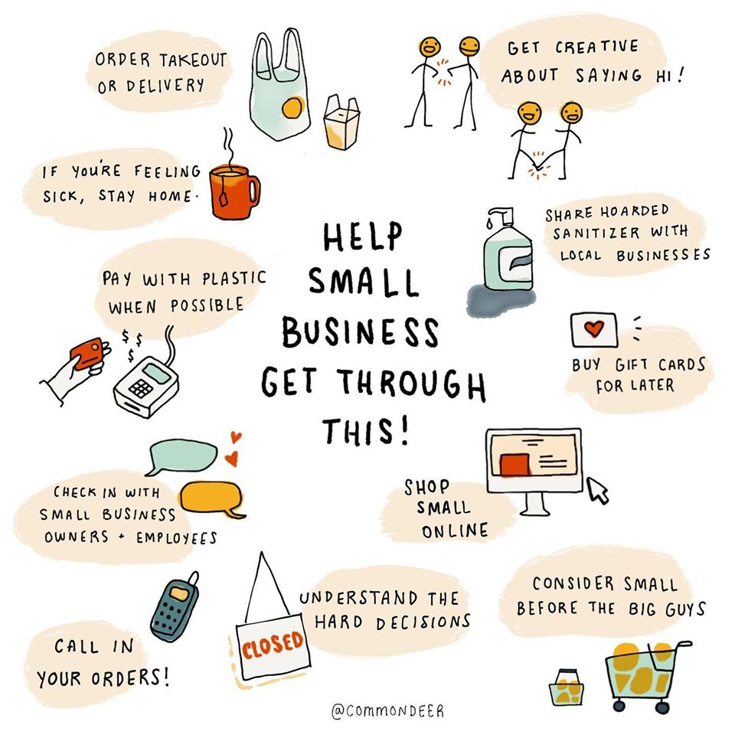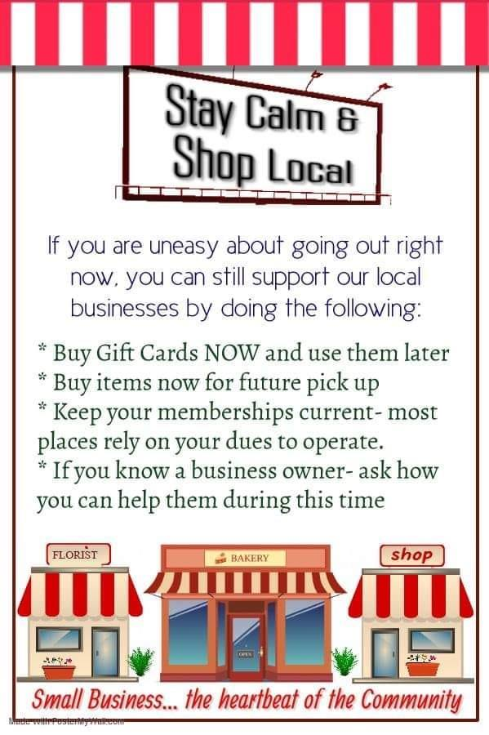
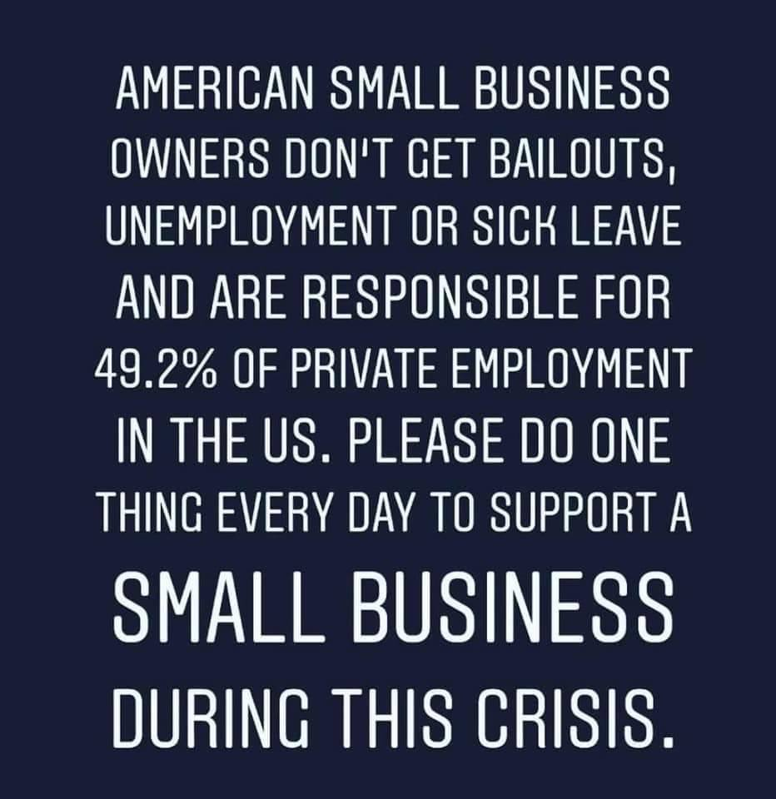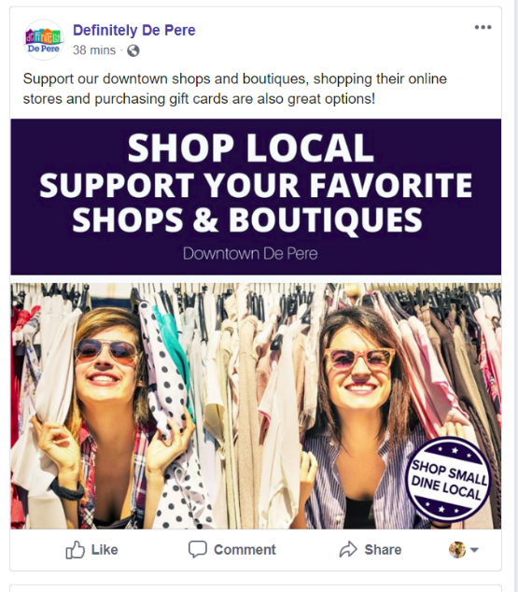

For Businesses
Many businesses have developed innovative products and services, or are packaging existing services to accommodate social distancing. Below are some creative marketing messages and social media posts that highlight unique services that acknowledge their customer’s needs.
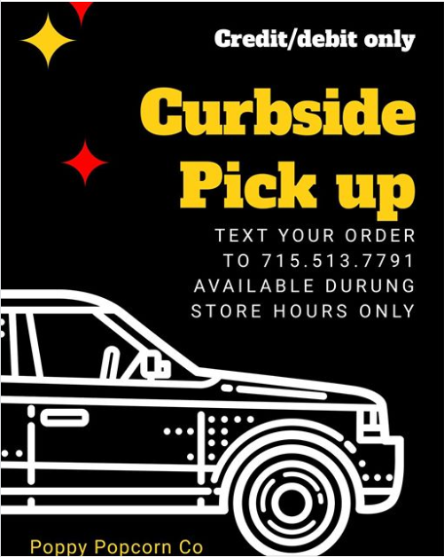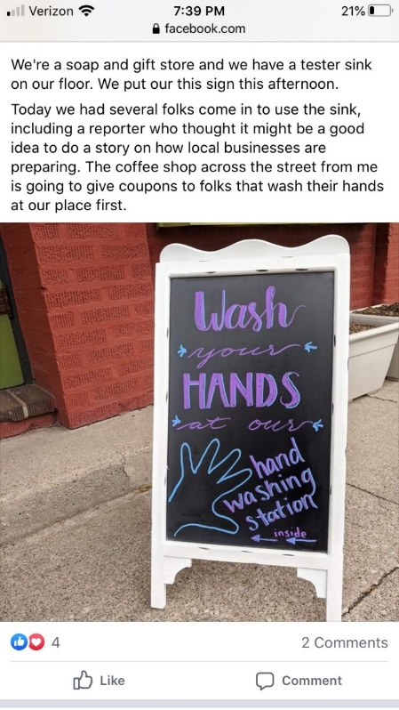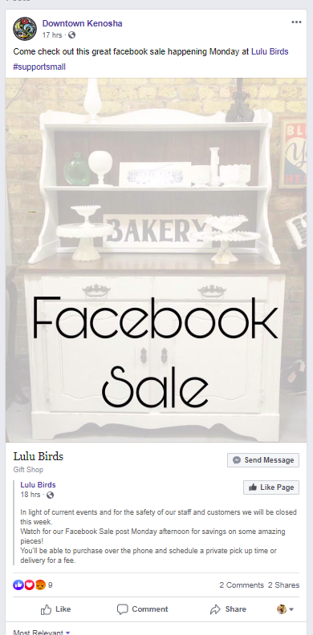
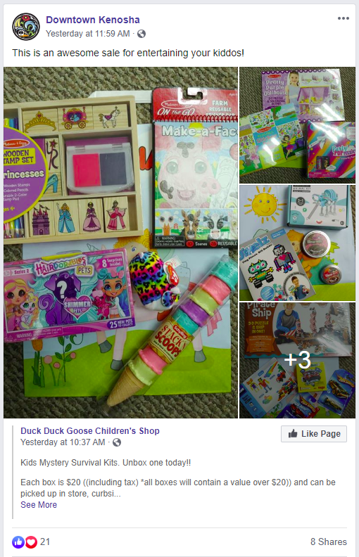

- Additional Resources
While most governments and organizations are still struggling to develop an effective response aid the numerous small businesses and employees negatively impacted by the pandemic, there have been a few programs made available, and other existing resources that can be applied in this instance. Those we are currently aware of are listed below.

Online Forums:

WhizBang! Retailers is an online forum for small retailers. From now until the pandemic subsides, they will be hosting a free call-in event at 1 pm eastern to allow small retailers to share ideas and best practices. www.whizbangtraining.com

Funding Options:

Kiva.org is a crowd-lending platform that provides 0% loans to small businesses through a platform of online lenders (local and global). WEDC initiated a 1:1 match for loans for downtown businesses that are women, minority or veteran-owned last year to expedite funding for these projects.
Effective immediately, U.S. applicants for a Kiva loan will have access to the following:
- Expanded eligibility: More businesses will be eligible for a Kiva loan.
- Larger loans: the maximum loan on the Kiva platform will increase from $10,000 to $15,000.
- Grace period: Applicants may receive a grace period of up to 6 months for greater financial flexibility.

The SBA has made disaster funds available to businesses. These loans can be for up to $2 million and These loans may be used to pay fixed debts, payroll, accounts payable and other bills that can’t be paid because of the disaster’s impact. The interest rate is 3.75% for small businesses without credit available elsewhere; businesses with credit available elsewhere are not eligible. The interest rate for non-profits is 2.75% over a 30-year term.

Delivery How-To:
When Delivery Services Are Available (major metros & adjacent)
- Before signing up for a delivery service – make sure to research pros and cons of every service you’re considering
- Most third-party applications offer prohibitively high fees, especially for small and mid-sized restaurants.
- Use the data from your POS to crunch the numbers before you decide which margins will be profitable to your business
- Update your Menu
  - Before uploading your menu to a third-part site – make sure you review it carefully
    - Are prices accurate?
    - Do you want to offer a discount to guests who order certain dishes online?
    - If any of your offerings will travel poorly, you might consider removing them from the online menu
- Train Your Staff
  - If you are hiring your own delivery drivers, make sure they all have proper insurance and that their cars are in working order
  - It is also important that you take the time to train your emplo9yees to handle phone calls from online orders
- Be Mindful of your Capacity
  - Size of your takeout containers
  - Speed at which your chefs can cook
  - Number of orders each driver can fit in their car
- Track Your Progress
  - Once you start working with a food delivery service, use your POS to keep careful track of every order
  - Track which items are the most profitable, and which ones don’t get ordered at all

DoorDash
- DoorDash is currently the market leader – using its Y-Model, focusing on all three segments of the delivery process (users, restaurants, dashers) to create an experience that all parties walk away from satisfied
- The company aims to partner with diners, restaurants, and its drivers to achieve an honest sense of cooperation
- The mobile app boasts a very user-friendly interface which allows GPS tracking, status updates, and instant customer service
- Most partners place their order commission around 20% - one of the smallest fees in the industry
- Operators may choose to pay steeper fees to have their establishment appear higher in searches

Grubhub
- Since 2013, Grubhub has acquired 12 other third-party delivery startups, including Eat24, Foodler, and Seamless
- Their overall share has dropped from 28% tot 26.7% with the aggressive growth of DoorDash. Although Grubhub boasts 14.5 million users across 1,700 cites and 80,000 restaurants
- Where Grubhub differs from most other services is the ability to allow restaurants use their own delivery staff – this means restaurant operators can maintain more control over their delivery operations, but still benefit from the marketing pow3er and convenience of Grubhub’s ordering system
- POS integration make it a seamless transition so that orders coming via their wesite or app pop into your queue no differently than your waitstaff entering it in at a POS device
- With this wide range of service levels, it is no surprise their range of fees reportedly spans from 15-30%

When Delivery Services Aren’t Available
- Restaurants Already Doing Delivery
  - Reach out to restaurants in your community that are already have delivery options and see if you can create a partnership with drivers or other services
  - A partnership could be positive for both parties - by sharing their drivers or cars they will also be sharing the cost with you
- Cab Companies / Rideshare
  - Reach out to local cab companies or rideshare companies and see if they are interested in partnering with your restaurant for food delivery
- Start a delivery service for your Restaurant
  - Upgrade your POS system - you need a POS system that can handle delivery
  - Check your kitchen line
  - Decide who provides transportation
    - When it come to hiring employees for delivery, there are a couple of different paths to take.
      - Hiring someone to be a part-time delivery person
      - Hiring someone full-time who does nothing but delivery
      - These employments closely resemble using a contract worker
    - Will delivery employees use their own vehicles or will you invest in your own company cars
  - Package food in branded wrapping
    - Invest in sturdy, temperature controlled, and possibly branded materials to keep food intact and delicious
  - Design a takeout menu
  - Minimum Deliveries & Tips
    - Having an employee leave for upward to an hour at a time while on the clock will start to add up in labor costs
    - Many restaurants have a required minimum order amount before delivery is an option
    - Some restaurants also include a delivery service fee
    - You also need to consider your tipping policy
      - It is custom in many places to be ready to tip your driver but with an increasingly digital world, many customers pay with card and may make things complicated by having to add a tip to an already run check

- My HomeTown Delivery app http://myhometowndelivery.com/
  - The app helps you earn money on your own schedule and have more time to pursue your dreams and goals – set your own fees and get paid for every delivery you make
  - With the My HomeTown Delivery App, drivers utilize the app to connect with customers, manage orders and make deliveries
  - A grocery/item delivery app that helps connect drivers and customers with one another to get all kinds of delivery services
  - The My HomeTown Delivery App is an easy way to get a little extra help when you need it – easy to use
  - Network of independent drivers is growing daily and the app helps connect customers with drivers in communities across the country

Selling on Social
- Simplify the purchase process on social media
  - Customers want to be able to complete their purchases quickly and easily – there should only be a few steps to take the buyer from the discovery stage through the checkout
  - Use “Buy” or “Shop Now” button on Instagram and Facebook ads
- Work with social media influencers
  - Influencers are people who have an impact on consumers’ purchase decisions. What they say about a product or brand can go a long way towards influencing how people feel about said product or brand
  - After identifying appropriate influencers – you could have them post a photo featuring one of your products – it is crucial that they either tag or mention you so that people know where to get that product

Facebook
- Product Catalog
  - This is a feature where you can link you inventory in your ecommerce store to your Facebook business profile and begin selling those same products directly on Facebook
  - Your online store and Facebook talk to each other as purchases are made, so your inventory is always correct, and you have more revenue in your pocket
  - You can link the items in your Product Catalog directly to your Facebook ads, so you can reach your customer in a highly targeted way – making them more likely to make a purchase
- Less is More
  - When selling on Facebook – you will always have the most success when you boost posts or run ads for your products
  - It is important to remember not to overwhelm users or they may be likely to unfollow/block you
  - Make sure to put a frequency cap on your ads so you limit the number of times a user sees your ad
- Get Personal
  - Users rather see a specific ad for a product they would actually like than see a bunch of ads for items they don’t want cluttering up their news feed
  - Promote products that are personalized or tailored to your target customer, and your sales are sur to increase
  - It is important to know your target audience when choosing which social media platform to sell on
  - You will know when you see a shoppable post on Instagram because it will have a small shopping bag ion
  - When a user taps one of these posts they will then see the name of the item and the price
  - You can make a purchase right there in the Instagram app

