éaooc/ 10

Coat Drive
Hosted by: The Sisterhood Innovators
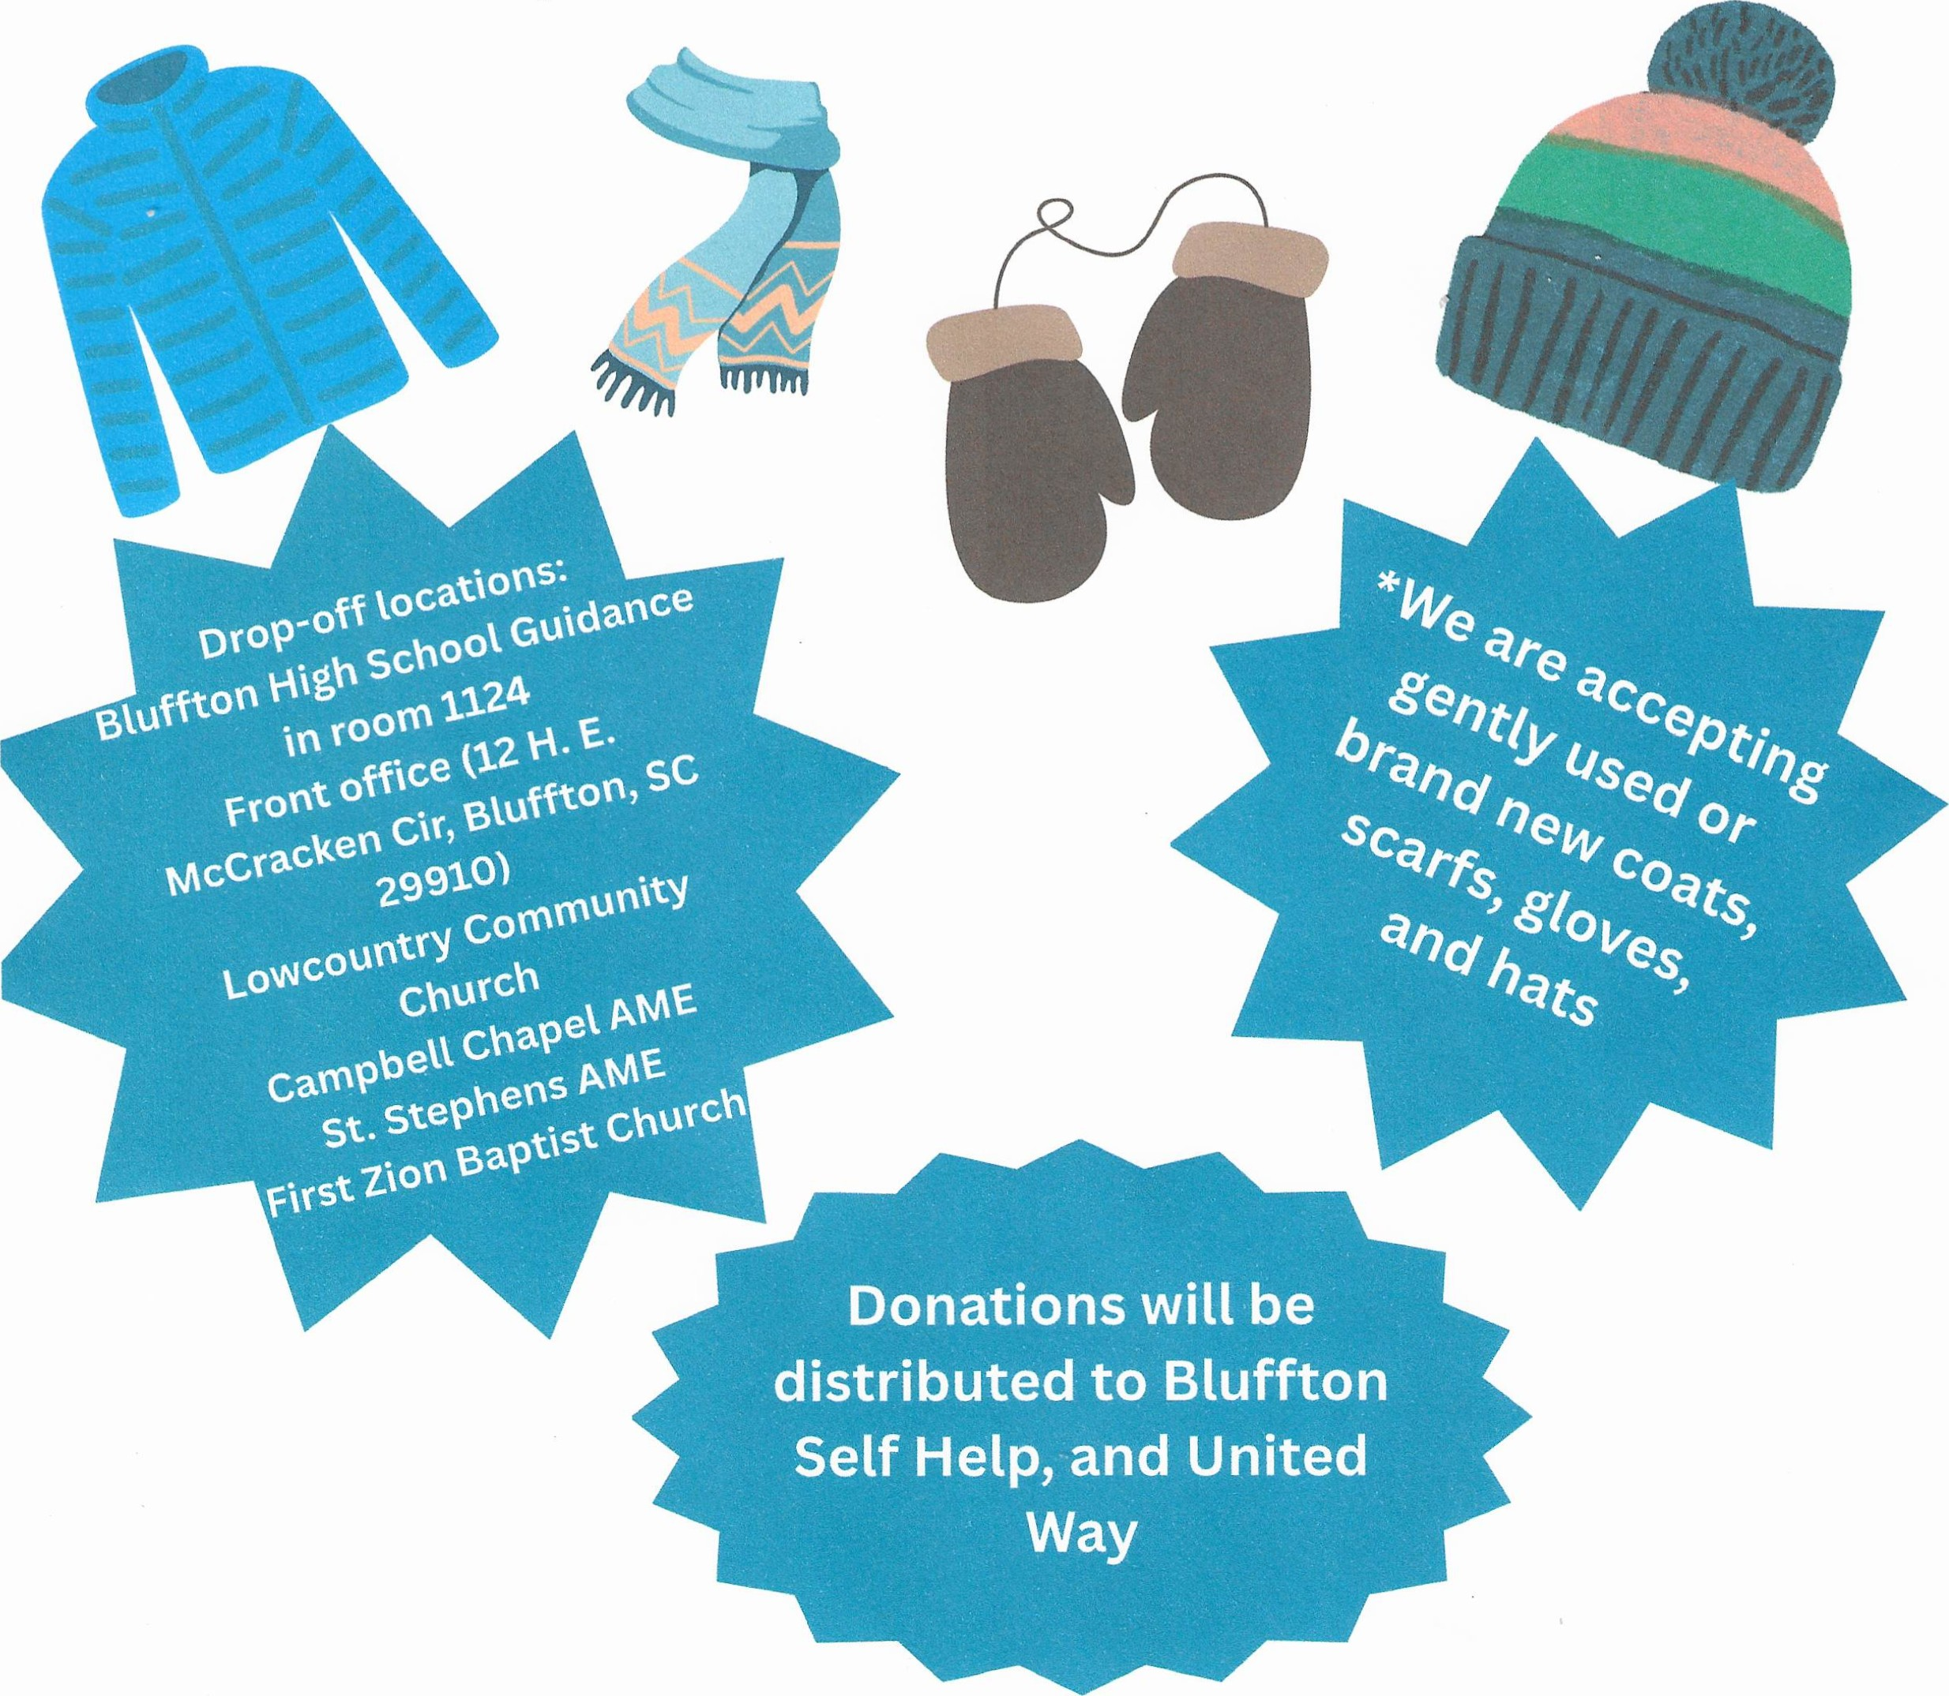
*For more information contact: Sharon Brown 843-706-8803
November 3rd-December 17th

DISCUSSION TOPICS
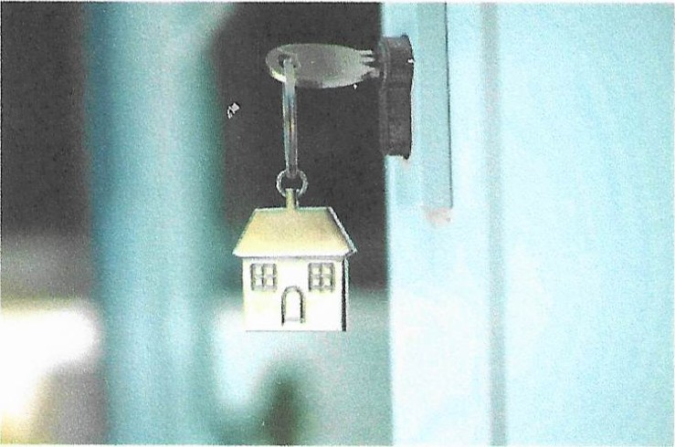
Credit Score
 Down Payment
Assistance Programs
CJ Mortgage Process
And More
 | 
  THURSDAY, DECEMBER 4, 2025
  6:00 PM - 8:00 PM 0 11 RECREATION COURT, ^{V} BLUFFTON, SC, 29910
Free and open to Beaufort & Jasper Counties Registration is encouraged:
vsmalls@townofbluffton.com or (843)706-7826

memory matters
FREE SUPPORT GROUPS
We are here to support you on your caregiverjourney and provide an oppoåunity to connect with others.
In-person at Memory Matters on Hilton Head & virtually via Zoom

MEN'S GROUP
1st Thursday of each month, 10:30 am - 11:30 am
CO-ED GROUP
2nd Thursday of each month, 10:30 am - 11:30 am
WOMEN'S GROUP
3rd Monday of each month, 1:00 pm - 2:00 pm
In-person at Okatie Pines Retirement Community - Conversation Room 142 Okatie Center Blvd N, Okatie, SC 29909
CO-ED GROUP /Veap
Last Wednesday of each month, 11:00 am - 12 pm

FOR zoom LINK - GO TO www.mymemorymatters.org/support-groups
memory 9 your comprehensive resource for memory care
Inatters SUPPORT - EDUCATION - RESPITE
v.8u2025

