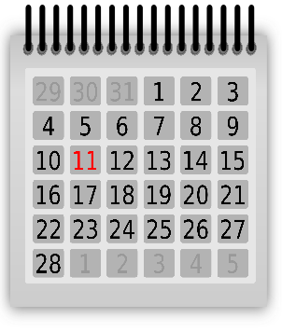

CCAME
2025 Calendar of Events

“Radical Hospitality”
Rev. Fedrick A. Wilson, Pastor
25 Boundary Street
Post Office Box 83
Bluffton, SC 29910
843-757-3652
www.campbellchapelame.com


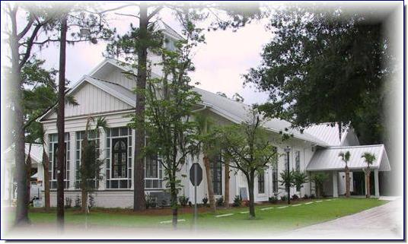
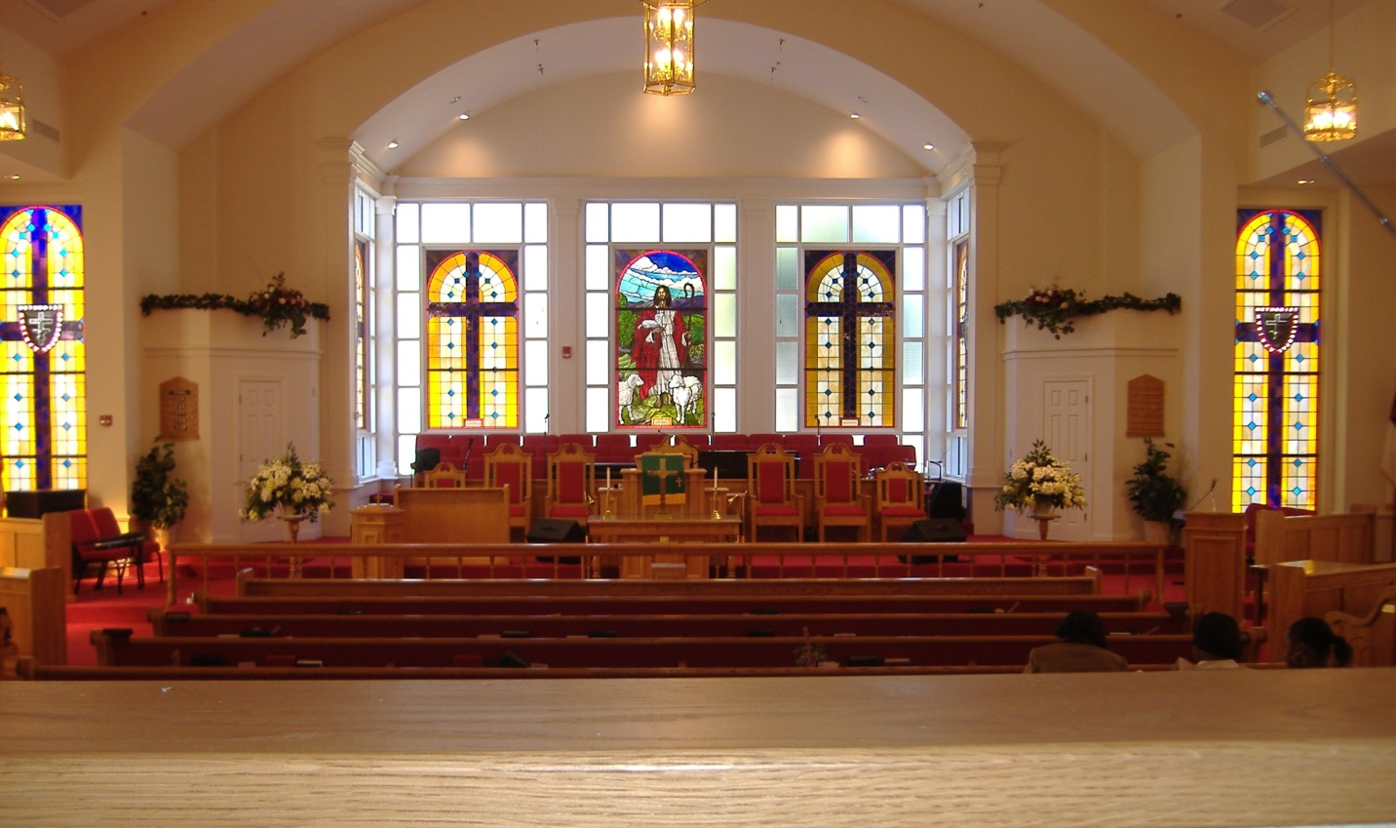
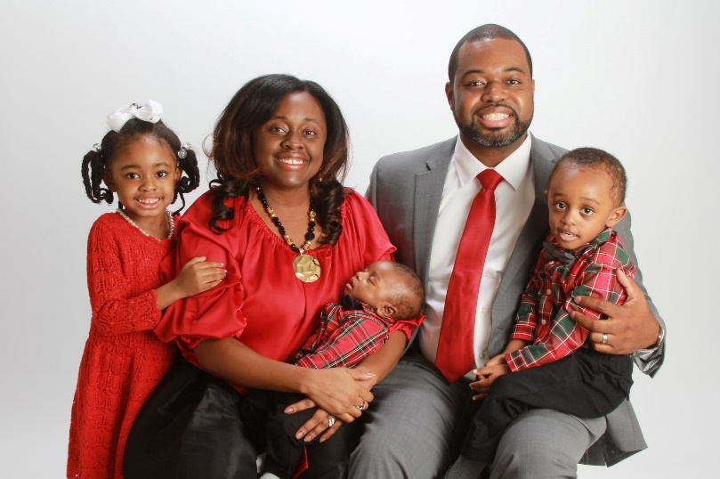
FROM THE PASTOR’S DESK…

Dear Campbell Chapel,
It is a blessing to stand together on the front porch of 2025, welcoming the dawn of a new year! We’ve all been through so much, and I am wholly convinced that “the steadfast love of the Lord never ceases; God’s mercies never come to an end; they are new every morning; great is God’s faithfulness” (Lamentations 3:22-23). Praise God for blessings and favor upon our lives!
I praise God for my appointment to serve as pastor of Campbell Chapel AME Church in Bluffton, SC, given by Bishop James L. Davis on Saturday, November 9, 2024, at the Seventh Episcopal District Planning Meeting in Florence, SC. My beloved wife, Tenessa B. Wilson, along with our children, Taylor (9 years old), Timothy (7 years old), and Trenton (5 years old), are excited about this God-given opportunity to serve this wonderful congregation. We are looking forward to moving to Beaufort County to live and serve in this thriving and growing community.
First, I praise God for the spiritual, innovative, faithful, and successful leadership of the Rev. Dr. Jon Black and First Lady Donna Black at Campbell Chapel for nine fruitful years. Campbell Chapel is better today because of their commitment to Christ and this community. I am looking forward to their compassionate and competent leadership as our new Presiding Elder and Area Consultant. Again, thank you, Dr. and Mrs. Black! We love you all.
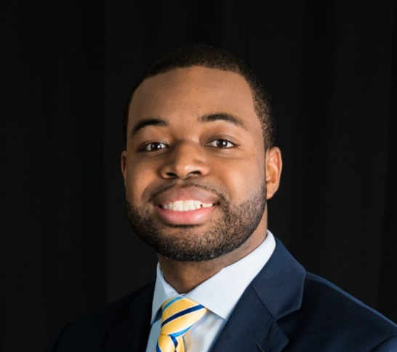
God gets excited when the Church has a passion for Christ. That’s why having a clear vision strategy is important to growing the church. There are four ways to accomplish this. First, we must know God and the Lord wholeheartedly. Second, we must find community; life is better together. Third, we must discover our purpose: Why are we here? What impact does God want us to make in the world? Finally, God calls us to make a difference—to influence numerous lives for God’s glory.
Just as healthy bodies depend on functioning systems, thriving churches rely on robust outreach, discipleship, and communication structures interconnecting people to God’s purposes. Together, we can move beyond surviving to thriving as God designed.
Well-functioning systems, as highlighted by Nelson Searcy, are crucial for a thriving church. They transform and streamline operations, clarify expectations, and save you Stress, Time, Energy, and Money (SYSTEMS). They also yield tangible results. Healthy systems allow impactful groups, teams, and ministries to facilitate meaning, anchor relationships, and reveal a purpose worth committing to the following:
- Worship Experience
- Hospitality and Guest Services
- Creative and Digital Services
- Connections and Discipling New Members
- Children and Youth
- Ministries and Small Groups
- Volunteer and Outreach
- Generosity and Stewardship
- Leadership Development
- Social Justice and Community Development

Implementing God’s vision for our congregation requires a collaborative approach between pastor and people. Successful transition requires a God-centered, thoughtful, and collaborative approach that engages officers, leaders, staff, members, volunteers, ministry leads, and key stakeholders. The goal is to implement God's vision for the greatest impact. It takes teamwork to make the dream work. We will do great things together and watch God work miracles through us working together!

Campbell Chapel AME Church is building a vibrant faith community where people can come as they are, meet Jesus, grow in their faith, and find a place to serve. Our mission is to make disciples of Jesus Christ through love, service, community transformation, and global impact. I eagerly anticipate the blessings and growth that our collaboration together under my spiritual leadership will usher into our church family. In the words of our Presiding Bishop, the Right Reverend James L. Davis, let us “trust God and IGNITE our passion, our people, and our purpose from a small spark to a mighty flame!”

You and yours have already become dear to me, and I feel overwhelming gratitude for being part of this Campbell Chapel family. And as we work together, let’s also hope together. We have the chance to bring reconciliation and hope to each other and the world.

So, Campbell Chapel, let us rely on one another as we were meant to, and let us look together toward all that lies ahead—the good and the challenging—reminding one another that God is ever present, ever faithful, and ever calling us to a holy mission according to the Way of Jesus.

I am praying for the light of God to shine upon you and bring you peace.

Blessings,

The Rev. Fedrick A. Wilson
Pastor

OUR MISSION:
The mission of Campbell Chapel AME Church is to make disciples of Jesus Christ through love, service, community transformation, and global impact.

OUR VISION:
Campbell Chapel is building a vibrant, faith community where people can come as they are, meet Jesus, grow in their faith, and find a place to serve.

OUR OBJECTIVES:
- Do all things to the glory of God.
- Actively establish ministries, activities, and programs to evangelize, disciple and nurture souls of all social and ethnic backgrounds.
- Nurture every willing believer to spiritual maturity, equip them to do the work of God, and provide each with the opportunity to exercise his/her gifts.
- Carry out all mandates handed down from the African Methodist Episcopal Church.
- Develop and participate in ministries and programs which only advance the Kingdom of God and serve for the wellbeing of fellow believers.
- Nurture and teach children and youth our faith and history, provide wholesome Christian social and recreational activities, and support them in their spiritual, intellectual and emotional development.
- Maintain the upkeep of all church facilities and grounds at the highest level and in accordance to state and municipal ordinances.
- Maintain a safe and clean environment for all people and for all activities and services under the auspices of Campbell Chapel AME Church.
- Live out our faith as a full-service church in word and deed.

MINISTERIAL TEAM
- Rev. Fedrick A. Wilson, Pastor
- Rev. Willie Ann Hamilton
- Dr. Nannette Pierson
- Lic. Tennessa Wilson
- Lic. Torrence Saxton
- Evangelist Ruth Peeples
- Evangelist Tonia Ramirez
- Minister Melvin Bobian
- Minister Courtney Peeples

CHURCH MINISTRIES:
The early church was a supernatural dynamic interactive community, operating in the power of the Holy Spirit. The call of God for the church to emulate Christ is still ours to perform. When the primary focus is placed on people and relationships, then the church functions as a living organism in which God’s presence and power are known wherever they go and in whatever they do.
The church has been uniquely equipped to give to people that which they cannot receive from any other source. There is no substitute for the work and ministry of the church because there is no need known among people that the living God cannot satisfy. Every member of the body of Christ in Campbell Chapel AME Church is called to serve the Lord through one or more ministries of the church. The following list represents the ministries of our Church.
STEWARD DUTIES:

A steward assists the pastor in all administrative capacities, helping to implement courses of action to facilitate decision-making. Stewards are responsible for accounting for the accuracy of church membership and church finances. A steward must be a person of solid piety who knows and loves the Word of God and the Doctrine of the African Methodist Episcopal Church. A steward must be fruitful and of good natural or acquired ability to transact the spiritual and temporal business of the church.

STEWARD BOARD:

Lucille Kannick (Pro Tem) | Phyllis L. Pritchett
Claryce G. Allen | Gelinda Simmons
Sharon Brown | Mary Smalls
Angela Douglas | Victoria Smalls
James Gilliard | Dr. Keith Taylor
Allyne Mitchell | Laura Wilson
Effie Moon, Emeritus

TRUSTEE DUTIES:

It is the duty of the Trustee to attend to the temporal concerns of God's Church. Trustees are accountable for all expenditures related to the upkeep and maintenance of the Church. They are additionally responsible for overseeing the discharge of all matters concerning all church properties. These include, but are not limited to, the acquisition, management, and maintenance processes of the Church's properties.

TRUSTEE BOARD:

Peggy Jaynes. (Pro Tem) | Lincoln Kannick
Frank Gadson | Anthony Mervin
James Gadson | Dwight Stephens
Curtis Howard | Ahmad Ward
Jerome Jenkins
Isaac Bryant, Emeritus | Thurman Moon, Emeritus

CLASS LEADER DUTIES:

The class leader’s responsibility is to provide support to his/her assigned members through visitation, communication, listening and praying with and for them. They also act as liaisons to the pastor and the Official Board for the well-being of their assigned members. Class leaders must also motivate their members to avail themselves to the means of grace, attend worship services, and to participate in the total life of the Church and its related activities and events.

THE CLASS LEADERS COUNCIL:

Rev. Willie Ann Hamilton, Pro-tem
Class Leader | Class Number | Class Leader | Class Number
Hazel Rickenbacker | Class 1 | Pauline Tyler | Class 8
Fred Hamilton, Jr. | Class 2 | Jannie Miranda | Class 9
Mary Smalls | Class 3 | Samuel Harris | Class 10
Laura Speaks | Class 4 | Rev. Willie Ann Hamilton | Class 11
Delores Anderson | Class 5 | Victoria Smalls | Class 12
Barbara Alston | Class 6 | Sharon Brown | Class 13
Joan Simmons | Class 7 | Jacqueline Fulton | Class 14

LOCAL COMMISSIONS:

The Commissions serve three purposes: (1) they supervise all local ministries, (2) provide expert leadership to other ministries as needed and (3) provide training to other ministries as requested. For example, the AV Ministry is supervised by the Commission on Public Relations. The Commission on Public Relations provides expert leadership to all ministries needing to publicize their work. Additionally, the Commission on Public Relations provides training in PR to all ministries that request their services.

COMMISSION CHAIRS:

Gelinda Simmons Membership, Evangelism, and Discipleship (MED)
Dr. Keith Taylor Health and Wellness
Evangelist Ruth Peeples Public Relations
James Gilliard Church Administration
Claryce Gibbons-Allen Christian Social Action
Rev. Fedrick Wilson Music and Worship
Victoria Smalls Christian Education
Lucille Kannick Stewardship and Finance
Mary Smalls Mission and Welfare

Membership, Evg./Discipleship |  | Health and Wellness |  | Public Relations
Gelinda Simmons |  | Dr. Keith Taylor |  | Evg. Ruth Peeples
Sarah Harris |  | Dr. LaChiana Hamilton |  | Ron Newsome
Peggy Jaynes |  | Dr. Chanda Medlock |  | Laura Wilson
Lincoln Kannick |  | Rhonda St. Thomas Rogers
Mary Smalls |  | Dwight Stephens
 |  | Dr. Monica Taylor
 |  | Vanessa Tiburcio
Christian Education |  | Christian Social Action |  | Mission and Welfare
Victoria Smalls |  | Claryce Gibbons-Allen |  | Mary Smalls
Dr LaChiana Hamilton |  | Angela Douglas |  | Anna Bolden
Allyne Mitchell |  | Jacqueline Fulton |  | Sharon Brown
Ronald James |  | Constance Martin-Witter |  | Peggy Jaynes
Hazel Rickenbacker |  | Hazel Rickenbacker |  | Constance Martin-Witter
Martin Sr. Thomas Rogers |  | Victoria Smalls |  | Joan Simmons
Mary Smalls |  | Dwight Stephens |  | Bernice Young
Church Admin |  | Stewardship and Finance |  | Music and Worship
James Gilliard |  | Lucille Kannick |  | Rev. Fedrick A. Wilson
Sherese Bailey |  | Jacqueline Fulton |  | Sherese Bailey
Angela Douglas |  | James Gilliard |  | Sharon Brown
Brenda Johnson |  | Peggy Jaynes |  | Glora Gadson
Lucille Kannick |  | Jerome Jenkins |  | James Gilliard
Liz McGuffey |  | Effie Moon |  | Dr. LaChiana Hamilton
Victoria Smalls |  | Gelinda Simmons |  | Ronald James
 |  | Dwight Stephens |  | Lucille Kannick
 |  | Ahmad Ward |  | Allyne Mitchell
 |  |  |  | Minister Courtney Peeples
 |  |  |  | Evag. Ruth Peeples
 |  |  |  | Hazel Rickenbacker
 |  |  |  | Mary Smalls
 |  |  |  | Victoria Smalls
 | MINISTRIES |  | PRESIDENTS |  | COMMISSIONS:
 | Audio Video |  | Lucille Kannick |  | Public Relations
 | Church School |  | Mary Smalls |  | Christian Education
 | Hospitality |  | Lincoln Kannick |  | Membership
 | Lay Organization |  | Lucille Kannick |  | Membership
 | Maletones |  | James Gadson |  | Music and Worship
 | Married Couples |  | Effie Moon |  | Church Administration
 | Pastor’s Aide |  | Bertha Gadson |  | Steward Board
 | Safety & Security |  | Ahmad Ward |  | Trustee Board
 | Sons of Allen |  | Samuel Harris |  | Public Relations
 | Stewardess Board |  | Gloria Gadson |  | Steward Board
 | Unity Choir |  | Evangelist Tonia Rameriz |  | Music and Worship
 | Usher Board |  | Jonathan Baker |  | Music and Worship
 | Women’s Missionary Society |  | Allyne Mitchell |  | Mission and Welfare
 | Young Voices of Praise |  | Lauren Lewis |  | Music and Worship
 | YPD |  | Dr. Keith Taylor |  | Mission and Welfare

PRAYER AND BIBLE STUDY:

The true power of Campbell Chapel can be found in its Day of Prayer and Weekly Bible Studies. Thursdays are our Day of Prayer. All members are asked to participate in one of the four opportunities provided weekly for corporate prayer.

INTERCESSORY PRAYER LEADER:

Thursdays 9:00 AM Bernice Young
Thursdays 12:00 PM James Gilliard
Delores Anderson

Thursdays 8:00 PM Gelinda Simmons

BIBLE STUDY LEADERSHIP:

Tuesdays at 12:00 PM Rev. Fedrick Wilson
Wednesdays at 6:30 PM Martin E. St. Thomas Rogers

THE MINISTRY OF MUSIC AND WORSHIP:

The music and worship ministry provides leadership for choirs and other temple servants in preparation and participation in worship services. Furthermore, it works to enable and enhance each person’s desire to appear in the presence of God to offer God praises and thanksgiving for who He is and what He has done through quality music and appropriate worship presentations.

MUSIC MINISTRY LEADERSHIP:

Organist Justin Temoney
Drummer Torrence Saxton
Maletones President James Gadson
Minister of Music John Simmons, Jr.
Unity Choir President Evangelist Tonia Ramirez
Young Voices of Praise Lauren Lewis

CHURCH SCHOOL DEPARTMENT:

This ministry provides the life vein of Bible teaching for all ages in the church. Included in this ministry is the training of the congregation in the history and traditions of our church which keeps us aware of our heritage both ethnically and spiritually.

CHURCH SCHOOL TEACHERS:

Church School Superintendent Mary Smalls (Interim)
Adult Class Teacher Fred Hamilton
Adult Class Teacher Lucille Kannick
Adult Class Teacher Mary Smalls
Adult Class Teacher Dr. Nanette Pierson
Junior Class Teacher Sharon Brown
Intermediate Class Teacher Rev. Willie Ann Hamilton
Pre-School Teacher Gelinda Simmons
Youth Department Teacher Victoria Smalls
Children’s Church Dr. S. Hamilton



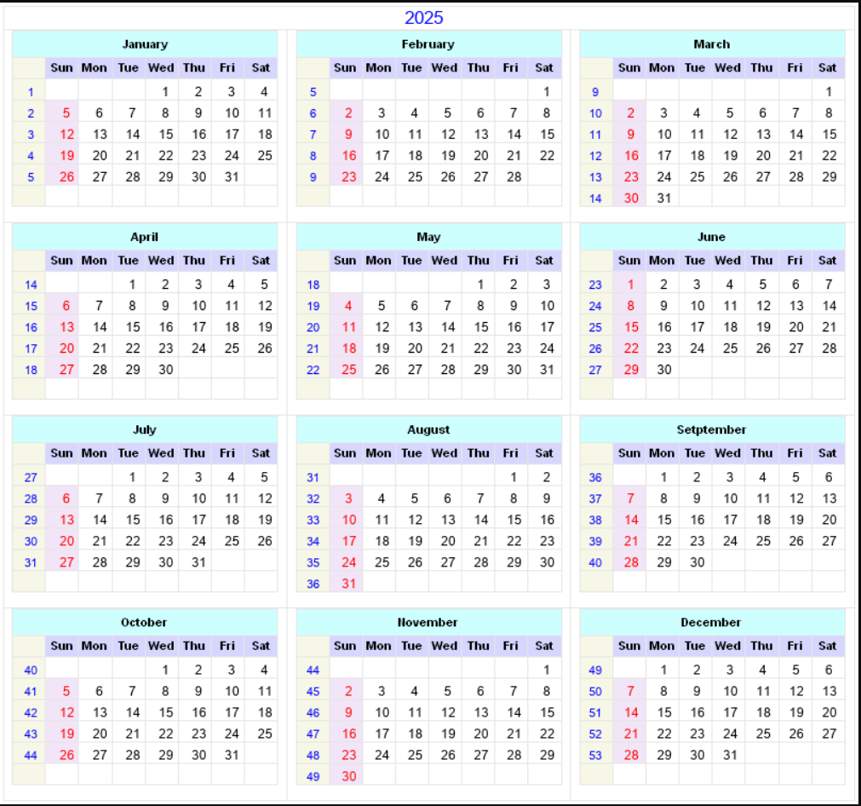


SUNDAYS and SPECIAL DAYS 2025 CALENDAR
JAN 05 | Epiphany Sunday (White or Gold)  Isa 60:1-6; Ps 72:1-7, 10-14 (UMH 795); Eph 3:1-12; Mt 2:1-12 | APR 14 | Monday of Holy Week (Purple or Red)  Isa 42:1-9; Ps 36:5-11 (UMH 743); Heb 9:11-15; John 12:1-11
JAN 12 | Baptism of the Lord (White or Gold)  Isa 43:1-7; Ps 29 (UMH 761); Acts 8:14-17; Luke 3:15-17, 21-22 | APR 15 | Tuesday of Holy Week (Purple or Red)  Isa 49:1-7; Ps 71:1-14 (UMH 794); 1 Cor 1:18-31; John 12:20-36
JAN 19 | 2nd Sunday after the Epiphany; Human Relations Day (Green) Isa 62:1-5; Ps 36:5-10 (UMH 771); 1 Cor 12:1-11; John 2:1-11 | APR 16 | Wednesday of Holy Week (Purple or Red)  Isa 50:4-9; Ps 70 (UMH 793); Heb 12:1-3; John 13:21-32
JAN 26 | 3rd Sunday after the Epiphany; Ecumenical Sunday (Green) Neh. 8:1-3, 5-6, 8-10; Ps 19 (UMH 750); 1 Cor 12:12-31a; Luke 4:14-21 | APR 17 | Maundy Thursday (Purple or Red)  Exod 12:1-4, 5-10, 11-14; Ps 116:1-4, 12-19 (UMH 837); 1 Cor 11:23-26; John 13:1-17, 31b-35
FEB 02 | 4th Sunday after the Epiphany (Green)  Jer 1:4-10; Ps 71:1-6 (UMH 794); 1 Cor 13:1-13; Luke 4:21-30 | APR 18 | Good Friday (No Color)  Isa 52:13-53:12; Ps 22 (UMH 752); Heb 10:16-25; John 18:1-19:42
FEB 09 | 5th Sunday after the Epiphany; Scouting Sunday (Green) Isa 6:1-8, 9-13; Ps 138 (UMH 853); 1 Cor 15:1-11; Luke 5:1-11 | APR 19 | Easter Eve / Easter Vigil (White or Gold)  Job 14:1-14; Ps 31:1-4, 15-16; 1 Peter 4:1-8; Matt 27:57-66
FEB 16 | 6th Sunday after the Epiphany (Green)  Jer 17:5-10; Ps 1 (UMH 738); 1 Cor 15:12-20; Luke 6:17-26 | APR 20 | Easter; Festival of God’s Creation Sunday (White or Gold)  Acts 10:34-43; Ps 118:1-2, 14-24 (UMH 839); 1 Cor 15:19-26; John 20:1-18 or Luke 24:1-12
FEB 23 | 7th Sunday after the Epiphany (Green)  Gen 45:3-11, 15; Ps 37:1-11, 39-40 (UMH 772); 1 Cor 15:35-38, 42-50; Luke 6:27-38 | APR 27 | 2nd Sunday of Easter (White or Gold)  Acts 5:27-35; Ps 150 (UMH 862); Rev 1:4-8; John 20:19-31
MAR 02 | Transfiguration Sunday (White)  Ex 34:29-35; Ps 99 (UMH 819); 2 Cor 3:12-4:2; Luke 9:28-36 (37-43) | MAY 04 | 3rd Sunday of Easter; Native American Ministries Sunday  (White or Gold) Acts 9:1-6 (7-20); Ps 30 (UMH 762); Rev 5:11-14; John 21:1-9
MAR 05 | Ash Wednesday (Purple or Grey)  Joel 2:1-2, 12-17; Ps 51:1-17 (UMH 785); 2 Cor 5:20b-6:10; Matt 6:1-6, 16-21 | MAY 11 | 4th Sunday of Easter; Mother’s Day; Festival of the Christian Home (White or Gold) Acts 9:36-43; Ps 23 (UMH 754); Rev 7:9-17; John 10:22-30
MAR 09 | 1st Sunday in Lent; Scouting Sunday (Alternate) (Purple) Deut 26:1-11; Ps 92:1-2, 9-16 (810); Romans 10:8b-13; Luke 4:1-13 | MAY 18 | 5th Sunday of Easter; Heritage Sunday (White or Gold) Acts 11:1-18; Ps 148 (UMH 861); Rev 21:1-16; John 13:31-35
MAR 16 | 2nd Sunday in Lent (Purple)  Gen 15: 1-12, 17-18; Ps 27 (UMH 758); Phil 3:17-4:1; Luke 13:31-35 | MAY 25 | 6th Sunday of Easter (White or Gold)  Acts 16:9-15; Ps 67 (UMH 791); Rev 21:10,22-22:5; John 14:23-29
MAR 23 | 3rd Sunday in Lent (Purple)  Isa 55:1-9; Ps 63:1-8 (UMH 788); 1 Cor 10:1-13; Luke 13:1-9 | MAY 29 | Ascension Day (White or Gold)  Acts 1:1-11; Ps 47 (UMH 781); Eph 1:15-23; Luke 24:44-53
MAR 30 | 4th Sunday in Lent; UMCOR Sunday (Purple)  Josh 5:9-12; Ps 32 (UMH 766); 2 Cor 5:16-21; Luke 15:1-3, 11b-32 | JUNE 01 | 7th Sunday of Easter; Ascension Sunday (White or Gold)  Acts 16:16-34; Ps 97 (UMH 816); Rev 22:12-14, 16-17, 20-21; John 17:20-26
APR 06 | 5th Sunday in Lent (Purple)  Isa 43:16-21; Ps 126 (UMH 847); Phil 3:4b-14; John 12:1-8 | JUNE 08 | Pentecost (Red)  Acts 2:1-21; Ps 104:24-34, 35b (UMH 826); Rom 8:14-17; John 14:8-17 (25-27)
APR 13 | Passion/Palm Sunday (Purple or Red)  Palms Lit: Luke 19:28-40; Ps 118:1-2, 19-29 (UMH 839) Passion Lit: Isa 50:4-9; Ps 31:9-16 (UMH 764); Phil 2:5-11; Luke 22:14-23:56 or Luke 23:1-49 | JUNE 15 | Trinity Sunday; Peace with Justice Sunday; Father’s Day  (White or Gold) Prov 8:1-4, 22-31; Ps 8 (UMH 743); Rom 5:1-5; John 14:8-17, 25-27
SUNDAYS and SPECIAL DAYS 2025 CALENDAR
JUNE 22 | 2nd Sunday after Pentecost (Green)  1 Kings 19:1-15a; Ps 42 (UMH 777); Gal 3:23-29; Luke 8:26-39 | OCT 05 | 17th Sunday after Pentecost; World Communion Sunday (Green) Lam 1:1-6; Ps 137 (UMH 852); 2 Tim 1:1-14; Luke 17:5-10
JUNE 29 | 3rd Sunday after Pentecost (Green)  2 Kings 2:1-2, 6-14; Ps 77:1-2, 11-20 (UMH 798); Gal 5:1, 13-25; Luke 9:51-62 | OCT 12 | 18th Sunday after Pentecost (Green)  Jer 29:1, 4-7; Ps 66:1-12 (UMH 790); 2 Tim 2:8-15; Luke 17:11-19
JULY 06 | 4th Sunday after Pentecost (Green)  2 Kings 5:1-14; Ps 30 (UMH 762); Gal 6:(1-6), 7-16; Luke 10:1-11, 16-20 | OCT 19 | 19th Sunday after Pentecost; Laity Sunday; Children’s Sabbath  (Green) Jer 31:27-34; Ps 119:97-104 (UMH 750); 2 Tim 3:14-4:5; Luke 18:1-8
JULY 13 | 5th Sunday after Pentecost (Green)  Amos 7:7-17; Ps 82 (UMH 804); Col 1:1-14; Luke 10:25-37 | OCT 26 | 20th Sunday after Pentecost; Reformation Sunday (Green) Joel 2:23-32; Ps 65 (UMH 789); 2 Tim 4:6-8, 16-18; Luke 18:9-14
JULY 20 | 6th Sunday after Pentecost (Green)  Amos 8:1-12; Ps 52 or 82 (UMH 804); Col 1:15-28; Luke 10:38-42 | NOV 02 | 21st Sunday after Pentecost; All Saints Sunday (Green or White) Hab 1:1-4, 2:1-4; Ps 119:137-144 (UMH 840); 2 Thes 1:1-4, 11-12. Luke 19:1-10 All Saints Lections: Daniel 7:1-3, 15-18; Ps 149 (UMH 862); Eph 1:11-23; Luke 6:20-31
JULY 27 | 7th Sunday after Pentecost (Green)  Hos 1:2-10; Ps 85 (UMH 806); Col 2:6-15 (16-19); Luke 11:1-13 | NOV 09 | 22nd Sunday after Pentecost; Organ & Tissue Donor Sunday (Green) Hab 1:15b-2:9; Ps 145:1-5, 17-21 (UMH 857); 2 Thess 2:1-5, 13-17; Luke 20:27-38
AUG 03 | 8th Sunday after Pentecost (Green)  Hos 11:1-11; Ps 107:1-9, 43 (UMH 830); Col 3:1-11; Luke 12:13-21 | NOV 16 | 23rd Sunday after Pentecost (Green)  Isa 65:17-25; Isa 12 (UMH 839); 2 Thess 3:6-13; Luke 21:5-19
AUG 10 | 9th Sunday after Pentecost (Green)  Isa 1:1, 10-20; Ps 50:1-8, 22-23 (UMH 783); Heb 11:1-3, 8-16; Luke 12:32-40 | NOV 23 | Christ the King/Reign of Christ Sunday; Thanksgiving Sunday (White)  Jer 23:1-6; Luke 1:68-79 (UMH 208); Col 1:11-20; Luke 23:33-43  Thanksgiving Day Lections (White or Red)  Deut. 26:1-11; Ps 100 (UMH 821); Phil 4:4-9; John 6:25-35
AUG 17 | 10th Sunday after Pentecost (Green)  Isa 5:1-7; Ps 80:1-2, 8-19 (UMH 801); Heb 11:29-12:2; Luke 12:49-56 | NOV 30 | 1st Sunday of Advent; UM Student Day; Beginning Lectionary Year A (Purple or Blue) Isa 2:1-5; Ps 122 (UMH 845); Rom 13:11-14; Matt 24:36-44
AUG 24 | 11th Sunday after Pentecost (Green)  Jer 1:4-10; Ps 71:1-6 (UMH 794); Heb 12:18-29; Luke 13:10-17 | DEC 07 | 2nd Sunday of Advent (Purple or Blue)  Isa 11:1-10; Ps 72:1-7, 18-19 (UMH 795); Rom 15:4-13; Matt 3:1-12
AUG 31 | 12th Sunday after Pentecost (Green)  Jer 2:4-13; Ps 81:1, 10-16 (UMH 803); Heb 13:1-8, 15-16; Luke 14:1, 7-14 | DEC 14 | 3rd Sunday of Advent (Purple or Blue)  Isa 35:1-10; Luke 1:46b-55 (UMH 199); James 5:7-10; Matt 11:2-11
SEPT 07 | 13th Sunday after Pentecost (Green)  Jer 18:1-11; Ps 139:1-6, 13-18 (UMH 854); Philem 1:17-27; Luke 14:25-33 | DEC 21 | 4th Sunday of Advent (Purple or Blue)  Isa 7:10-16; Ps 80:1-7, 17-19 (UMH 801); Rom 1:1-7; Matt 1:18-25
SEPT 14 | 14th Sunday after Pentecost; Grandparent’s Day (Green) Jer 4:11-12, 22-28; Ps 14 (UMH 746); 1 Tim 1:12-17; Luke 15:1-10 | DEC 24 | Christmas Eve (White or Gold)  Isa 9:2-7; Ps 96 (UMH 815); Titus 2:11-14; Luke 2:1-14, (15-20)
SEPT 21 | 15th Sunday after Pentecost (Green)  Jer 8:8-9:1; Ps 79:1-9 or Ps 4 (UMH 741); 1 Tim 2:1-7; Luke 16:1-13 | DEC 25 | Christmas Day (White or Gold)  Isa 52:7-10; Ps 98 (UMH 818); Heb 1:1-4 (5-12); John 1:1-14
SEPT 28 | 16th Sunday after Pentecost (Green)  Jer 32:1-3a, 6-15; Ps 91:1-6, 14-16 (UMH 810); 1 Tim 6:6-19; Luke 16:19-31 | DEC 28 | 1st Sunday after Christmas Day (White or Gold) Isa 63:7-9; Ps 148 (UMH 861); Heb 2:10-18; Matt 2:13-23
THE 2025 CALENDAR OF EVENTS
FOR CAMPBELL CHAPEL AME CHURCH
Campbell |  | Beaufort District | SC Conference | Episcopal District | Holiday
JANUARY 2025
January 1 | New Year’s Day
January 3-5 | WMS Retreat (Myrtle Beach, SC)
January 10-11 | Lay Organization Retreat (Myrtle Beach, SC)
January 11 | Beaufort District SOA Prayer Breakfast (St. Peters- Walterboro)
January 13 | Beaufort District Zoom Meeting (Grants Donors, and Community Ministry)
January 14 | 2nd Quarterly Conference
January 18 | Beaufort District Lay Organization Bi-monthly Meeting
January 19 | CCAME Christian Social Action General Meeting Via Zoom: 6:00 PM
January 20 | Pastor’s Birthday/Dr. Martin L. King Holiday
January 25 | Beaufort District WMS/YPD Planning Meeting - TBA
January 26 | Annual Conference Planning Meeting (After Worship Service)
January 29 | AME Day at the State House – Columbia, SC: 1:30 PM
FEBRUARY 2025
February 1-28 | CCAME Youth Black History Presentation (Every Sunday during Worship)
February 1 | Beaufort District SOA Super Bowl Chili Cook Off (Mt. Zion – Round O)
February 2 | CCAME Lay Organization Executive Board Meeting Via Zoom: 6:00 PM
February 6 | Lic. Tenessa Wilson’s Birthday (Pastor’s wife)
February 7 | UNCF Richard Allen Gala (Columbia, SC)
February 9 | Beaufort Area YPD Super Bowl of Caring
February 9 | AME Founder’s Day
February 9 | CCAME Christian Social Action Executive Board Meeting Via Zoom: 6:00 PM
February 10 | Beaufort District Zoom Meeting (Grants Donors, and Community Ministry)
February 14 | Valentine’s Day
February 16 | CCAME Christian Social Action General Meeting Via Zoom: 6:00 PM
February 17 | President’s Day
February 23 | Annual Conference Planning Meeting (After Worship Service)
February 23 | Beaufort District YPD Black History Program – TBD
February 23 | SCCB WMS 116 Anniversary Service
February 23 | HBCU/Pan Hellenic/Sports Day
MARCH 2025
March 5 | Ash Wednesday (Combined Service with Queen Chapel: Hilton Head) 7:00 PM
March 3 | CCAME Lay Organization Executive Board Meeting Via Zoom 6:00 PM
March 7-9 | SED YPD Retreat (Mrytle Beach, SC)
March 9 | CCAME Christian Social Action Executive Board Meeting Via Zoom: 6:00 PM
March 10 | Beaufort District Zoom Meeting (Grants Donors, and Community Ministry)
March 11 | Beaufort District Social Action Commission Meeting (Zoom – 7:00 PM)
March 15 | District Conference (Allen AME Church- Burton) 9:00 AM
March 16 | CCAME Christian Social Action General Meeting Via Zoom: 6:00 PM
March 20-22 | Annual Ministries in Christian Education Training & Planning Mtg.
March 23 | Annual Conference Planning Meeting (After Worship Service)
March 23 | Beaufort Area WMS Women’s History Month Celebration
March 29 | Beaufort District Line Dance Class (TBA)
March 29 | CCAME Lay Training Day 9:00 AM – 12:00 PM
March 30 | Lay Day Worship Service
March 30 | Beaufort District WMS 5th Sunday Service (TBA)
March 30 | Oratorical/Madame Seven Elimination
APRIL 2025
April 7 | Beaufort District Zoom Meeting (Grants, Donors and Community Ministry)
April 9 | SCCB YPD Bible Talk
April 10-12 | SED Mid-Year Conference
April 12 | YPD Easter Picnic and Egg Hunt
April 12 | Beaufort Area YPD – Glow for Christ Program (TBA)
April 12 | Beaufort District Lay Organization Bi-monthly Meeting
April 13 | CCAME Christian Social Action Executive Board Meeting Via Zoom: 6:00 PM
April 13 | Holy Week/Palm Sunday
April 17 | Maundy Thursday (Combined Service with Queen Chapel: Bluffton) 7:00 PM
April 18 | Good Friday (12:00 PM)
April 20 | Easter/Resurrection Sunday/Sunrise Service 6:00 AM
April 20 | CCAME Christian Social Action General Meeting Via Zoom: 6:00 PM
April 26 | Annual Conference Planning Meeting (After Worship Service)
April 26 | Beaufort Area Self Denial Program (TBA)
MAY 2025
May 1 | National Day of Prayer
May 5 | CCAME Lay Organization Executive Board Meeting Via Zoom
May 9 | Allen University Graduation (Columbia, SC)
May 10 | Beaufort District Women of the Bible Program
May 11 | Mother’s Day
May 11 | CCAME Christian Social Action Executive Board Meeting Via Zoom: 6:00 PM
May 12 | Beaufort District Zoom Meeting (Grants, Donors, and Community Ministry)
May 12-16 | Self-Denial Week
May 16 | Ella C. White Banquet
May 18 | CCAME Christian Social Action General Meeting Via Zoom: 6:00 PM
May 25 | Annual Conference Planning Meeting (After Worship Service)
May 26 | Memorial Day
JUNE 2025
June 1-28 | SCCB Mission Outreach Project Collection of Light Bulbs
June 2 | CCAME Lay Organization Executive Board Meeting Via Zoom
June 7 | Beaufort District Christian Education Day (St. John – Cottageville 9:00AM)
June 8 | Pentecost
June 8 | CCAME Christian Social Action Executive Board Meeting Via Zoom: 6:00 PM
June 9 | Beaufort District Zoom Meeting (Grants, Donors, and Community Ministry)
June 10 | Beaufort District Social Action Commission Zoom
June 14 | Beaufort Area WMS Meeting
June 15 | Father’s Day
June 15 | CCAME Christian Social Action General Meeting Via Zoom: 6:00 PM
June 16 | Beaufort District SOA Evangelism Night (St. Peter – Gifford)
June 19 | Juneteenth
June 20-21 | SED Lay State Convention (Columbia, SC)
June 21 | Beaufort Area WMS/YPD End of Year Celebration
June 22 | Annual Conference Planning Meeting (After Worship Service)
June 23-25 | AME General Board Meeting
June 27-28 | Beaufort Area RAYAC Retreat
June 28 | SCCB WMS/YPD End of the Year Meeting
June 30 | Family and Friends Week Begins
JULY 2025
July 1-3 | Family and Friends Week
July 4 | Independence Day
July 6 | CCAME Church Anniversary
July 7-11 | Connectional Lay Biennial (Atlanta, GA)
July 13-16 | SED Christian Education Congress and Leadership Training
July 13 | CCAME Christian Social Action Executive Board Meeting Via Zoom: 6:00 PM
July 19 | Beaufort District Lay Bi-monthly Meeting
July 20 | CCAME Christian Social Action General Meeting Via Zoom: 6:00 PM
July 21 | Beaufort District Zoom Meeting (Grants, Donors, and Community Ministry)
July 26 | Beaufort District Church School Convention (Hendersonville Elementary) 9:00 AM
July 27 | Beaufort District Annual SOA Outreach/Closing Service (Mt. Pisgah – Seabrook)
July 27 | Annual Conference Planning Meeting (After Worship Service)
AUGUST 2025
August 4 | CCAME Lay Organization Executive Board Meeting Via Zoom
August 6-8 | 2nd Annual Youth Revival
August 9 | Beaufort Area WMS End of the Year Meeting
August 9 | Beaufort Area YPD Back to School Event
August 10 | Beaufort District Closing Worship (Grace Chapel – Lady’s Island) 3:00 PM
August 10 | CCAME Christian Social Action Executive Board Meeting Via Zoom: 6:00 PM
August 11 | Beaufort District Zoom Meeting (Grants, Donors, and Community Ministry)
August 12 | Beaufort District Social Action Commission Meeting
August 17 | CCAME Christian Social Action General Meeting Via Zoom: 6:00 PM
August 24 | Annual Conference Planning Meeting (After Worship Service)
SEPTEMBER 2025
September 1 | Labor Day
September 7 | Pastor’s Appreciation
September 10-13 | Palmetto Annual Conference
September 14 | CCAME Christian Social Action Executive Board Meeting Via Zoom: 6:00 PM
September 17-20 | South Carolina Annual Conference (Campbell Chapel – Bluffton)
September 21 | CCAME Christian Social Action General Meeting Via Zoom: 6:00 PM
September 24 | CCAME First Family Wedding Anniversary
OCTOBER 2025
October 1-4 | Piedmont Annual Conference (Popular Springs – Greenville)
October 6 | CCAME Lay Organization Executive Board Meeting Via Zoom: 6:00 PM
October 8-11 | Northeast Annual Conference (Mt. Olive – Myrtle Beach)
October 10 | Columbia Annual Conference (St. Paul – Irmo)
October 10 | Central Annual Conference (Heyward AME)
October 12 | CCAME Christian Social Action Executive Board Meeting Via Zoom: 6:00 PM
October 19 | CCAME Christian Social Action General Meeting Via Zoom: 6:00 PM
October 26 | Fall Fest Social (After Worship Service)
NOVEMBER 2025
November 1-26 | Service Project: Collection of Non-perishable items for Bluffton Self Help
November 4 | Election Day
November 9 | CCAME First Family 1st Year Anniversary
November 9 | CCAME Christian Social Action Executive Board Meeting Via Zoom: 6:00 PM
November 11 | Veterans Day
November 13-15 | SED Planning Meeting
November 16 | CCAME Christian Social Action General Meeting Via Zoom: 6:00 PM
November 27 | Thanksgiving Day
November 30 | 1st Sunday of Advent
DECEMBER 2025
December 1-14 | Service Project: Collection of Unwrapped Toys for Bluffton Self Help Christmas
December 6 | Beaufort District Planning Meeting (Greater Mt. Olive – Smoaks)
December 7 | 2nd Sunday of Advent
December 14 | Youth Christmas Program and Luncheon  3rd Sunday of Advent
December 14 | CCAME Christian Social Action Executive Board Meeting Via Zoom: 6:00 PM
December 21 | CCAME Christian Social Action General Meeting Via Zoom: 6:00 PM  4th Sunday of Advent
December 24 | Community Christmas Eve Service
December 25 | Christmas Day
December 31 | Watch Night Service 12:00 PM

RECURRING MEETINGS

MEETING | DATE | TIME | Place
Joint Stewards and Trustees Meeting | 1st Tuesdays | 6:00 PM | Zoom
Official Board Meeting | 3rd Tuesdays | 6:00 PM | Zoom
Class Leaders Meeting | 4th Tuesdays | 6:00 PM | Zoom

Making a Motion (Lay Tidbits)

Action | What to Say | Can interrupt speaker? | Need a Second? | Can be Debated? | Can be Amended? | Votes Needed
Introduce a main motion | “I move to …” | No | Yes | Yes | Yes | Majority
Amend a motion | “I move to amend the motion by (add or strike words or both)” | No | Yes | Yes | Yes | Majority
Move them to committee | “I mover that we refer the matter to committee” | No | Yes | Yes | No | Majority
Postpone item | “I move to postpone the matter until…” | No | Yes | Yes | No | Majority
End debate | “I move the previous question” | No | Yes | Yes | No | Majority
Object to procedure | “Point of order” | Yes | No | No | No | Chair decision
Recess the meeting | “I move that we recess until…” | No | Yes | No | No | Majority
Adjourn the meeting | I move to adjourn the meeting.” | No | Yes | No | No | Majority
Request information | “Point of information.” | Yes | No | No | No | No Vote
Overrule the chair’s ruling | “I move to overrule the chair’s ruling” | Yes | Yes | Yes | No | Majority

