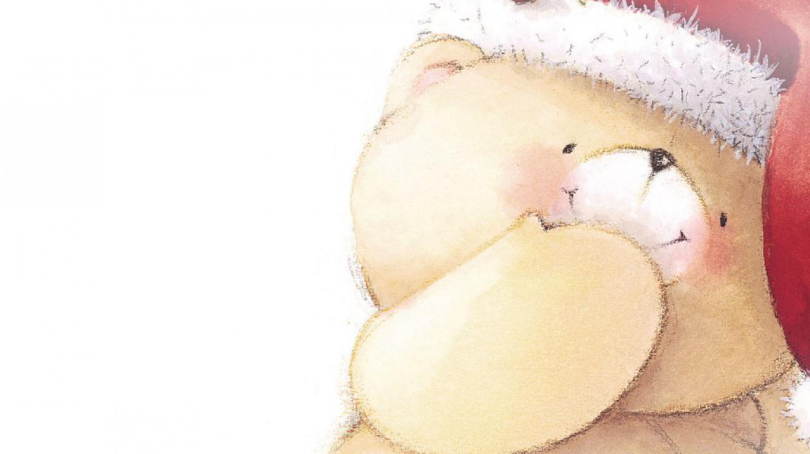
BE A Resource for CPS Kids!

Many children who have experienced abuse and neglect have never known
the thrill and anticipation of the holiday season and the excitement that
Christmas morning brings. BEARing Gifts is the annual holiday program of
BEAR... BE A Resource for CPS Kids. BEAR is a 501 (c)(3) non-profit that provides
emergency items to abused and neglected children. Our greatest need is gifts
and toys for children under the age of five and for teens. Below is a list of the
most popular gifts requested according to age. Learn more at
www.bearesourcehouston.org or contact BEAR at 713-940-3087.
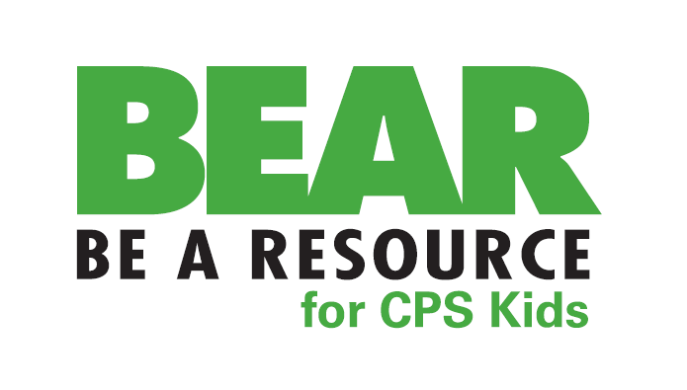
Infants/Toddlers: Musical toys, Barbie Dolls, Baby Dolls, Doll houses, Activity Blankets, Educational Toys, Handheld games, Riding Toys, Blocks/Legos, Play Phones, Play Registers, Stuffed Animals, Balls, Play Food/Dishes
Children (6-11yrs.): Dolls, Action Figures, Bikes, Scooters, Jewelry, Movies, Basketballs/Baseballs, Tween Make-Up Sets, Electronic Games, Stereos, Portable DVD Players, Remote Control Cars, Headphones/Ear buds, Handheld games
Teenagers: Make-up Kits, Gift Cards (Any Increments), iPods, Portable DVD Players, Watches, Digital Cameras, Stereos, MP3 Players, Bedding, Bath & Body Sets, Bikes, Headphones/Ear buds, Jewelry, Cologne/Perfume

