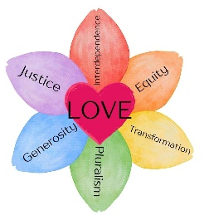
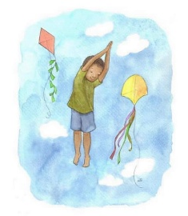
East Shore Unitarian’s Diversity and Justice Summer Reading Bingo Challenge
Read a book that includes the diversity element or theme from each square. We have lots of these books at our church library and KCLS and SPL also have great options. Mark off each completed square as you go. Complete five in a row to get BINGO! Then, bring your BINGO to our Summer Reading Party at East Shore Unitarian Church Sunday September 6 for a fun morning of stories, crafts, playtime, and prizes.
Justice | Author/Illustrator whose name starts with the first letter of your name. | Refugees & Immigrants | Asian, Asian-American, & Pacific Islander | Person who is a lot like you
A life very different from your own | African & African American | Science or a scientist | An animal | Native Nations & Indigenous Peoples
LatinX | Person who lives in a different country than you do | Free space | Diversity | An artist or musician
Nature | LGBTQIA+ | A banned book | Bodies & Abilities | Women & Girls
Culture & Traditions | Poetry | Families | Religion | Gender

