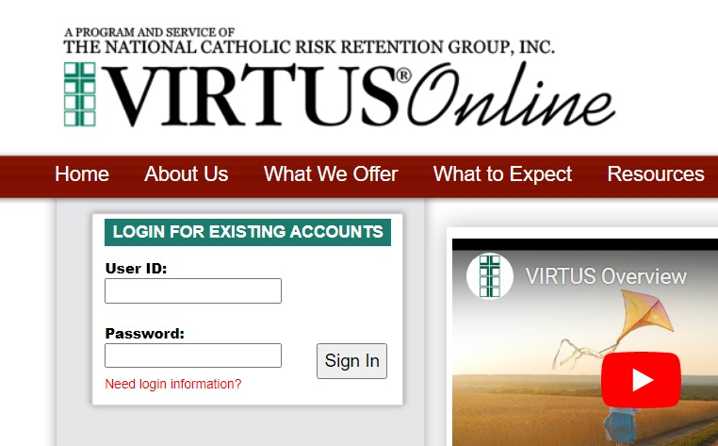

Go to www.virtusonline.org
Enter User ID and Password
Click “Need login information?” to retrieve username or reset password, if needed.

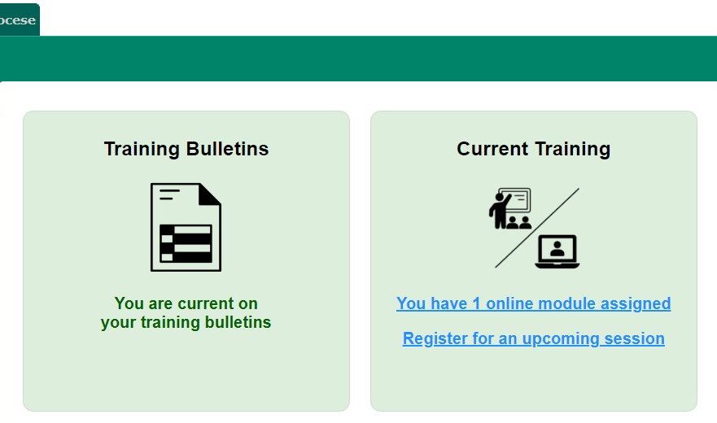

Click the link “You have X modules assigned” (number of assigned modules will vary by employee).

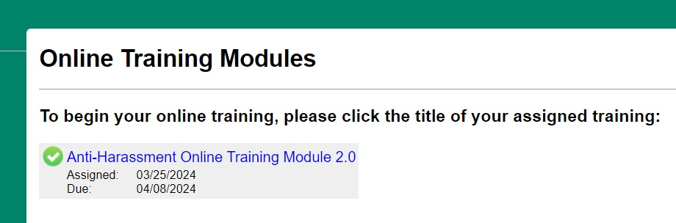
Select the training by clicking on the link.

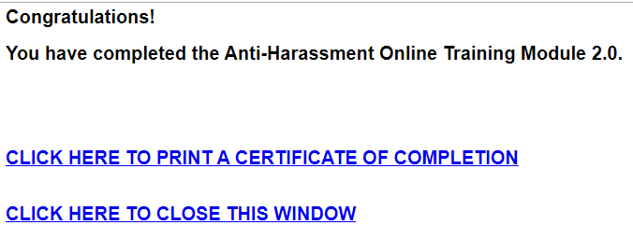
Once the module is completed, click the link to print the certificate and save it as a PDF (Last name, First Name, Date).
Email the certificate to bartosz.fryckowski@rcan.org and CC your direct Supervisor.

