
July 02, 2024
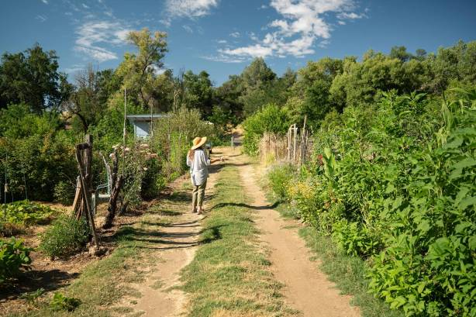
A Living Legacy: The Matson, Mowder & Howe Community Gardens
If you live in Redding, you may have driven by or even visited the two gardens that bear the names Matson, Mowder, and Howe. But do you know the people and the story behind two distinct green spaces? The Matson, Mowder, and Howe Celebration and Community Gardens have been sources of beauty and food in the Redding community for decades. They serve as memorials and living reminders of how a community can turn a tragedy into a lasting force for good.
The Matson, Mowder, and Howe gardens are named after Gary Matson, Winfield Mowder, and Marcia Howe. In the early 1980s, Gary Matson, a UC Davis-trained horticulturist and plant enthusiast, began planting native California plants west of the Carter House Natural Science Museum at Caldwell Park. Matson co-founded the museum in 1978 with Marcia Howe, an accomplished environmentalist who was Gary’s former partner and the mother of their daughter, Clea.
Marcia Howe became the museum's Executive Director, and both Gary and Marcia were involved in initially planning what eventually became Turtle Bay Exploration Park. Gary and Marcia were also largely responsible for securing the land and completing the initial master plan for what was then known as the Arboretum by the River. It has since become The McConnell Arboretum & Botanical Gardens. Gary facilitated the initial plant propagation and plantings as the arboretum took shape in the late 1990s. With a profound knack for identifying plants and trees, Gary discovered a previously unclassified light pink flower along Sulfur Creek. In 2011, a Sacramento botanist assigned the plant Gary discovered an official name: Brodiaea matsonii.
Winfield Mowder, Gary’s partner, earned a degree in anthropology from Chico State and was a beloved employee of Orchard Supply Hardware’s Garden Department. He frequently spoke at local high schools about LGBTQIA+ issues and his experiences as a gay man, serving as a source of support for area teens from all backgrounds. Both Gary and Winfield were avid members of the Shasta Chapter of the California Native Plant Society (CNPS).
On July 1, 1999, the Redding community experienced the worst form of hate and intolerance. Gary Matson and Winfield Mowder, targeted for their relationship, were murdered in a hate crime in their Happy Valley home. Their deaths shocked and devastated the Redding community and inspired a movement in support of Redding’s local LGBTQIA+ community that continues to this day.
Marcia Howe, who had remained very close to Gary and Winfield, shared a remarkable relationship with the couple as the three worked together to care for their daughter, Clea. After their deaths, she served as a spokesperson for tolerance and remained an outspoken advocate for the LGBTQIA+ community throughout her lifetime. In 2003, Marcia died of lung disease at 53 years old.
The tragic and untimely passing of Gary Matson, Winfield Mowder, and Marcia Howe inspired the North Valley Art League (NVAL) and some community members to honor Gary, Winfield, and Marcia’s legacy with a memorial garden. Led by Michele Driggs, a dedicated gardener and friend of Gary, Winfield, and Marcia, the Shasta Chapter of the CNPS and the NVAL harnessed their collaborative energy, resurrecting and expanding Gary’s original vision for a community garden. The Celebration Garden in Caldwell Park, dedicated in 2006, flourishes with California native and non-native plants alongside the North Valley Carter House Gallery. The Celebration Garden is open to the public free of charge.
For many years, the community gathered to commemorate the day Gary and Winfield were killed. That annual gathering, known as the Celebration of Life & Diversity, was instrumental in raising funds to commemorate their lives in a meaningful way. The Community Gardens were initially started in the 1970s by People of Progress (POP). Gary helped found POP and was passionate about creating community food resources. When Gary, Winfield, and Marcia died, POP renamed and refurbished the Community Gardens in their honor using funds raised during the Celebration of Life & Diversity.
Today, the Matson, Mowder, and Howe Community Gardens are a members-only shared space where people can grow food for their families and community. The garden is the living legacy of a family who contributed to the community's beauty and sustainability through their compassion and love for nature.
When it was time to update the Matson, Mowder, and Howe Community Gardens sign, Kim Niemer, former Director of Community Services for the City of Redding, selected local artist Phillip Moller of Red Bluff to paint the new sign.
“Painting a community garden sign in memory of Matson, Mowder, and Howe holds deep significance on multiple levels for me. It is an act of remembrance and honoring the lives of individuals who were victims of a heinous act of violence. It is a meaningful way to commemorate their lives and create a lasting memorial that pays tribute to their memory. It is a way for me to actively participate in creating a more inclusive and accepting community,” says Moller, a Red Bluff-based artist, muralist, and former board member with NorCal OUTreach Project.
“The Matson, Mowder, and Howe Community Gardens are more than just a place where food is grown. It’s a way of honoring the memory of Gary Matson, Winfield Mowder, and Marcia Howe—three people who were committed to making this community better, more sustainable, and more inclusive. These gardens are a legacy we are honored to have as a part of our city,” says Travis Menne, Director of Community Services with the City of Redding.
25 years after Gary and Winfield's tragic deaths and 21 years after the loss of her mother, Clea Matson continues to share her family’s passion for nature with the world. She has published a book of her father’s science and nature writings, including portions of an unfinished book about trees with botanical illustrations by Noreen Braithwaite, called Trees for Cities and Towns. She also visits both gardens and the arboretum when she happens to be in Redding.
“It makes me feel proud of and connected to the amazing work that all three of my parents did in the short time they were alive,” says Clea Matson. “I’m really thankful to everyone who made these two community parks happen and those who work so hard to maintain them.”
The community is welcome to visit the Celebration Garden year-round at 48 Quartz Hill Road, at Caldwell Park. If you are interested in a plot at the Matson, Mowder, and Howe Community Gardens, at 3000 Benton Drive, contact Plantable Nursery at 530.215.1922 or email plantable@gmail.com.

