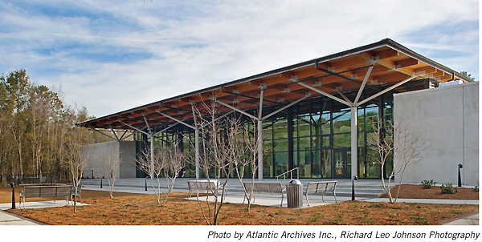
  - Friends for the Future

  - 2020 Virtual Conference

  - Friends of
  - South Carolina Libraries

  - November 6, 2020

  - Hosted by
  - Beaufort County Libraries

  - St. Helena Branch Library

Time | Event
9:00 am - 9:45 am | Welcome & Announcements  Marlena White, President of FOSCL  Amanda Dickman, Beaufort County Library System, Interim Director
9:50 am – 10:20 am | The State of the State Library System During COVID-19  Leesa Aiken, South Carolina State Library Director—
10:20 am - 10:50 am | Jonathan Newton, USC Upstate— “Advocating for your Library”
10:50 am – 11:00 am | Break
11:00 am – 11:45 | Debbie Cahoon, VP for Community Investment  Community Foundation of the Lowcountry  "Sustaining Your Non-Profits in a Virtual World”
11:45 am – 1:00 pm | Lunch with your Friends at Home
1:00pm – 1:50 pm | Jimmy Wooten, Community Engagement Manager  Greenville County Library System  “Communicating Your Story Digitally”
1:50 pm – 2:00 pm | Break
2:00 pm – 3:00 pm | Keynote Address ~ Brad Taylor, Author  Hosted by Jonathan Haupt, Executive Director Pat Conroy Literary Center
3:10 pm – 4:00 pm | Dan Aldridge, President of Friends of Georgia Libraries  “Memorandums of Understanding”
4:00 pm | Conference Farewell  Marlena White, President FOSCL
5:00 pm – 6:00 pm | “Before We Were Writers” Panel Discussion, Pat Conroy Center Literary Festival
SCHEDULE OF EVENTS
2020 Conference Speakers

Keynote – Brad Taylor
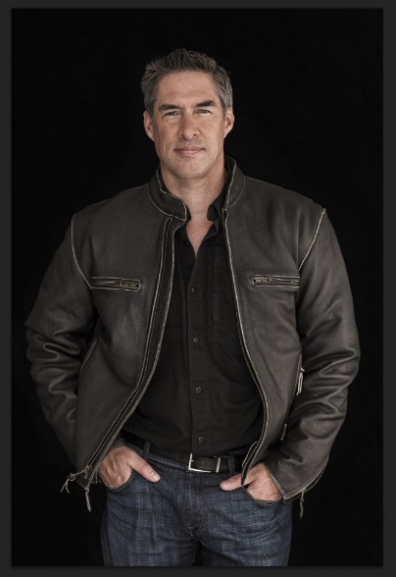
New York Times bestselling novelist Brad Taylor was born on Okinawa, Japan, but grew up on 40-acres in rural Texas. Graduating from the University of Texas, he was commissioned as a second lieutenant in the U.S. Army Infantry. Brad served for more than 21 years, retiring as a Special Forces Lieutenant Colonel. During that time, he held numerous Infantry and Special Forces positions, including eight years in 1st Special Forces Operational Detachment – Delta where he commanded multiple troops and a squadron. He has conducted operations in support of US national interests in Iraq, Afghanistan, and other classified locations.
His final assignment was as an assistant professor of military science at The Citadel in Charleston, SC. He holds a Master’s of Science in Defense Analysis from the Naval Postgraduate School, with a concentration in Irregular Warfare. In 2011, Brad published his debut novel, One Rough Man, which was an immediate success and launched the Pike Logan series. Now with more than 13 installments and more than 2 million copies sold, the series has consistently hit the New York Times bestseller list. When not writing, he serves as a security consultant on asymmetric threats for various agencies. He lives in Charleston, SC with his wife and two daughters.
Learn more at https://bradtaylorbooks.com/
Photo by Claudio Marinesco.
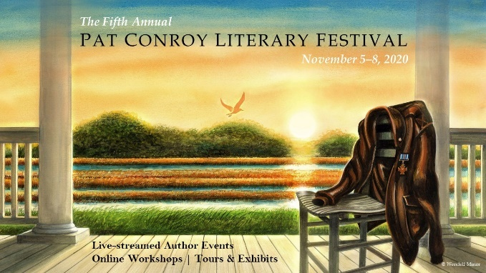

Debbie Cahoon
VP of Community Investment,
Community Foundation of the Lowcountry

Sustaining Non-Profits

Debbie was born in New Mexico and raised in
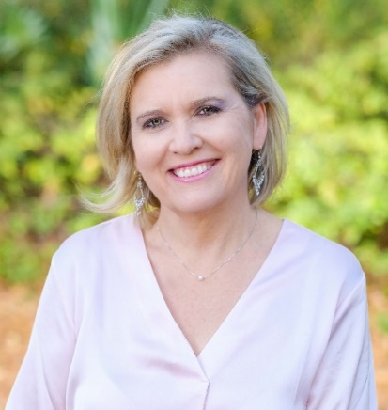
southeastern Texas. She relocated with her family to the Lowcountry in 1996 when her company opened a satellite office in Bluffton. Debbie brings experience in accounting, quality control and customer service. She served as Controller for several businesses in the Houston area. Projects there included single and multi-family construction as well as commercial properties and military housing. Her tenure as Controller at Fulcrum Properties, Inc., in Savannah brought experience in property management accounting for both multi-family and commercial properties, and customer, tenant relationships.

Debbie learned the value of working "for a mission" when she joined the staff of Community Foundation of the Lowcountry in 2013 as Program Assistant. Since then, she has worked extensively with all the programs offered by the foundation. She has a keen interest in the people and the programs of the Lowcountry and holds a special place in her heart for education as she has guided many students (and their families) through the scholarship application process.
Debbie currently serves as Vice President of Community Investment at Community Foundation of the Lowcountry. Debbie is a graduate of Hilton Head Island Leadership and Rapport Leadership International Training. She holds a Bachelor's Degree in Business Administration from USCB with a concentration in Management. She is currently working on an MBA at USCA.

Contact Information:
Debbie Cahoon
843-681-9100
dcahoon@cf-lowcountry.org

Leesa Aiken
Director, South Carolina State Library

The State of South Carolina Libraries

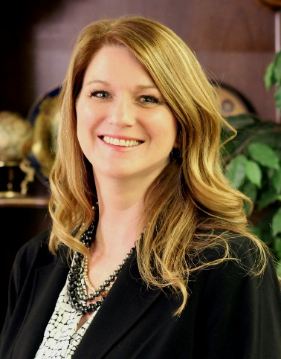
Leesa Aiken is the Director of the South Carolina State Library, where she has worked for thirteen years in various capacities before becoming the Agency Director. She enjoys creating programs that provide equal access to information for all South Carolinians and believes that access to information creates opportunities for success.

Ms. Aiken received a Bachelor of Arts degree in Child and Family Studies with an emphasis on Early Care and Education from Columbia College, a Master of Arts in Organizational Change and Leadership from Columbia College, and a Master of Library and Information Science from the University of South Carolina. She is a Certified Public Manager, a Master Project Manager, and holds a Senior Professional in Human Resources designation.

She is active in the Chief Officers of State Library Agencies, the International Federation of Library Associations and Institutions, the Society for Human Resource Management, the Greater Columbia Chamber of Commerce, and in state and local government. Ms. Aiken has served on numerous boards to include, the South Carolina State Employee Grievance Committee, South Carolina First Steps, Rolling Readers, the International Public Management Association, the South Carolina State Employee Association, the Partnership among South Carolina Academic Libraries, and the South Carolina K-12 Technology Board.

Aiken’s fundamental goal is to provide inclusive access, which meets the needs of the diverse population in South Carolina. The State Library is committed to developing, supporting, and sustaining a thriving community of learners, who make South Carolina stronger through innovation and collaboration.

Contact Information:
Leesa M. Aiken
Agency Director
(803)734-8668 office, (803)338-0861 cell
laiken@statelibrary.sc.gov

Jimmy Wooten
Community Engagement Manager,
Greenville County Library System

Communicating Your Story Digitally

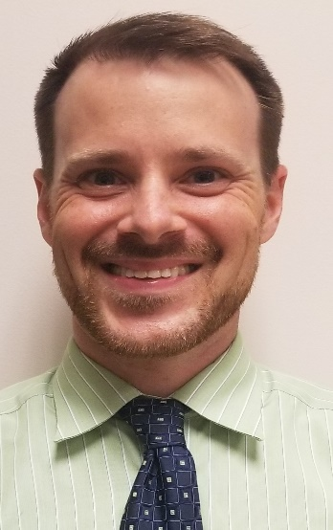
Jimmy Wooten is the Community Engagement Manager with the Greenville County Library System in Greenville, South Carolina. Jimmy oversees the responsibilities of managing communications, marketing, programming, community relations, and resource development as well as providing supervision and administrative responsibilities in the administrative office for the Library System.
Prior to the start of his role in October 2018,
he served as the Director of Fund
Development and Marketing and as
the Director of Public Affairs and Marketing
for two non-profit organizations in Greenville.
Previously, he had over 15 years of business
experience working in event planning,
hospitality, marketing, and customer service
industries.
To him, every brand has a story to tell. These
stories impact, engage, inform, and surprise
their audience no matter the platform. He
strives for organization, creativity, and
detailed analytics in the work he does.
Jimmy’s most important job though is as a husband and a dad. He has 2 young boys and will celebrate his 12th anniversary with his wife next Spring!

Contact Information:
Jimmy Wooten, Community Engagement Manager
Greenville County Library System
864-527-9235
jwooten@greenvillelibrary.org
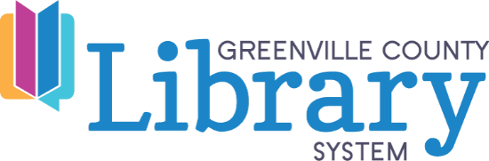

Dan Aldridge
President, Friends of Georgia Libraries

Memorandum of Understandings

BS in Commerce – University of Virginia JD – University of Georgia
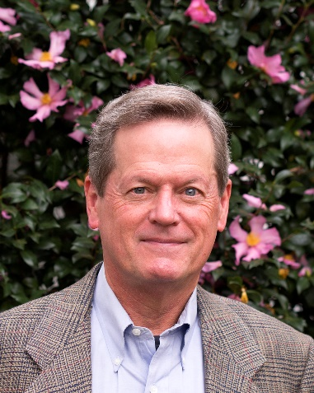
Library:
Former President, Friends of the Braselton-West Jacksons Library (winner of the Best Friends Group in Georgia-2016) President, Friends of Georgia Libraries (Since 2016) Board Member, Friends of Georgia Libraries for Accessible Statewide Services - Atlanta (Since 2019) [Library for the sight-impaired, stablished in 2019 with assistance of FOGL]
Awards:
2016 White House Conference on Libraries and Information Services Award, presented by the American Library Association in Washington, DC. (The first time a resident of Georgia has received this national award).
2019 Georgia Librarian Champion, presented by the Governor of Georgia
2016 Excellence in Documenting Georgia’s History Award, presented by the Georgia Archives.
2017 Georgia Author of the Year Award Finalist in the History

Publications:
Author of the nonfiction work: To Lasso the Clouds, The Beginning of Aviation in Georgia, published by Mercer University Press, May

Contact information:
Dan Aldridge
friendsbwjlibrary@gmail.com
678-761-3222

Jonathan Newton
Access Services Coordinator,
USC Upstate Library

Advocacy for Your Library
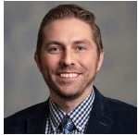
Jonathan Newton was born in Charleston, grew up in Bangkok, and now lives in Greenville. He has nearly 20 years’ experience working in public and university libraries in South Carolina, and as a past president of the South Carolina Library Association he has been an advocate for library users of all ages at the state and national level.
He is currently the Access Services Coordinator at the USC Upstate Library where he works with students and educators to promote and support education, research, and information literacy.

Contact Information:
jdn3@uscupstate.edu
864-320-9837

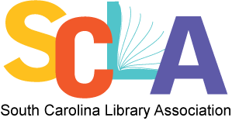
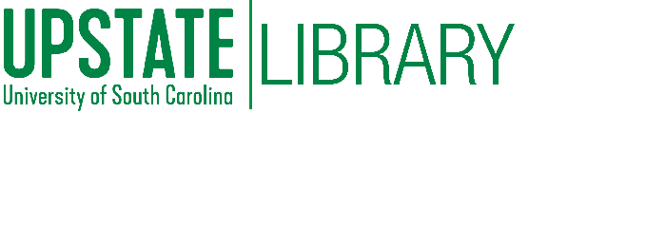

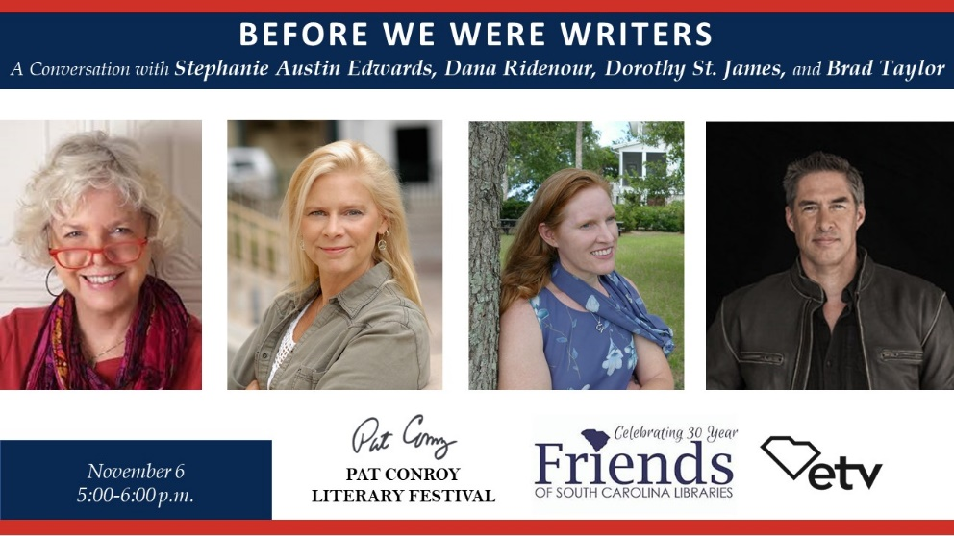

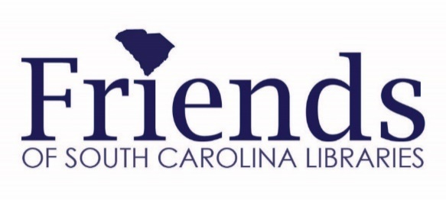

Website: www.foscl.org
Facebook: www.facebook.com/FoSCL
South Carolina State Library: www.statelibrary.sc.gov
South Carolina Library Association: www.scla.org
United for Libraries: www.united forlibraries.org

2020 Friends of South Carolina Libraries
Board & Officers

Marlena White, President
803-261-8697
Marlenawhite@hotmail.com

Sarah McMaster, Vice President
H: 803-635-5811
C: 803-718-3004
sbdmcm@gmail.com

Maurice Cherry, Secretary
H: 864-246-1145
Maurice.cherry@furman.edu

Libby Law, Treasurer
H: 803-782-8324
C: 803 446-3585
libbyplaw@mindspring.com

Paul Dove, Awards
H: 803-635-9104
C: 803-718-2298
Peedeejr41@gmail.com

Jonathan Haupt
803-528-0608
jonathan@patconroyliterarycenter.org

Maryellen Ham
H: 864-330-1320
Mcham1219@gmail.com

Donna Lolos, Liaison—SC State Library
dlolos@statelibrary.sc.gov
Kitty Spires
803-622-8396
rkspires@bellsouth.net

Helen Ann Rawlinson
803-794-6428
helenannrawlinson@gmail.com

NOTES

