Outstanding Individual Award
The Outstanding Individual Award recognizes an individual whose contributions to the support and advancement of public libraries has been outstanding. Nominees do not need to be South Carolina residents, but a connection with South Carolina public libraries is preferred. Nominees may include, but are not limited to, volunteers, library staff, library trustees, government officials or legislators, school and university personnel, Friends of Libraries members, and philanthropists. The award is intended to recognize a broad spectrum of appropriate personal qualities and activities including:
- Activities that support and advance the mission of South Carolina public libraries;
- Lifelong use and devotion to public libraries;
- Evident appreciation and support of the mission of public libraries;
- Leadership role in service on behalf of public libraries

John Landrum Advocacy Award
The John Landrum Advocacy Award recognizes individuals whose advocacy, support, and encouragement have been critical in recognition of the value of library services and ensuring that South Carolina’s public libraries remain prominent and vibrant institutions. Nominees may include, but are not limited to, volunteers, library staff, library trustees, government officials or legislators, school and university personnel, Friends of Libraries members, and philanthropists. The award is intended to recognize a broad spectrum of advocacy activities, including:

- Activities that increase public awareness of the value of S.C. public libraries;
- Activities that contribute to legislation favorable to S.C. public libraries;
- Activities that contribute to improvements in the funding and resources that further S.C. public library service.
Public Library Employee Excellence Award
The Public Library Employee Excellence Award recognizes public library personnel who are critical to library services and without whom South Carolina’s public libraries would be substantially diminished. Two awards may be given annually. Only current public library employees are eligible nominees. The award recognizes excellence in job performance as it relates to one of the following criteria:
- Exemplary performance both in the employee’s own responsibilities as well as service beyond assigned duties.
- Established record of significant achievement sustained over a period of time.
- Continuous leadership in the conduct or improvement of library programs, services or operations.
- Contributing to positive patron relations by offering helpful and friendly assistance, which can serve as a model for other employees.
- Innovative and/or creative ideas that have improved the efficiency and/or effectiveness of a library unit or service. Ideas that might contribute to the resolution of a difficult problem or a method, which would improve department output or quality of work.

Outstanding Elected Official Award
The Friends of South Carolina Libraries’ Outstanding Elected Official Award recognizes outstanding South Carolina elected officials who have been honored by a local Friends’ board. Local Friends’ Boards may nominate for consideration by FOSCL those individuals whose advocacy, support, and encouragement have been critical to the success of their own local library services.
Criteria: The nomination must be submitted/endorsed by the Board of the local friends group and by the Director of the Library to which the group is affiliated. Nominees must hold elective office in South Carolina at any government level. The local Friends of the Library organization must have recognized the nominee for outstanding support. The local Friends group must be a member of Friends of South Carolina Libraries. This award is intended to recognize a broad spectrum of advocacy activities, including:
- Activities that increase public awareness of the value of South Carolina’s public libraries;
- Activities that contribute to legislation favorable to South Carolina’s public libraries;
- Activities that contribute to improvements in the funding and resources that further South Carolina’s public library services.

Members of Friends of South Carolina Libraries (FOSCL) may submit nominations. The name and contributions of this individual nominated should be sent on the form on the verso of this brochure or in the form of a letter, addressed to Friends of South Carolina Libraries, PO Box 11121, Columbia, SC 29211 and describe the nominee’s contribution.

Please include a return email address if a receipt confirmation is requested.
Guidelines: The nomination must include name of the nominee, the name of the award and the name and address of the individual or Friends group that is nominating the elected official. The letter may be no longer than one 8½“ by 11” page and signed by the individual or group submitting the individual and any co-nominators. The letter should clearly state the reasons that the nominee should be considered.
No supplementary material is required and, if sent, will not be returned.
Letters may be sent as email attachments to fosclpresident@gmail.com, or they may be mailed to FOSCL Awards, P.O. Box 11121, Columbia, SC 29211.

Name of the Nominee:

Name of Award:

Library Affiliation:
Contact information for person(s) submitting the nomination
Name(s) of Nominator(s):

Contact Address:
City State ZIP

Contact Phone:
( ) -
Email Address:

Group/Library Affiliation:

Attach a one-page (8½” and 11”) description of the reasons that the nominee should be considered.
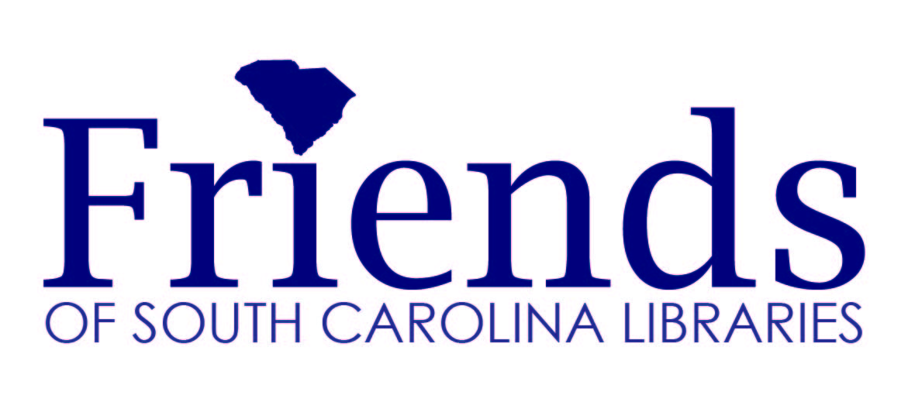
Annual Awards
The FOSCL Awards Program is intended to recognize individuals who are critical to helping and supporting individuals who help South Carolina public libraries enrich the lives of all South Carolinians and without whom SC public libraries would be substantially diminished. Public libraries provide information that helps people make critical and day-to-day decisions, lead young people to the joy of reading and the excitement of using new technologies, enrich our understanding of our history and help us chart our future and provide materials that lift our spirits and help us understand the difficulties that we encounter.

Deadline for Nominations February 14th

