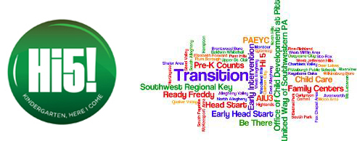

Since 2014, all 43 Allegheny County School Districts are committed to early and on-time kindergarten registration thanks to partnership with the United Way of Southwestern Pennsylvania, Allegheny Intermediate Unit, and Pittsburgh Association for the Education of Young Children (PAEYC). Each district receives a $700 mini-grant from UWSWPA to implement the activities of their individualized transition plan the year prior to kindergarten, fostering school readiness and boosting self-confidence in this transition. The transition plans include activities to support the children, the families, the early care and learning providers, and the community.

Transition teams are created, plans are written and revised yearly, and all teams are invited to a celebration in May to highlight one of their transition best practices. This yearly event has fostered some similar practices and messaging, and provides a fellowship of committed educators who are comfortable with each other to ask questions and share what works. One participant said, “I feel that because all school districts participate (in the Hi5! Project) there is a feeling of unity within the county...that everyone is involved in a county-wide goal...not just a school district goal.”
Since 2014 the average percentage of early registration is 82.1% and on-time is 95.5% thanks to the Hi5! Project, the branded signage and the commitment from all engaged partners.

Click on the links below to view some of the ways districts advertise the transition to kindergarten process:

Avonworth
http://www.edline.net/pages/Avonworth_Primary_Center/Kindergarten
Duquesne City
https://www.youtube.com/watch?v=6LMevF4Nggc&feature=youtu.be

Fox Chapel Area
http://clp504.wixsite.com/clpfcasd/kindergarten-info
McKeesport Area
- Francis McClure
https://www.youtube.com/watch?v=BQA45_Glqfw&feature=youtu.be

- Twin Rivers
https://www.youtube.com/watch?v=O6hbn_l16wM

Mt. Lebanon
https://sites.google.com/a/mtlsd.net/mtlsdkindergarten/

