How to Schedule an Event

- Go to www.papdregistry.org.

- Click ‘Login’ in the top right corner.


- Enter your email address and password, then click ‘Login’.
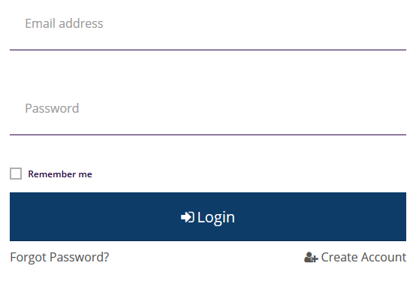

- If you are entering an event for your organization, make sure you select your organization profile (purple box) from the drop down in the upper right hand by your name.

- Select ‘Training Entry’ in the left-hand menu.


- Click ‘New Event’.
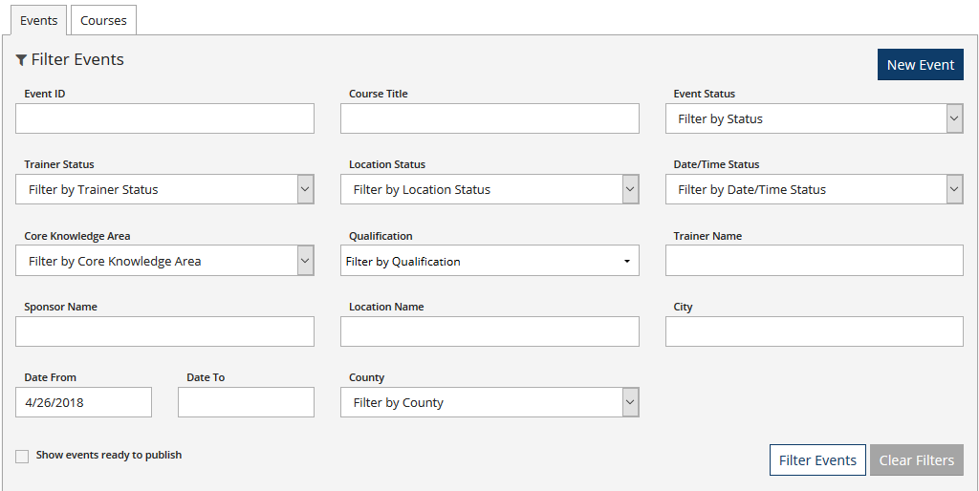

- Select a Course
- Enter the Course Title or Course ID.
- Click ‘Search’.

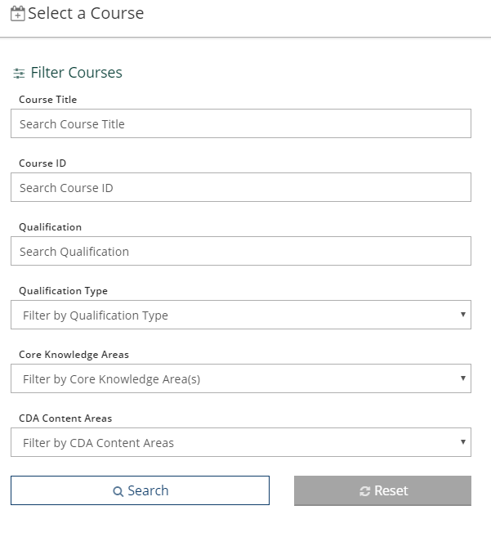

- Click ‘Select’ next to the course you want to schedule.
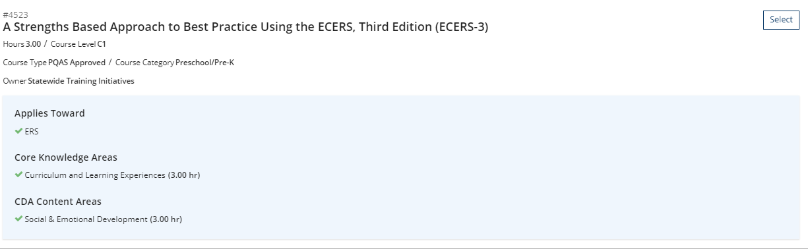

- Training Event Entry
On this screen you will be able to toggle through each tab (Course, Trainer & Sponsor, Assessments & Delivery, Event, Registration). You will also be able to toggle through the event by clicking on the edit icons on the left-hand side next to Event Trainer and Event Details.

The next steps will provide you with directions for each tab.

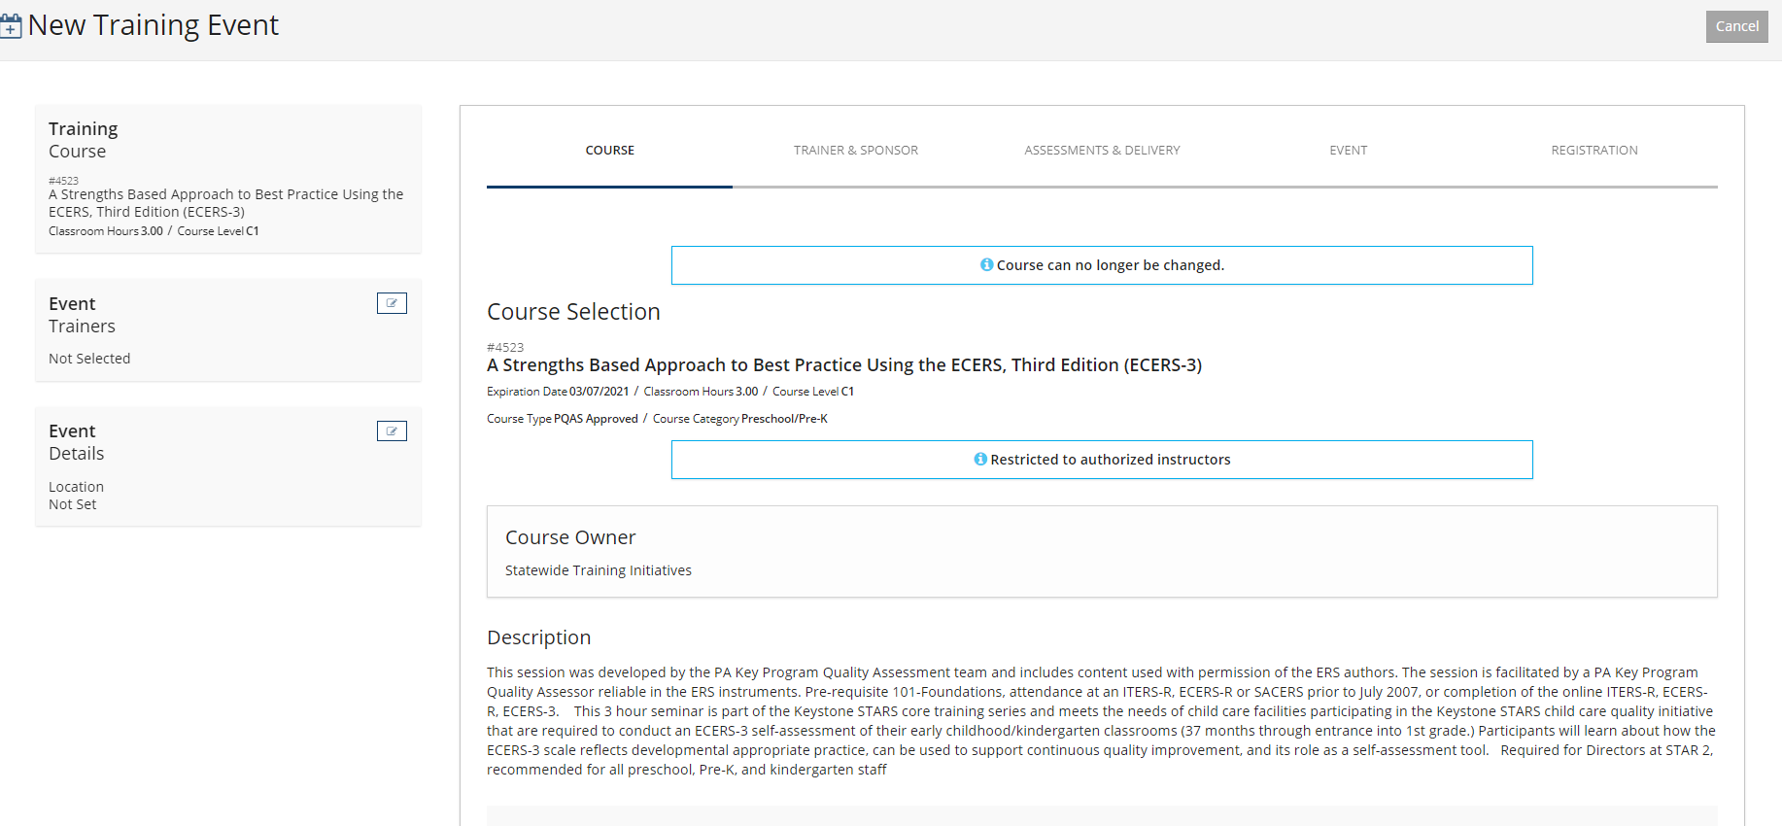
- Course Tab
You will be able to review the course information this page.

- Trainer & Sponsor Tab
  - Click ‘Select’ next to the Instructor providing this event.
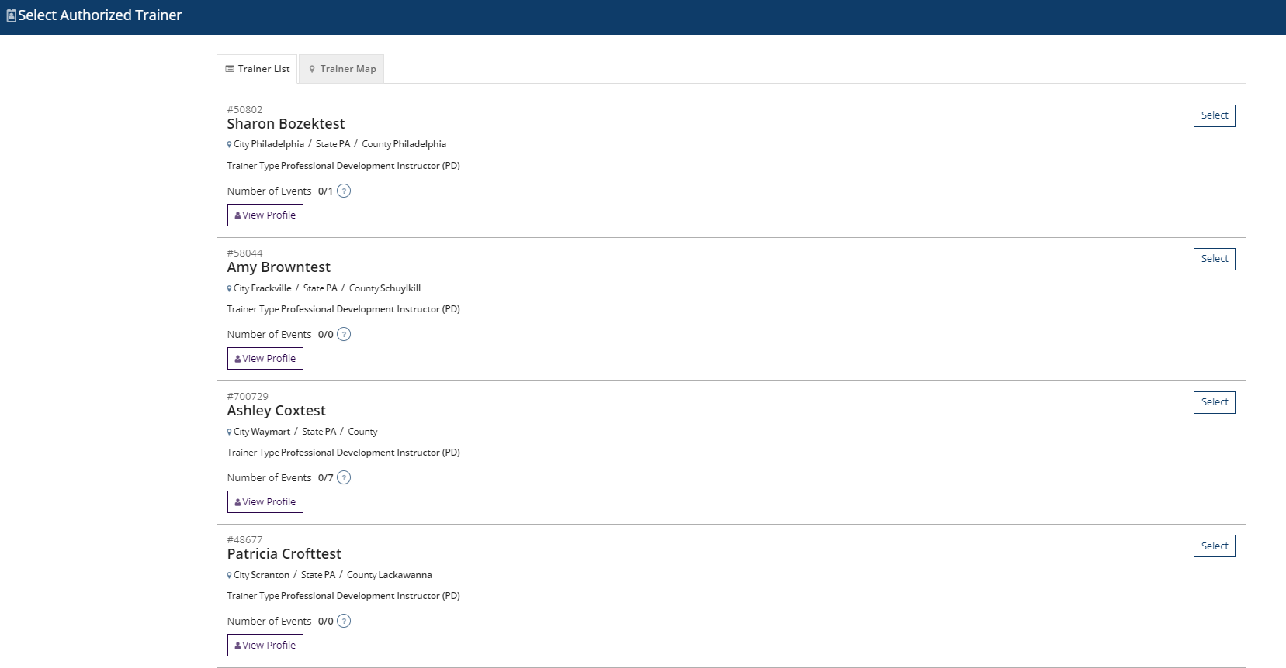

  - Click ‘No’ if you are done adding instructors. Click Yes if you would like to add another.
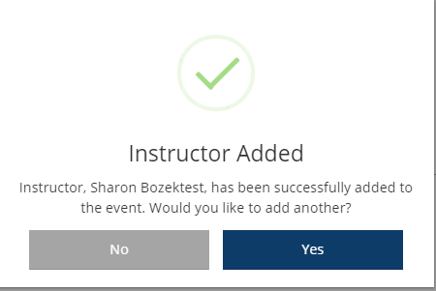
If you select ‘Yes’, this is the screen you will see. Enter in the Instructors Registry ID# within the Trainer ID section or the Trainer’s name. Click Search.

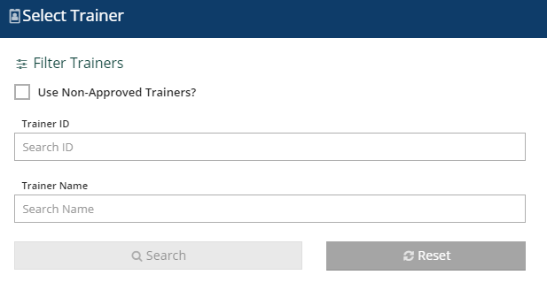
If you need to exit this page, click on the X in the upper right-hand corner to continue to the event entry.

  - Check the Confirmed box, to confirm the instructor.
  - Select the Training Language.
  - Select the Event Funder (only for funded events).
  - Click ‘Continue’.
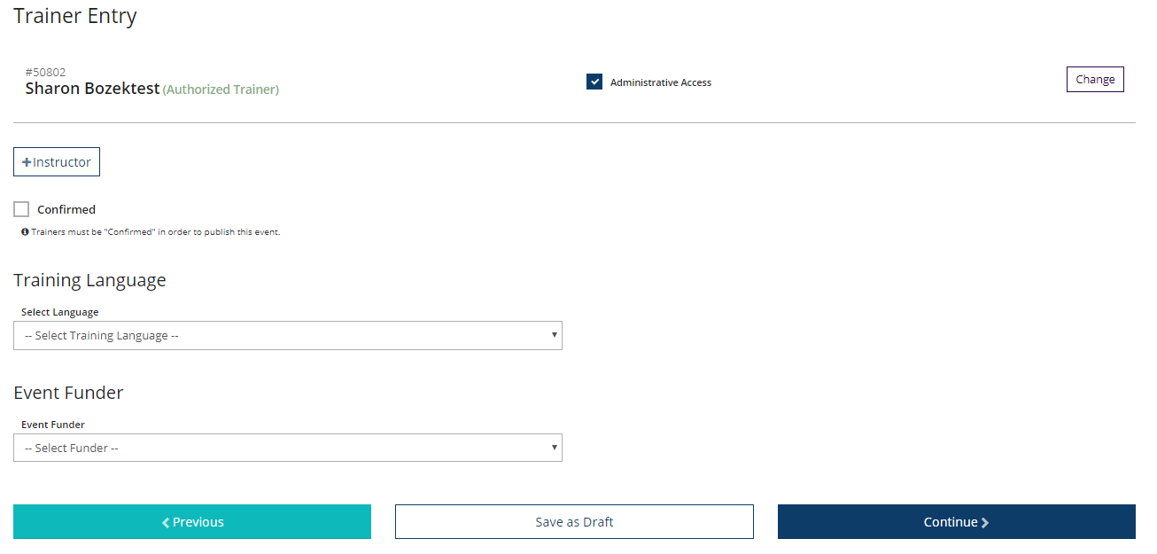

- Assessment & Delivery Tab
  - Complete the ‘Assessment of Learning’ and ‘Delivery Methods’ sections on this page.
  - Click ‘Continue’.
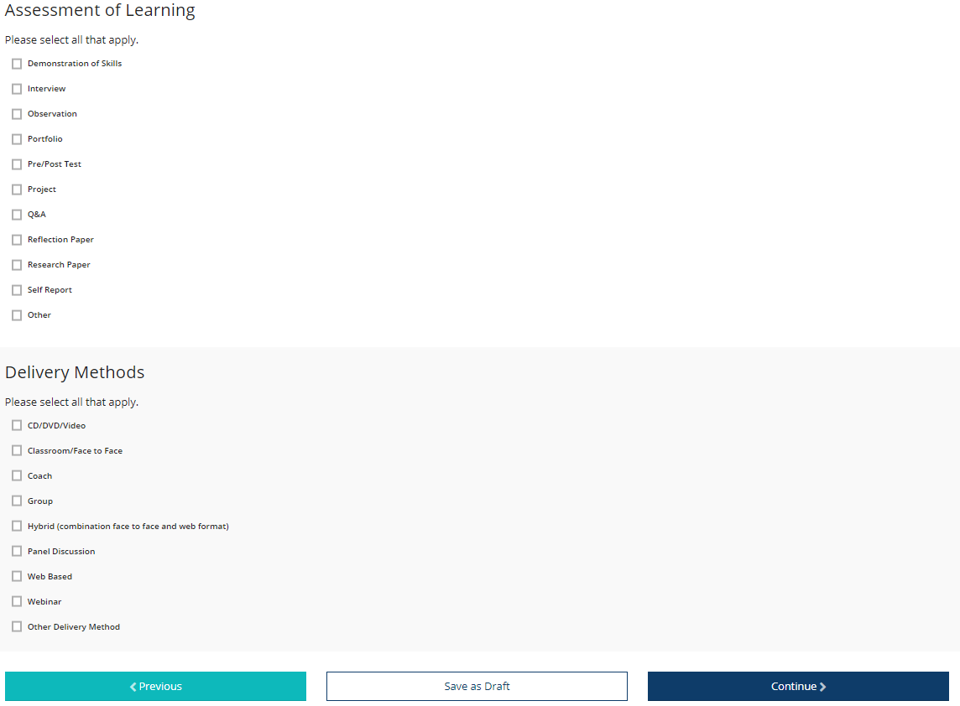

- Event Tab
  - Event Details
    - Select ‘No’ or ‘Yes’ to show this event in public search results.
    - Select the type of event location your event is. If you select web-based, enter in the website or URL to access the event.
    - Check the Confirmed box to confirm the location.
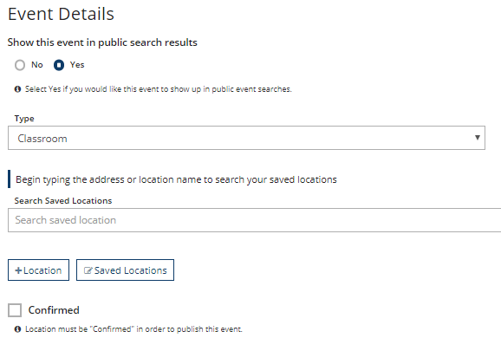

  - Event Date & Time
    - Select ‘No’ or ‘Yes’ if this a Self-Paced event
    - Select ‘No’ or ‘Yes’ if the course will be held over multiple sessions
    - Enter the Start Date and End Date
    - Enter the Start Time and End Time (note, the hours are attached to the course, if you are providing this event for more or fewer hours than what that course has been approved for, you will need to submit a new course to reflect the correct number of hours)
    - Check the Confirmed box to confirm the date and time.
    - Additional Date/Time Info box: you may include any additional information about the event in this box.
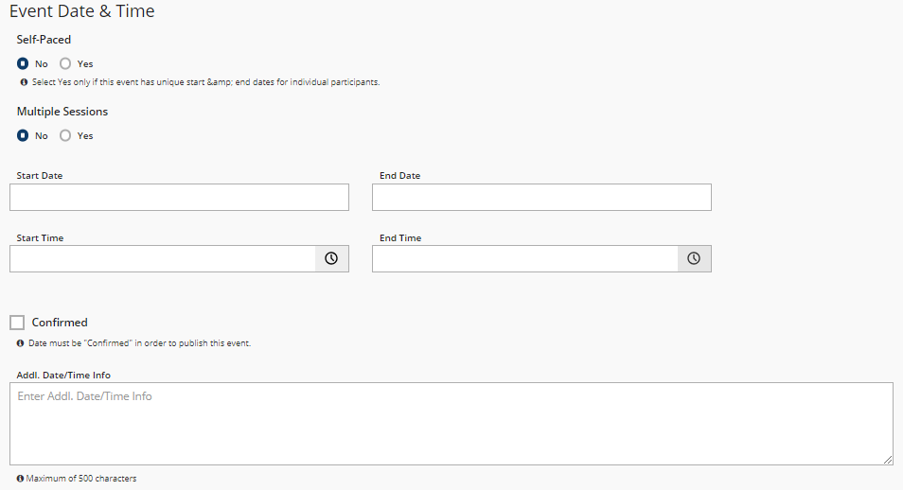

  - Contact Info
    - This information will default to the contact information used on your profile or the org profile. This may be edited if needed.
    - Additional Contact Info box: you may include any additional information about the event in this box.
    - Click ‘Continue’.

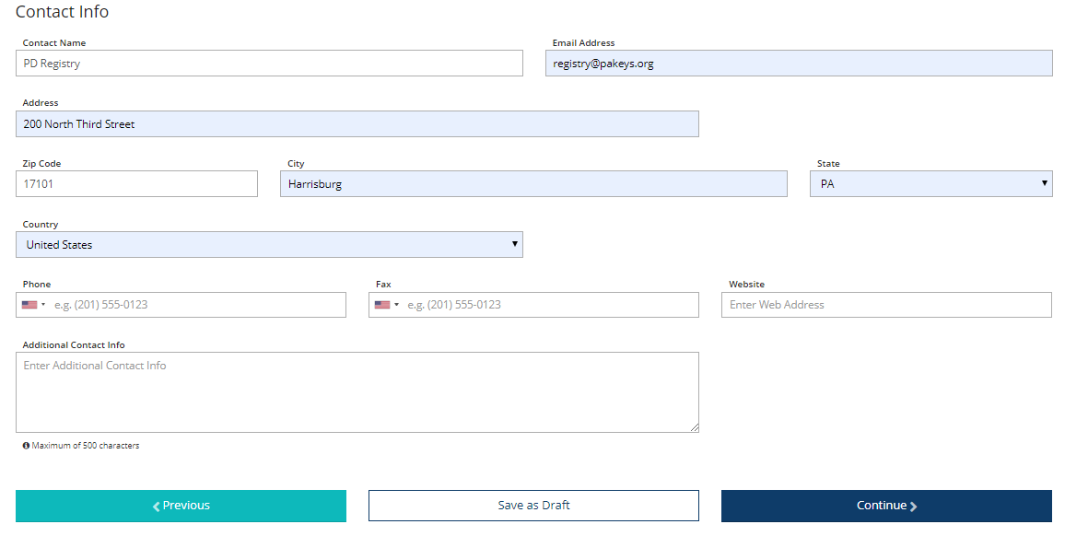

- Registration Tab: Select ‘Yes’ or ‘No’ if registration is required
  - If registration is NOT required, Click ‘Save & Review’ to continue. (If yes, go to below step)

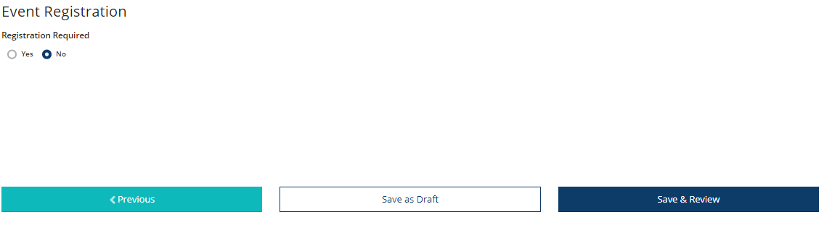

  - If registration IS required, complete the below:
Note, to allow online registration through the system you must have a Stripe account linked to your Org Profile. For more information on this process, please review our tipsheet on How to create a Stripe Account.
    - If you have a Stripe account linked to an Org Profile AND you are scheduling this event within that Org Profile, check the Register Online box.
    - Enter the Max Number of Participants.
    - Enter the Registration Start and End Dates.
    - Click ‘Save & Review’ to continue.
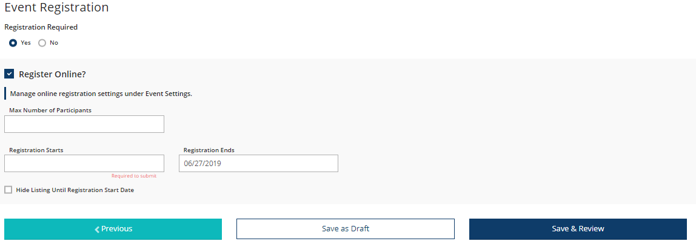
    - If you do not have a Stripe account linked to an Org Profile, enter the Registration Deadline
    - Registration Web Address
    - Registration Fee
    - Click ‘Save & Review’ to continue
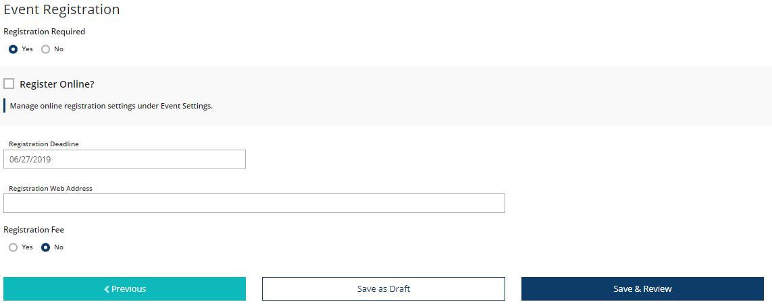

- Event Saved: Click ‘OK’
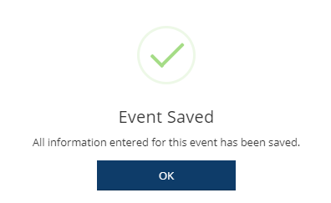

- Review the information on this page and click Submit Event at the top.

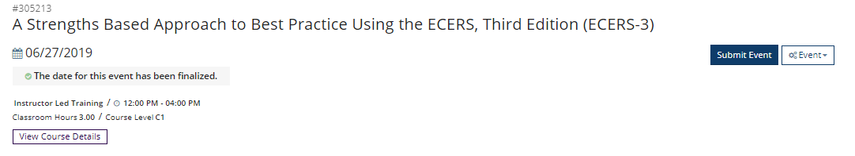
- Event Saved: Click ‘OK’

- To active Online Registration (stripe required), click on the ‘Event dropdown’ in the upper right-hand corner.


- Click on ‘Manage Online Registration’.
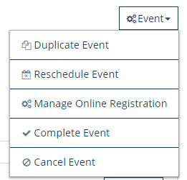

- Information Collection
  - Attendee Details section: complete if you want to collect more or less information from your attendees.
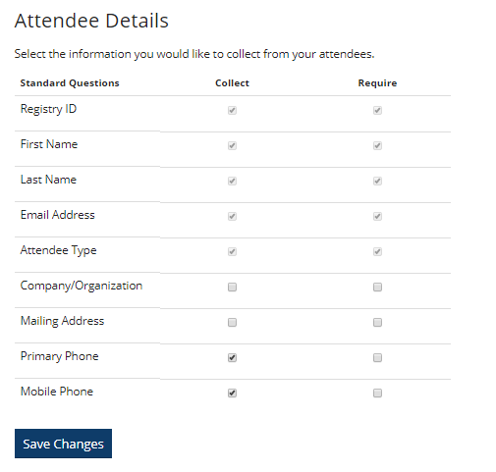
  - Registration Fees section:
    - Select ‘Add Fee’ if the event has a fee and you are accepting payment through the system.
    - Select ‘Free Event’ if the event has no cost or you are taking payment outside of the system.

  - Additional Items section: you may skip this section

  - Click ‘Next’ to continue.

- Text & Email section: Review the emails on this page that are sent out to the participants. Click ‘Next’ to continue.

- Activation
  - Registration Setting section: review this information and make any necessary changes.
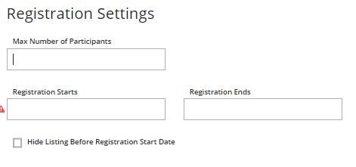
  - Terms and Conditions section: check the ‘I agree to the terms and conditions as defined above’ box.
  - Click ‘Activate’ to finish online registration setup.
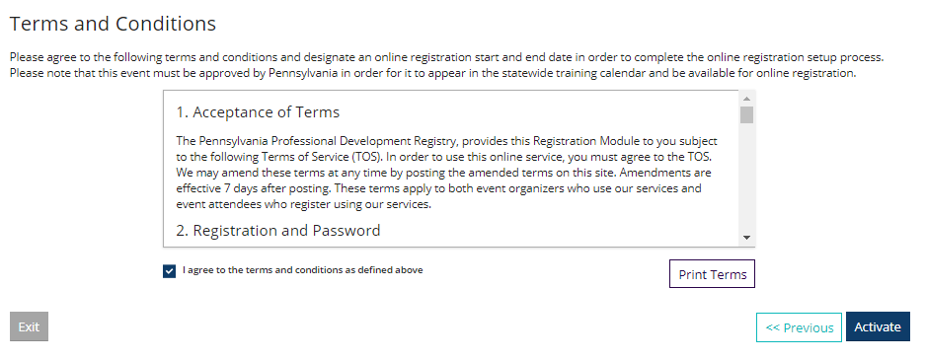

- If this is a private event, you can copy and paste, and email the Registration Page Link to the participants you wish to invite.
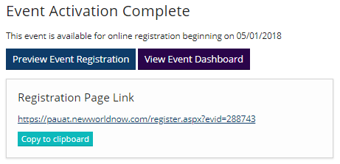

Editable Event Information (after an event has been approved)

The PD Registry has enhanced the system to allow for individuals to edit Non-Essential Event Information.
To edit any of the below information, locate the event and click on Manage next to the section you wish to edit.

These fields will be defined as follows:

- Which trainer has administrative access to the event
- Only applies to events created by training sponsor organizations
- Administrative training sponsor organization
- Administrative training sponsor organization can be added, changed, or removed
- Only applies to events created by individual trainers
- Training language
- Location name, address line 1, address line 2, city, state, zip, county, country
- Location capacity (stored in location library)
- Location staff notes (stored in location library)
- For events on a single date or that span a date range:
- Event start time and event end time
- For multi-session events
- Individual session start and end times
- Additional date/time information
- Delivery methods
- Contact information
- Contact name
- Address
- Phone number
- Fax number
- Web site
- Email address
- Registration options
- Show event in public search results
- Whether or not registration is required
- Whether or not event is using online registration
- For events using online registration:
- Event capacity
- Registration start date
- Registration end date
- Hide listing until registration start date
- For events not using online registration:
- Registration deadline
- Registration URL (for events not using online registration)
- Registration fee

Manage Roster

You will be able to add participants to an event roster once the event has occurred.
Below are the steps on how to do this.
- Go into the event
- Click the Event drop down menu
- Select Manage Roster
- Click +Attendees to add participants.

