How to Schedule a Conference

Conference entry is only available to training sponsor organizations
who are approved as a Conference Organizer.

- Go to www.papdregistry.org.

- Click ‘Login’ in the top right corner.


- Enter your email address and password, then click ‘Login’.
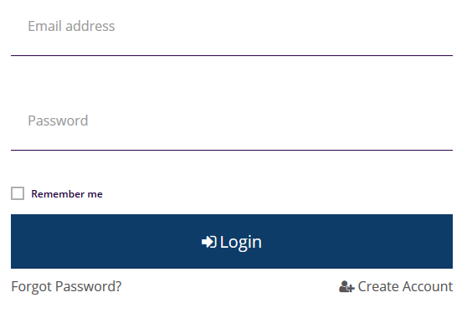

- Select your organization profile (purple box) from the drop down in the upper right hand by your name.

- Select ‘Training Entry’ in the left-hand menu.


- Click ‘New Conference’.
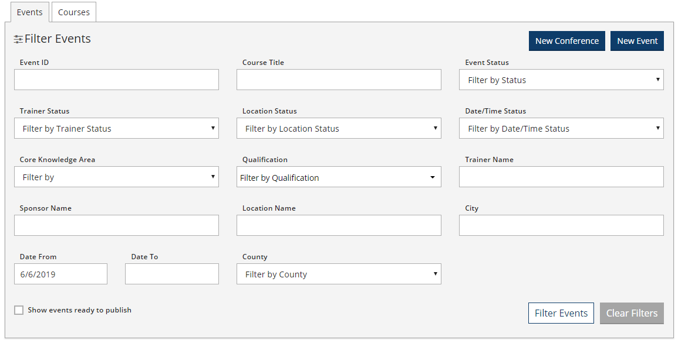

- Enter the Conference Name and click ‘Save & Open’.
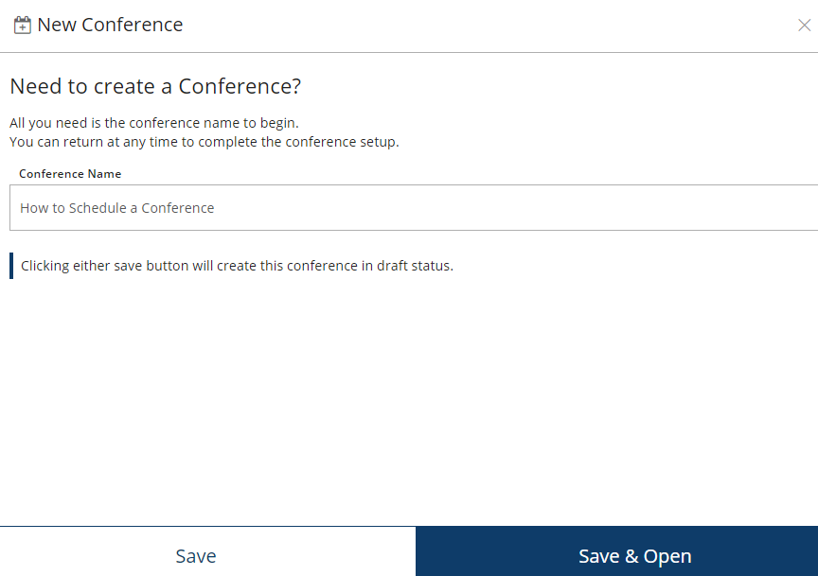

- Conference Details
  - Click ‘Manage’
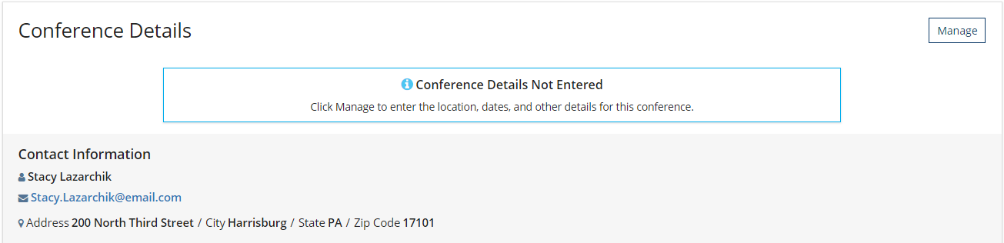
  - Select ‘No’ or ‘Yes’ to show this event in public search results.
  - Enter the Start Date and End Date.
  - Enter the Overview.
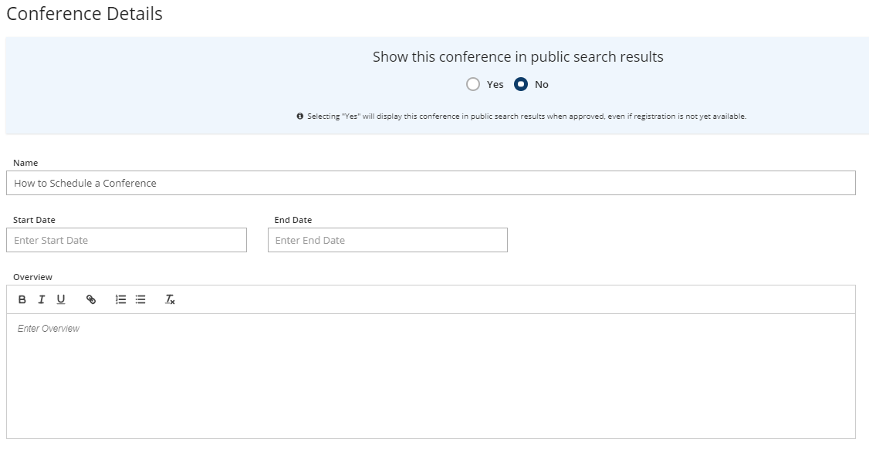

  - Location: Enter in the location for the conference.
  - Contact Information: This information will default to the contact information used on the org profile. This may be edited if needed.
  - Additional Contact Info box: you may include any additional information about the event in this box.
  - Click ‘Save’.
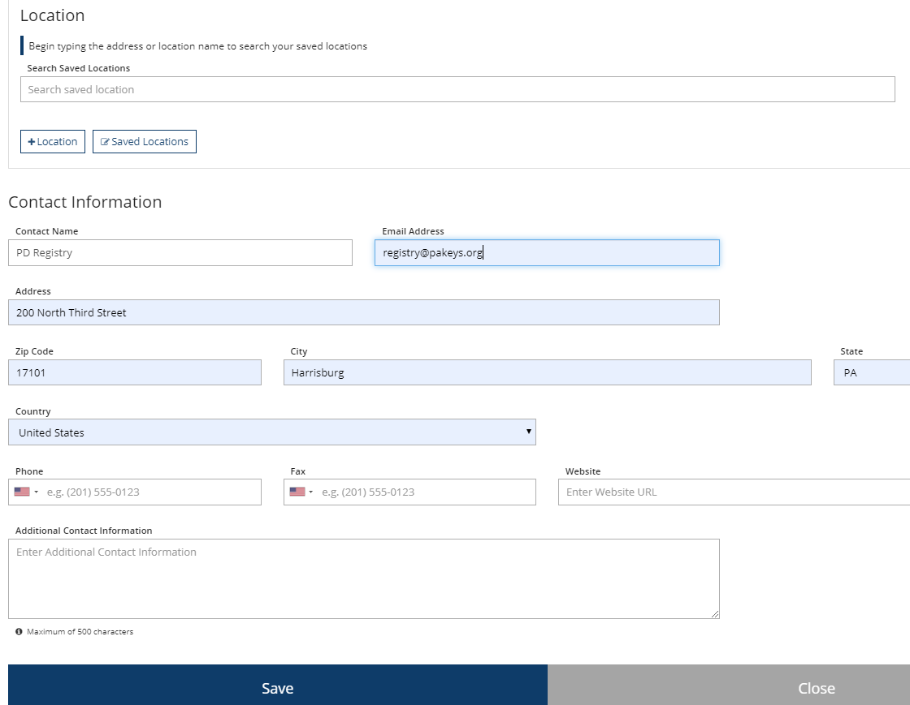

- Conference Information Updated
  - Click ‘OK’
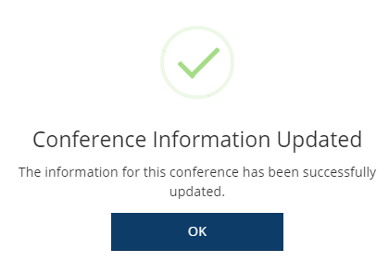

- Conference Registration
  - Click ‘Manage’

  - Select ‘Yes’ or ‘No’ if registration is required
Yes, is for Online Registration through the registry. No, is for registration through another system or in person.
    - If registration is NOT required
      - Enter the Registration Deadline
      - Conference (Registration) Web Address
      - Click ‘Save’ to continue
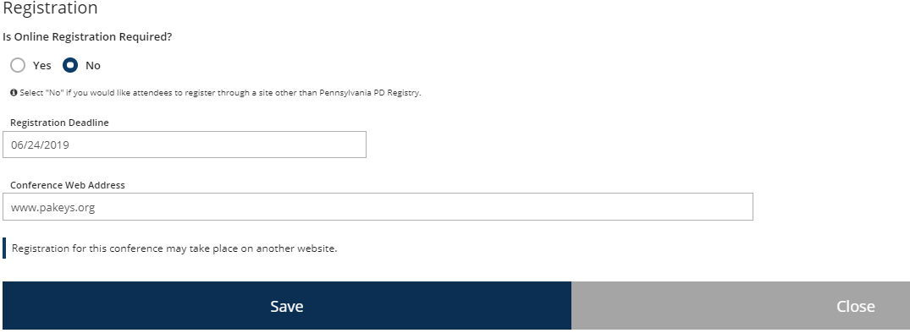

    - If registration IS required
      - Enter the Max Number of Attendees
      - Click ‘Save’ to continue
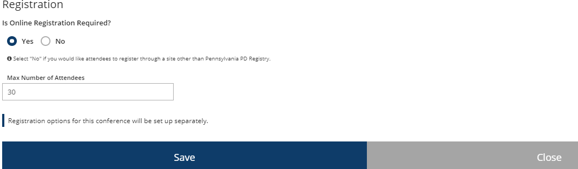

  - Conference Registration Emails: If you selected Yes for the above step (10.b) and the conference will use online registration, click ‘Manage’ > ‘Registration Emails’.
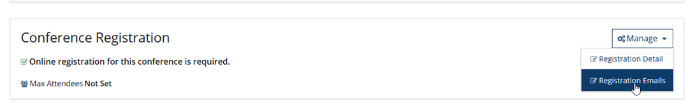
    - Text entered in Confirmation Email Text will be included in the email that gets sent to users when they register for the conference.
    - Text entered in Reminder Email Text will be included in the email that gets sent to users 3 days prior to the conference.
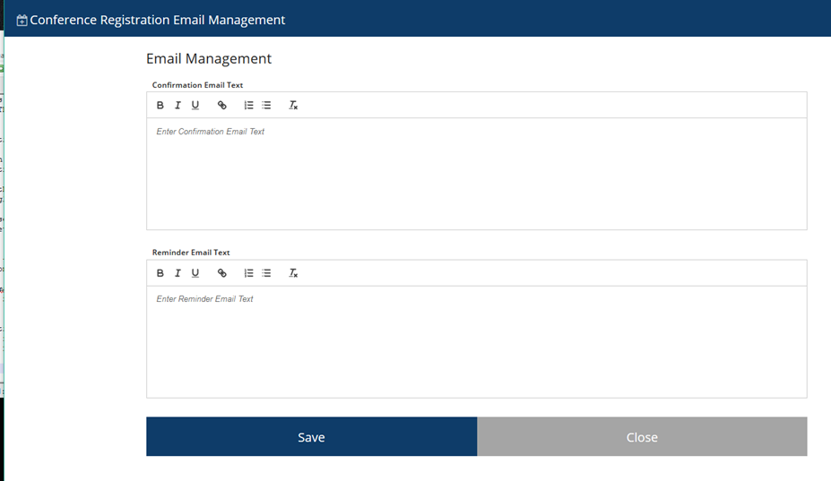
- The text for these boxes is defaulted based on information from the Org Profile > Settings tab. Any edits here affect only the conference, and if left blank will exclude the selected text below.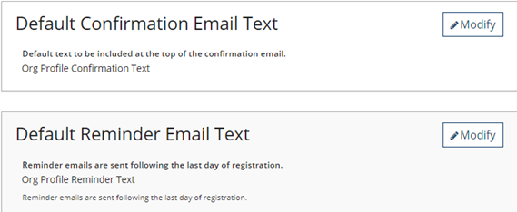
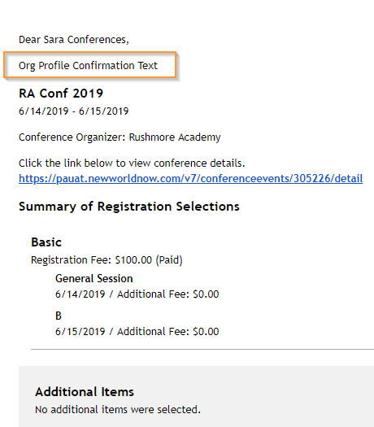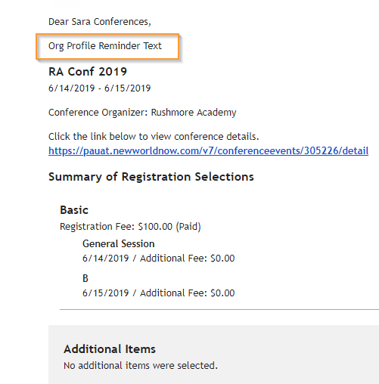

- Conference Registration Updated
  - Click ‘OK’
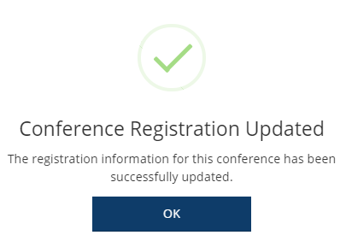

- Sessions
  - Click ‘+Session’

  - Session Type: General Session or Training Session. Select "General Session" if NO training hours will be counted for this session.
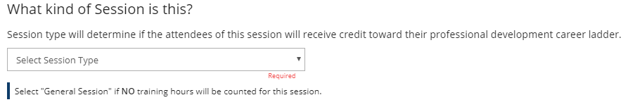

  - Session Details:
    - Enter the Name of the session
    - Enter the room location for the session
    - Select the date if the conference is more than one day. Otherwise the date is defaulted for single-day conferences.
    - Enter the start and end time
    - Enter the overview for this session
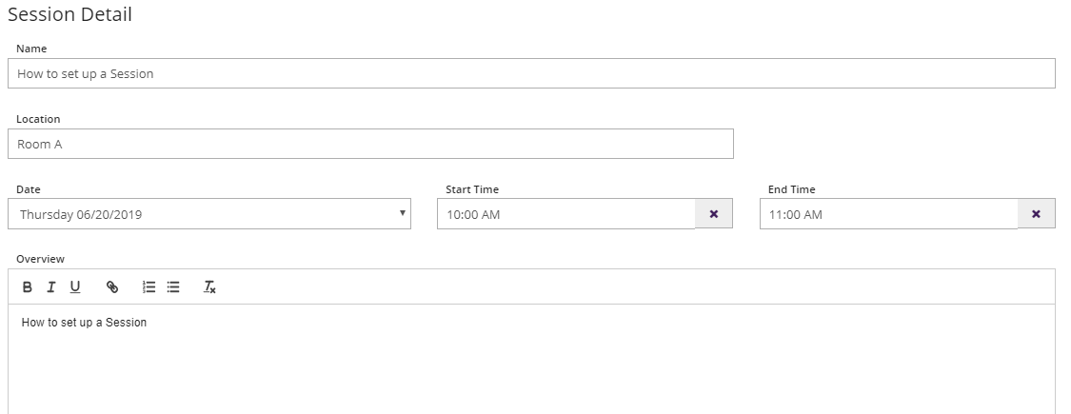
  - Attendance: This section is only available for conferences that require Online Registration. It determines whether the session can be included in a registration option.
    - Select ‘Yes’ or ‘No’ if verified attendance is required.
    - If YES, enter in the capacity for this session.
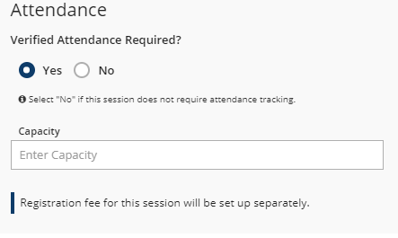

  - Instructor
    - Click ‘+Instructor’
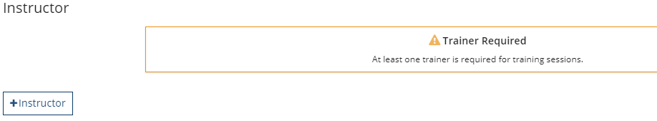

    - Enter in the Instructors Registry ID# within the Trainer ID section or the Trainer’s name. Click ‘Search’.
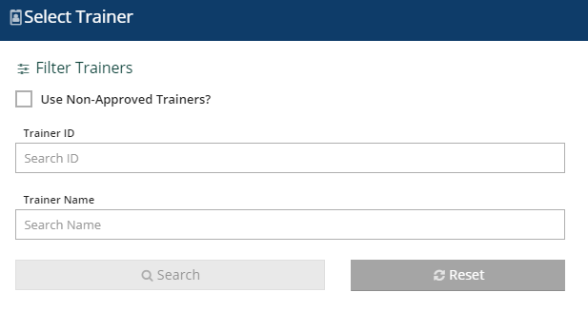
    - If the trainer is a non-approved PQAS instructor, check the ‘Use Non-Approved Trainer’ box and complete the Trainer’s Name, Organization and Qualifications boxes.
    - Click ‘Add to Event’.
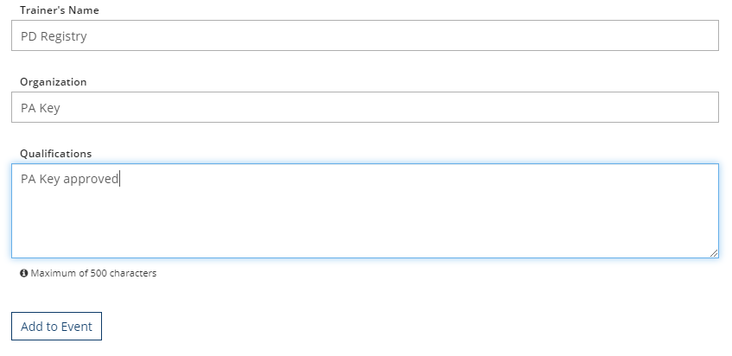

    - Click ‘No’ if you are done adding instructors. Click ‘Yes’ if you would like to add another.
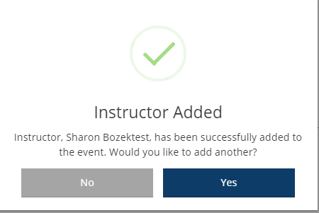

    - If this instructor should have Administrative Access to this session to Manage the Roster, check the ‘Administrative Access’ box.
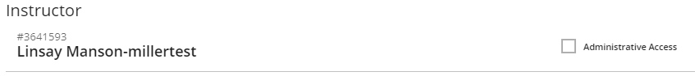

  - Select the Training Language.
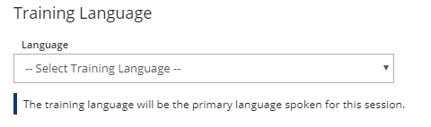

  - Course Details
    - Select the ‘Course Level’ (C1, C2, C3)
    - Course Category
    - Training Hours- enter the amount of time this session will be. (not the whole conference)
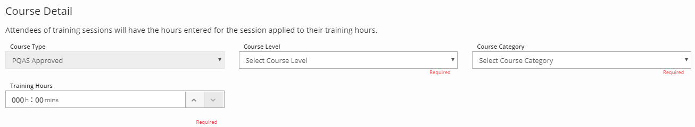
  - Add the hours for the course to the Knowledge Areas that the content applies. You may select multiple Knowledge Areas.

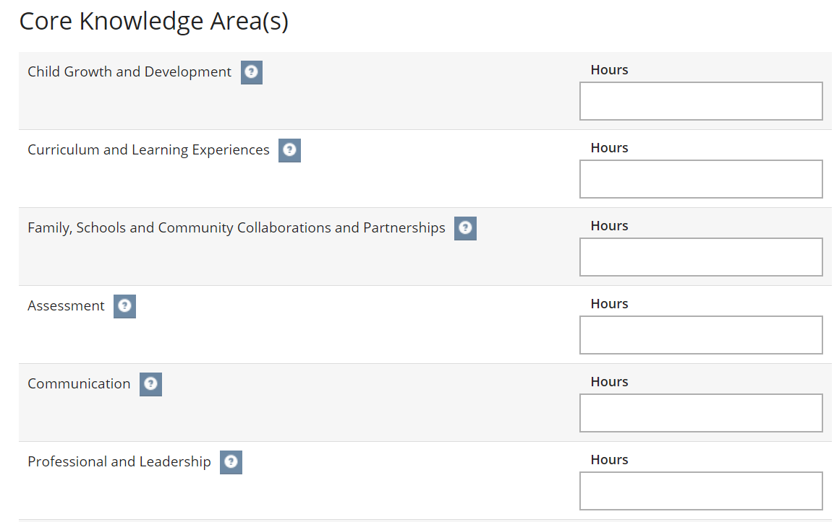

  - Add the hours for the course to the CDA Content Area that the content applies. You may select multiple areas.

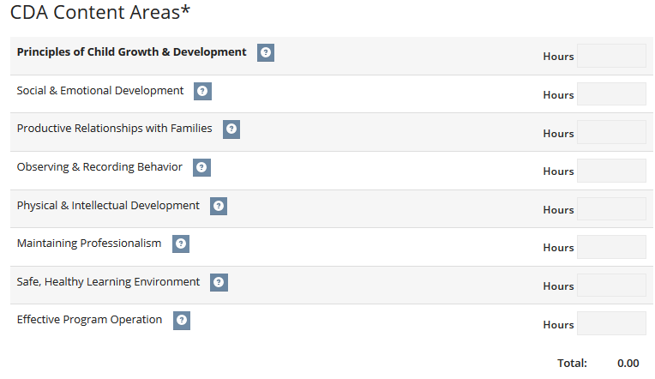
  - Click ‘Save’ to continue


- Add Another Session?
  - If you want to add another session click ‘YES’ and repeat step 12.
  - If you do not want to add another session click ‘NO’.
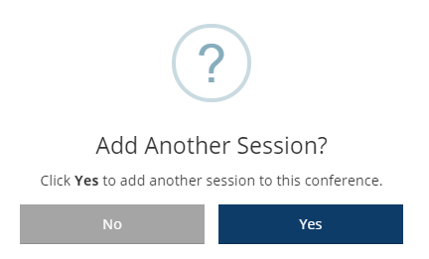

- Registration Options: This section is only available for conferences that require Online Registration.
  - Click ‘+Option’

  - Enter a Registration Name.
  - Enter the Base Registration Fee (this is the amount for the whole conference).
  - Enter the Registration Start and End dates.
  - Enter the Registration Description.
  - If you are charging for the conference AND each session, you can add additional session fees.
  - Clicking the checkmark next to a session will make this session available for end-user to register for as part of this option.
  - Click ‘Save’ to continue.

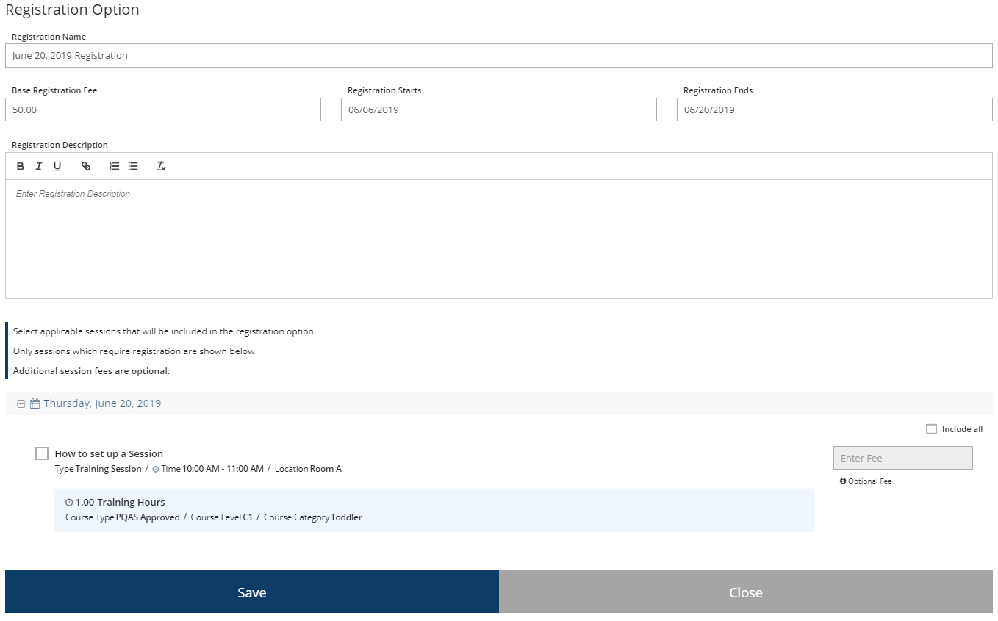

- Registration Option Add
  - Click ‘OK’
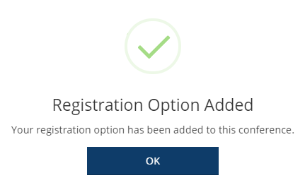

- Click ‘Submit Conference’


- Conference Terms and Conditions:
  - Read and Click I agree to the conference terms and conditions.
  - Click ‘Continue’.
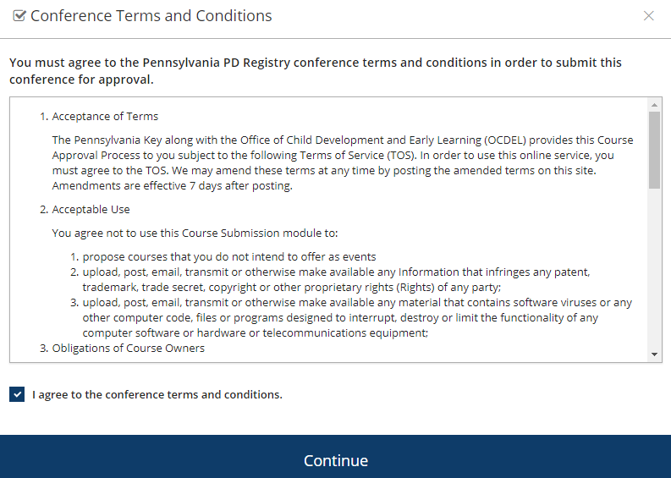

- Conference Submitted
  - Click ‘Review Conference’
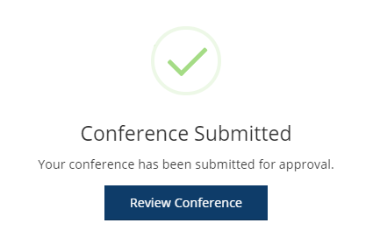

Once you submit your conference, it will go into a pending status. Please allow 2-3 weeks for the conference to be reviewed.

