Pennsylvania Head Start Oral Health Champion Award

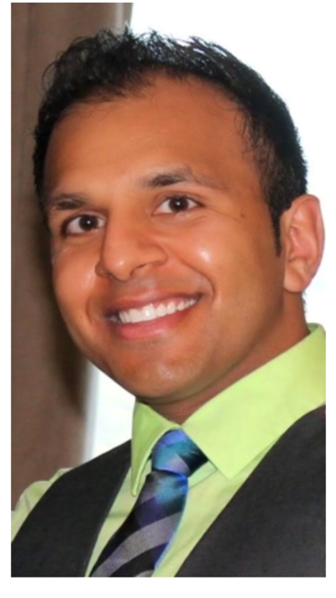
Deep I. Shah, D.M.D
Pediatric Dentistry and Special Needs
Diplomate of the American Board of Pediatric Dentistry

Dr. Deep I. Shah, D.M.D, has been selected to receive the PA Head Start Oral Health Champion Award. The award will be presented at the PA Head Start Healthy Smiles Task Force Meeting on March 8, 2018, from 10 am-3 pm at the Harrisburg Area/Camp Hill Giant Store Community Center in Camp Hill, PA.

Dr. Shah, a specialist in Pediatric Dentistry, considers his role as a health care clinician for children to be a genuine privilege and blessing and believes that a customized oral health plan for each child is essential to each child’s overall well-being and continued growth and development.
Upon earning his bachelor’s degree in biological sciences and minor in business administration from Drexel University, Dr. Shah pursued his dental education at the University of Pennsylvania School of Dental Medicine. Dr. Shah further trained at the Children’s Hospital of Pittsburgh where he acquired extensive experience in the areas of growth and development, special health care needs, dental trauma, pharmacological modalities and behavior modification/management. He believes working with other pediatric specialists and utilizing an interdisciplinary approach is integral to the successful management of each child’s care.
Dr. Shah has served on the Luzerne County Head Start Board of Directors since January 2016, and has also served on Luzerne County Head Start’s Health Services Advisory Committee since the fall of 2015. Throughout the Luzerne County Head Start’s relationship with Dr. Shah, he has not only served over 100 Head Start children, but has graciously visited numerous centers, providing children and families invaluable dental services, resources, and follow-up advice. It is for all these reasons, and many more, Luzerne County Head Start has enthusiastically nominated Dr. Shah as a Pennsylvania Head Start Oral Health Champion.
All Early Learning professionals are welcome to attend the PA Head Start Healthy Smiles Task Force Meeting on Thursday, March 8th in Camp Hill. Registration is requested. Register online at the PA Head Start Association website. (See Upcoming Events, then Event Calendar for March 8, 2018.) For questions, please contact Amy Requa, State Oral Health Coordinator: amyrequa@paheadstart.org

