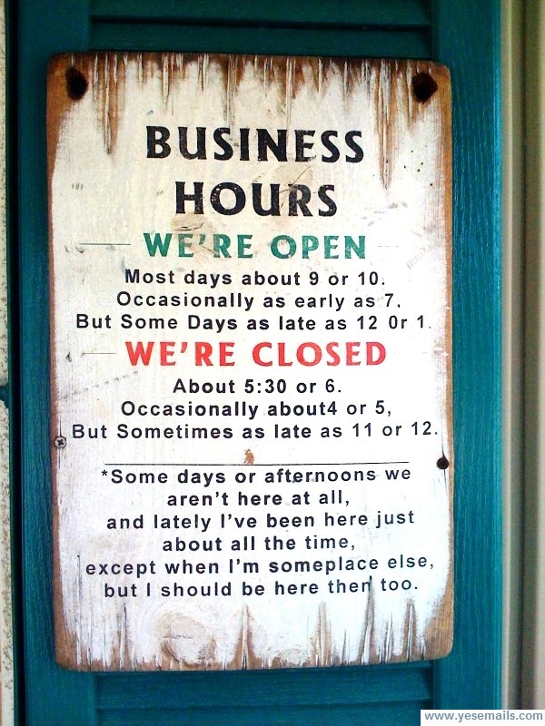
E-mail :
TiltedHaloPete@gmail.com
TiltedHaloDesiree@gmail.com

Office Phone:
(970) 325-6825

Mail:
TiltedHaloServices, Inc.
1725 Yucca Ct.
Fort Collins, C0 80525-2437

