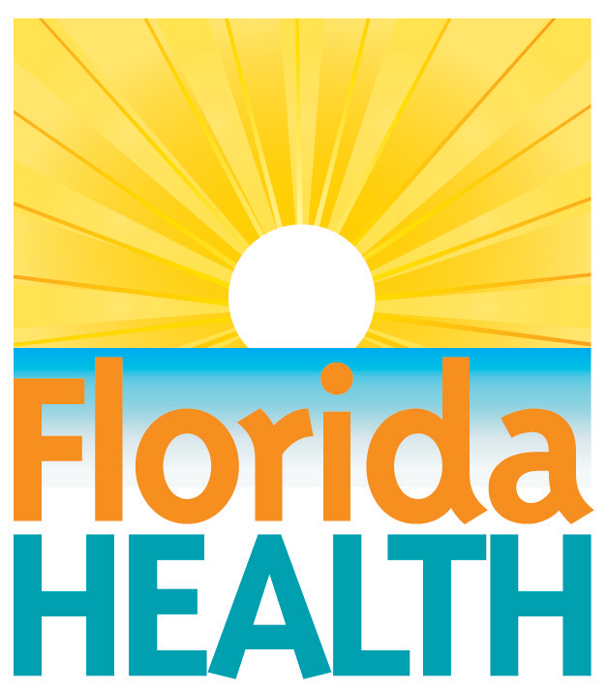
August 5, 2021
DOH-INDIAN RIVER LAUNCHES
BUSINESS/ORGANIZATION MOBILE
COVID-19 VACCINATION EVENT REQUEST
FORM

Contact:
Stacy Brock, Public Information Officer
Stacy.Brock@flhealth.gov
772-794-7479

Indian River County, FL— The Florida Department of Health in Indian River County (DOH-Indian River) is offering businesses, organizations, and community partners the opportunity to host a COVID-19 vaccination event at their businesses or organizations. The Business/Organization Mobile COVID-19 Vaccination Event Request Form is located on DOH-Indian River’s website or use the link Business/Organization Mobile COVID-19 Vaccination Event Request Form.

This form will allow businesses, organizations, and community partners who are interested in vaccinating their employees, members, or the community, the ability to request the DOH-Indian River mobile vaccination team to host a vaccination event at their place of business or organization.

“We need to increase the vaccination rate to help decrease the spread of COVID-19 in Indian River County. DOH-Indian River is working with our community partners, businesses, and organizations to provide the COVID-19 vaccine at work sites, churches, and other places in the community”, stated Miranda Hawker, Florida Department of Health in Indian River County Health Officer.

For more information, please contact DOH-Indian River at 772-794-7479.
About the Florida Department of Health
The Department, nationally accredited by the Public Health Accreditation Board, works to protect, promote and improve the health of all people in Florida through integrated state, county and community efforts.

Follow us on Facebook, Instagram and Twitter at @HealthyFla. For more information about the Florida Department of Health please visit www.FloridaHealth.gov.

