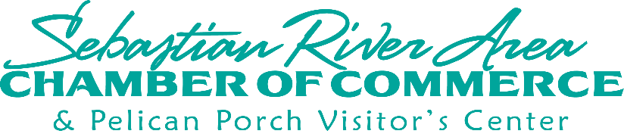
Sebastian River Area Chamber of Commerce
31st Annual “Roaring Twenties Gala” Lifestyle & Media Auction

LIFESTYLE DONATION (minimum $50 package/basket -DEADLINE SEPTEMBER 6TH)

BUSINESS NAME: _____________________________________________________________________
CONTACT NAME: _____________________________________________________________________
ADDRESS: ___________________________________________________________________________
CITY, STATE, ZIP______________________________________________________________________
PHONE: ____________________________EMAIL___________________________________________
ITEM TYPE: __________________________________________________________________________
VALUE: ______________________________________
ITEM DESCRIPTION: ___________________________________________________________________
____________________________________________________________________________________
CONTRIBUTOR SIGNATURE: ______________________________________DATE: __________________

MEDIA DONATION (minimum $50 package – DEADLINE SEPTEMBER 6TH)

BUSINESS NAME: ______________________________________________________________________
CONTACT NAME: ______________________________________________________________________
ADDRESS: ____________________________________________________________________________
CITY, STATE, ZIP: _______________________________________________________________________
PHONE: ______________________________ EMAIL:_______________________________________
CONTRIBUTION DESCRIPTION: ____________________________________________________________
_____________________________________________________________________________________

CONTRIBUTOR SIGNATURE: ___________________________________________DATE: _____________

700 Main Street, Sebastian, FL 32958 | 772-589-5969 | cthibault@sebastianchamber.com

