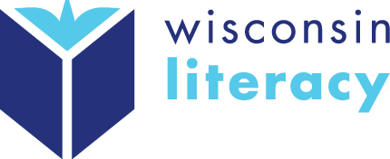

New Online Resources
Scavenger Hunt

See our new and improved online resources…and win a $25 gift card and free resource. (One per agency)
- Go to: https://wisconsinliteracy.org/resources/ (you don’t need to log in anymore!)
- Use the online resources to complete this Scavenger Hunt
- Email the completed form to your RLC for a $25 gift card... OR…Bring it to the Annual Meeting for a $25 gift card + free resource

Annual Meeting

Wednesday, Oct. 16 (4:00-5:00pm)
Red Lion Hotel in Appleton, WI (during the Common Grounds Conference)

- enjoy heavy hors' d'oeuvres and soft drinks
- meet Wisconsin Literacy board directors
- hear from Peter Waite, Executive Vice President at ProLiteracy
- learn about our reinvented Board of Directors nomination and election process
- learn from other member agencies

Scavenger Hunt

- In which section can you download a sample Volunteer Contract?
- What are 3 tips for connecting with local workforce partners?
- What 5 steps should you follow to screen volunteers?
- What are 3 tips for successful staff management?
- How can you make sure reporters and editors pay attention to your news releases?
- Why might you consider using a consent agenda during board meetings?
- Should you use the word “outcomes” or “objectives” when you write grant proposals?
- What are 3 ways you can track learner progress outside of formally assessing proficiency levels?
- Where can you find a list of online learning resources for adults who want to use a computer or mobile device to practice basic skills?
- Does Wisconsin Literacy have a tutor training that agencies can use?

