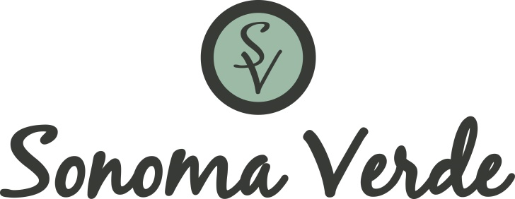

SPONSORSHIP & ADVERTISING

Sonoma Verde is a master-planned community in McLendon-Chisholm, Texas that will host 1,050 single-family homes at build-out. As the premier master-planned community in Rockwall County, Sonoma Verde has a very active Association with a wide range of events, holiday celebrations, clubs and group activities designed to connect the community and create a fun, engaging lifestyle.

We would love the opportunity to get your business in front of our community through advertising and partnership in our events. Let’s do something GREAT together!

Weekly Newsletter and Social Media Advertising: Our weekly newsletter is sent to each of our residents and is also posted on our community Facebook page.

PACKAGE DESCRIPTIONS

IN-KIND DONATIONS FOR SPECIFIC EVENTS: (Include but not limited to) – Sponsoring one item or portion of a specific event, (i.e. bottled water for an outdoor event, ice pops for a day at the pool, etc.). Your company will receive 1 Ad in the Sonoma Verde Weekly Newsletter and a table with your signage at the corresponding event.

BRONZE SPONSORSHIP - $150
3 Ads in the Sonoma Verde Weekly Newsletter and a table with your signage at any events that fall within your Ad time.

SILVER SPONSORSHIP - $300
5 Ads in the Sonoma Verde Weekly Newsletter and a table with your signage at any events that fall within your Ad time.

GOLD SPONSORSHIP - $500
8 Ads in the Sonoma Verde Weekly Newsletter and a table with your signage at any events that fall within your Ad time.

PLATINUM SPONSORSHIP - $1,000
Annual (52) Ads in the Sonoma Verde Weekly Newsletter and a table with your signage at any events throughout the year.

DIAMOND SPONSORSHIP - $1,500 (or more)
Annual (52) Ads in the Sonoma Verde Weekly Newsletter (placed at the top of the sponsors section) and a table with your signage at any events throughout the year.

All ads should be submitted in jpeg form, 500 x 600 pixels and can be changed or updated throughout your ad time. Please include any email or website that you wish to have the ad linked to in the newsletter. We are excited to be able to connect your business to the Sonoma Verde Community. Please feel free to reach out to me with any questions and we can get your ad started as early as next week!

