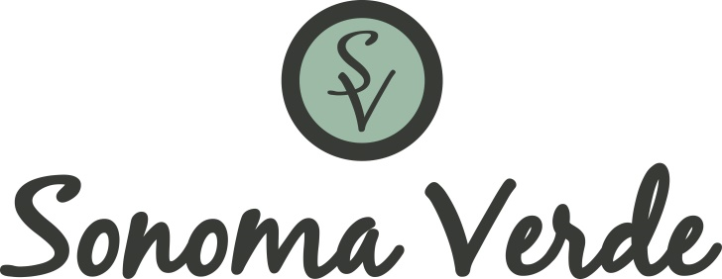

RELEASE OF LIABILITY AND ASSUMPTION OF ALL RISKS

EVENT: _____________________________________________

I acknowledge and understand that I have voluntarily applied to host or participate in the event specified above. I am knowingly and voluntarily participating in this event with full knowledge of the numerous risks and dangers involved, including illness and serious personal injuries. I fully understand that there may be other risks and social and economic losses either not known to me or not readily foreseeable at this time. I agree to follow all written and verbal rules of safety and instructions presented to me by the Sonoma Verde Homeowners Association, Inc., a Texas nonprofit corporation, (“Association”). I HEREBY AGREE TO BE FULLY RESPONSIBLE FOR MY OWN WELFARE, PHYSICAL PROPERTY, AND ACCEPT ANY AND ALL RISKS OF DELAY, DAMAGE, UNANTICIPATED EVENTS, ILLNESS, UNJURY, EMOTIONAL TRAUMA OR DEATH TO MY PERSON OR PROPERTY.

Therefore, as lawful consideration for the right to participate in such event(s), I hereby RELEASE AND DISCHARGE FOREVER THE ASSOCIATION AND CCMC, INLCUDING EMPLOYEES AND STAFF, FROM AND AGAINST ANY AND ALL LIABILITY, INJURIES OR DAMAGES ARISING FROM MY PARTICIPATION IN THE EVENT. I agree that this release shall be legally binding upon me personally, all members of my family, including minors attending with me, their heirs, successors, assigns and legal representatives, it being my intention to fully assume all the risk of performance and to release the Association from any and all liabilities to the maximum extent permitted by the law.

I understand that the Association reserves the right to take photographic or film records of any of its events and hereby agree that the Association may use any such photographic or film records for promotional and/or commercial purposes.

I am 18 years of age or older and have been given amply time to read this Release. I HAVE READ AND FULLY UNDERSTAND THIS RELEASE OF LIABILITY AND ASSUMPTION OF ALL RISKS. I am aware that by signing this agreement I am waiving certain legal rights which I or my heirs, next of kin, executors, administrators and assigns may have against the Association. I certify that all personal information provided in this agreement is true and correct.

PARTICIPANT OR GUARDIAN NAME AND SIGNATURE:

___________________________________ ___________________________________
Name Signature

Date: ______________________________

PARTICIPANT NAME AND SIGNATURE (if under 18):

___________________________________ ___________________________________
Name Signature

