Love Walk 2026 Registration Form: Celebrating 76 Years of Service!
“It’s A Love Thang!”

How to register:
- Church, Organization, or Group - See your Love Walk Coordinator.
- Independent Walkers - Call (912) 236-4226

How to participate:
  - Request people to sponsor you.
  - Record your sponsor's name, address, and the amount of their donation on this form.
  - Collect your donations prior to the Walk, and give to the Coordinator to turn in to Wesley on "Bank Days" designated anytime the weeks of January 12 - 16, January 20 - 23, January 26- 30, and February 2 - 13, 2026 between 8:00 A.M - 3:30 P.M.
  - If you live out of town, your walk money can be mailed in before the Walk Day.
  - Please remember this is a Hybrid Love Walk

Checks:
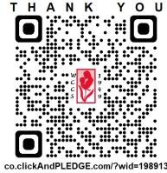
Make all checks payable to Wesley Community Centers of Savannah, Inc.

Credit Cards:
Credit card donations can be made from the Wesley website at the following link: http://www.wesleysav.org
SPONSOR FORM

WALKER Organization

ADDRESS PHONE

PARENTAL CONSENT (require for walker under age 18)

SPONSOR | ADDRESS | PLEDGED | PAID

(912) 236-4226 www.wesleyctrs-sav.org Find us on Facebook

