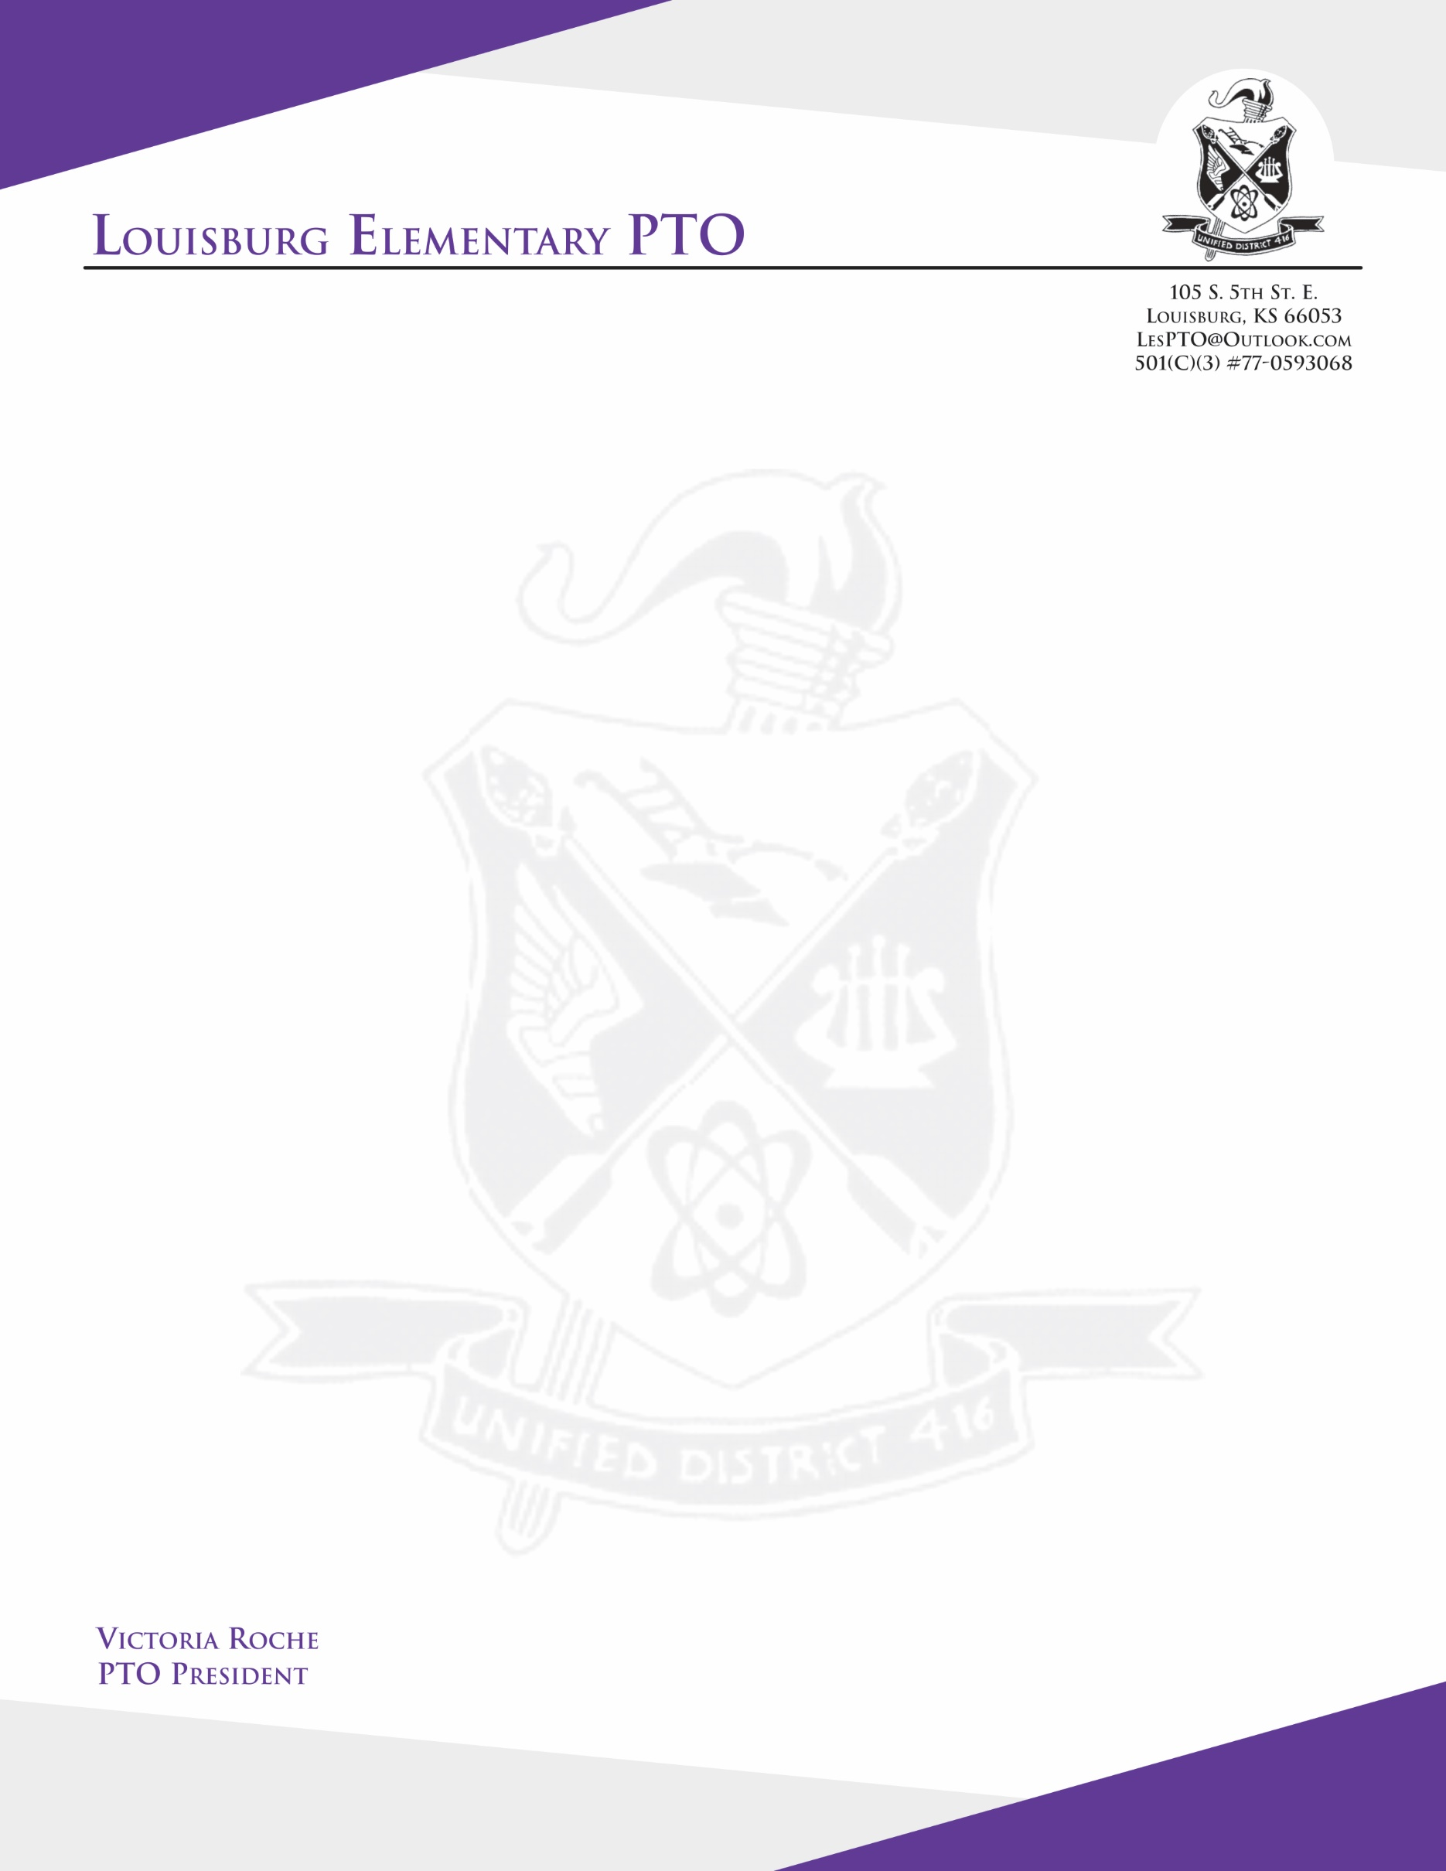

Dear Business Owner,

  The Louisburg Elementary (LES) PTO is currently seeking business sponsors for our 1st annual Dinner Fundraiser, an 80's themed adults night, being held on Saturday March 7th, 2020 at 7PM. This adult’s night out event will feature a silent auction, dinner, raffle, and games. Your sponsorship will further our mission of supporting our Louisburg Elementary School Community. This is our final fundraiser for the 2019/2020 school year; the funds raised from this event will dictate the amount of support we will be able to offer for the 2020/2021 school year.

Our suggested donation tiers are as follows:

**PLATINUM - $250 - AND UP**(a $348 donation is equivalent to a $2 donation for every school day).

- Named as sponsor of one of our featured entertainment DJ/Bingo/Trivia/Candy Buffet.

- Special thank you announcement made during the event by our MC.

- Your company will receive a thank you and shout out post on the LES PTO Facebook page.

- Your business will be listed as a PLATINUM sponsor on event program and signage.

**GOLD - $100-$249**(a $174 donation is equivalent to a $1 donation for every school day)

- Sponsor a dinner table at our event, have your business name and logo placed at your specified table

- Your company will receive a thank you and shout out post on the LES PTO Facebook page.

- Your business will be listed as a GOLD sponsor on event program and signage.

**SILVER - $50-$99**(an $87 donation is equivalent to a $0.50 donation for every school day)

- Your business will be announced as the sponsor of one of our bingo or trivia prizes.

- Your company will receive a thank you and shout out post on the LES PTO Facebook page.

- Your business will be listed as a SILVER sponsor on event program and signage.

We hope you will seriously consider becoming one of our sponsors and partnering with us to make this event successful for the benefit of our children, Louisburg Elementary Schools, and community. If you would like to be a sponsor or have any questions please email or call me, contact info below.

Thank you for your consideration,

Tara Gerber

Fundraising Coordinator and Auction Committee Co-Chair

Louisburg Elementary PTO

[tara.gerber85@gmail.com](mailto:tara.gerber85@gmail.com)

816-419-6857