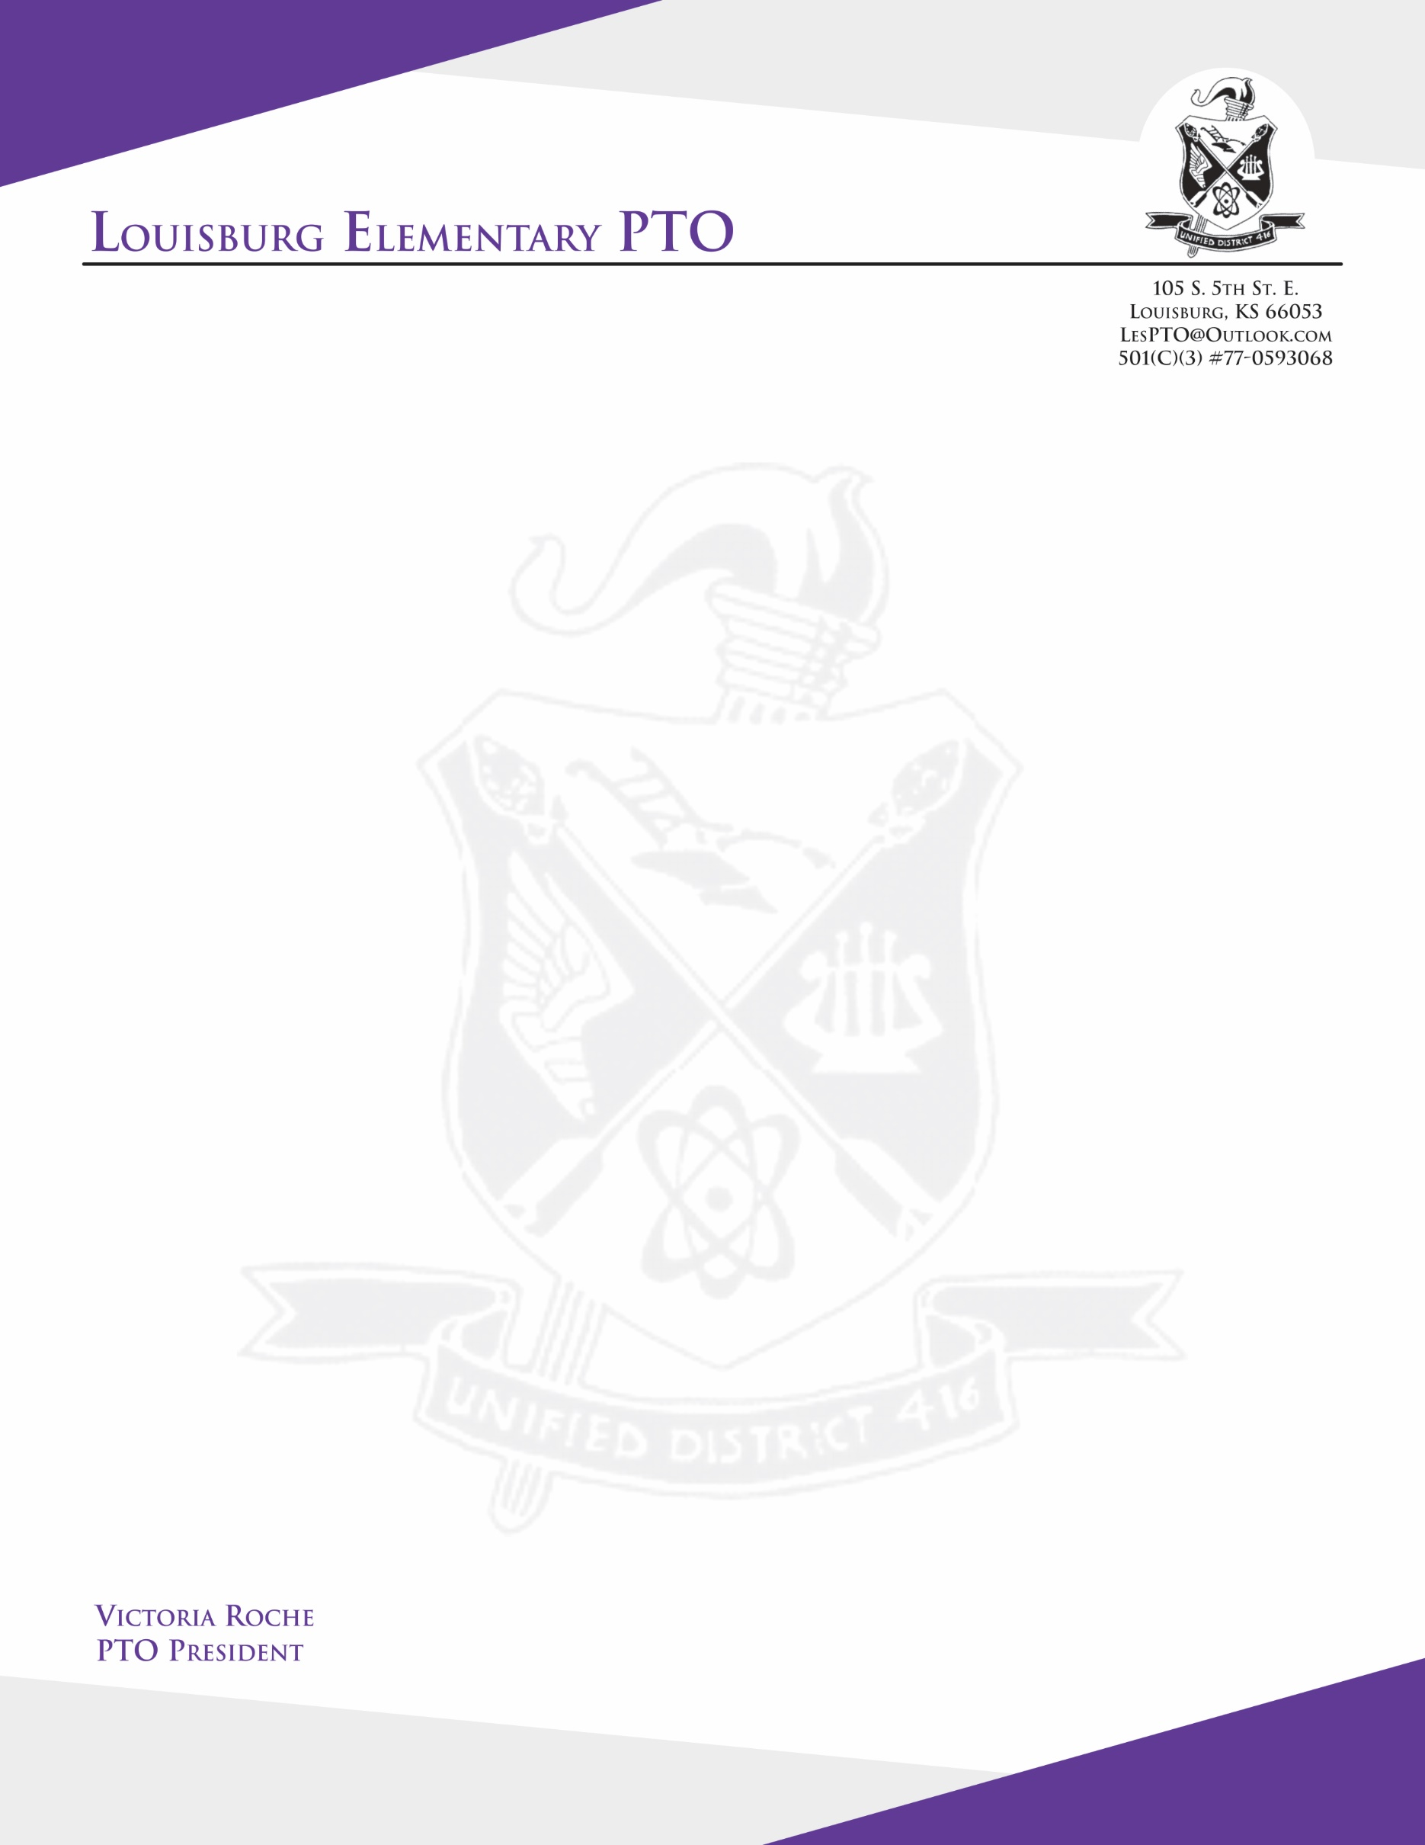

Dear Business Owner,

The Louisburg Elementary (LES) PTO is having its 1st annual Dinner Fundraiser, an 80’s themed adults night, on Saturday March 7th, 2020 at 7PM.

The purpose of this fundraiser is to allow the LES PTO to continue and grow our support for the children, staff and community of the Louisburg Elementary Schools. The family events, teacher appreciation, enrichment opportunities not offered in the regular curriculum, and overall support of our teachers and students are a few of the items which are funded by the PTO.

We need help from the business community! We would appreciate any type of donation whether it be services offered, silent auction items, or monetary donations - anything your business can offer to make this event a great success is truly appreciated. All donations are tax deductible. Our tax identification number is 77-0593068.

Thank you in advance for supporting the Louisburg PTO and the Louisburg’s Elementary School children.   
Donations can be picked up or mailed to:

Louisburg Elementary PTO  
Attn. Tara Gerber

105 S. 5th St E.

Louisburg, KS 66053  
  
Sincerely,  
Tara Gerber

Fundraising Coordinator and Auction Committee Co-Chair

Louisburg Elementary PTO

[tara.gerber85@gmail.com](mailto:tara.gerber85@gmail.com)

816-419-6857