STEP 1: Accept the Connect invitation
Tomorrow, you will receive an email invitation with the subject “Connect to Catholic Memorial School”. Click on the Accept Invitation button to open the sign-up page. Please check your junk/spam just in case.

STEP 2: Create your Blackbaud ID Account
On the signup page, do not edit or change your email address. If you are a student, you are required to use your CM email address. If you prefer to use a different email, please contact Kristina Patel at kristinapatel@catholicmemorial.org.
Complete the form by entering a password and your first and last name. Your password should be a unique password that you do not use for other accounts/websites. Once you’ve entered the required information, select “Sign up”.

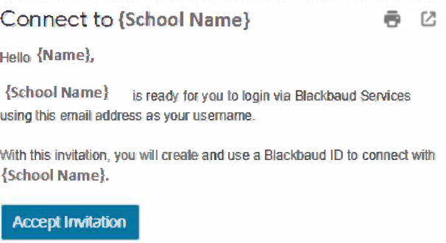

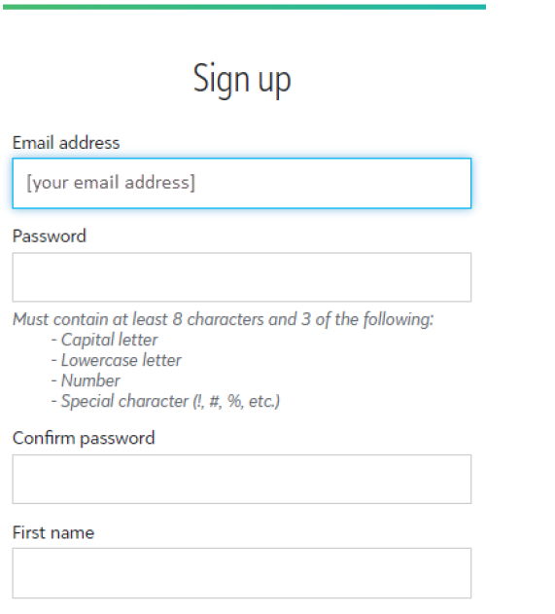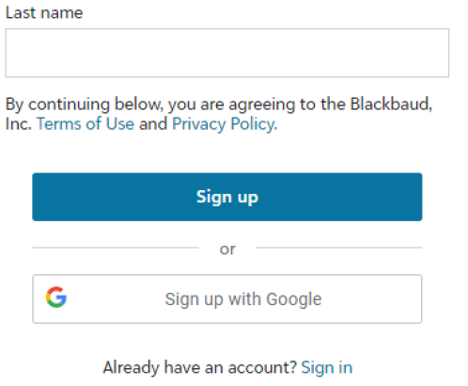

STEP 3: Confirm your account
Within a few minutes of signing up, you will receive an email with the subject “Confirm your Blackbaud ID.” Click the “Confirm” button in this email within 24 hours to confirm your account creation.

STEP 4: Sign in with your Blackbaud ID
On the Catholic Memorial website, click on “Login” where you sign in to OnCampus, and enter your email address.

The first time you sign in with Blackbaud ID, you may receive a message that your account is being converted.
Click Continue.
If your Blackbaud ID session is still active from Step 3, you will automatically be signed in after clicking continue.

If your Blackbaud ID session is not active, sign in with your email address and the password you created.

