SAR War with Spain Medal (1898)
In May 1899, the Sons of the American Revolution created a medal for the 438 active SAR compatriots who served in the Spanish-American War of 1898. The War with Spain, from April 21 to December 10, 1898, resulted in a US protectorate over Cuba, and the US acquiring the territories of the Philippines, Guam, and Puerto Rico from Spain.
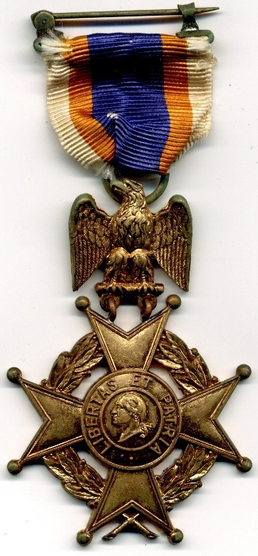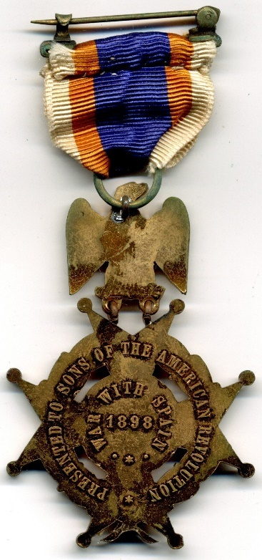
The medal was struck in bronze, and had no enameling. The obverse of the medal has the SAR Insignia on a ribbon drape. The eagle measures 13/16-inches by 14/16-inches. The cross measures 1 9/16-inches by 1 9/16-inches. The obverse is flat with no detail of the eagle or cross, and has the words: “Presented to the Sons of the American Revolution,” “War With Spain,” “1898.” Very few medals were engraved with the name of the recipient on the reverse of the eagle. The medal depicted above is from the collection of the late Compatriot James Charles McHargue (1947-2024), who was a member of the Sons of Liberty Chapter.
Fifteen members of the California Society of the Sons of the American Revolution were presented with medals. Below are biographies of the fifteen recipients.

Sergeant Charles Goodridge Austin, Jr.
1st Battalion California Heavy Artillery, US Volunteers
(CA#194, NS#3594, September 12, 1896)
Born October 3, 1861 in Cleveland, Ohio
Died December 22, 1947 in Alameda County, California

Charles Austin was born in 1861 in Ohio. In 1870, he was living with his parents in Tiffin, Ohio. He moved with his parents to San Francisco by 1880, when he living with his parents, and was working in a cigar box factory. By 1886, he was a millman living in San Francisco.
On May 9, 1898, he enlisted as a private in the 1st Battalion, California Heavy Artillery, Spanish War Volunteers, for the Spanish-American War in San Francisco. In June 1898, Sergeant Austin of Battery A, 1st Battalion, California Heavy Artillery, was tasked with recruiting another full battery in Sacramento to be sent to the Philippines for the fourth Manila Expedition. At the end of the Spanish-American War, he served in the Philippine Insurrection. On September 21, 1899, he was mustered out of volunteer service in the Philippine Insurrection at the Presidio in San Francisco.
In April 1902, Charles Austin, a member of the California Heavy Artillery, served on a committee of the 1st California Infantry to petition the US Congress to provide funds for travel pay for the volunteers of the 8th Army Corps, who served in the Philippines after April 12, 1899, during the Philippine Insurrection. In 1910, he was an inmate of the Yountville Veterans Home in Napa, and he was a pantryman there. In May 1915, he was admitted to the Sawtelle Veterans Home in Los Angeles with rheumatism, constipation, bronchitis and rapid heartbeat. He was discharged from the Sawtelle in December 1917 to Yountville, California. In 1920, he was an inmate at the Yountville Veterans Home in Napa. In 1930 and 1940, he was living in San Francisco, and he was a journalist. In December 1942, Austin announced there would be a meeting at the Labor Temple in San Rafael to organize a reserve group of cavalrymen for the California State Guard. He died in 1947 in Alameda County, California, was buried in the Golden Gate National Cemetery in San Bruno, California.

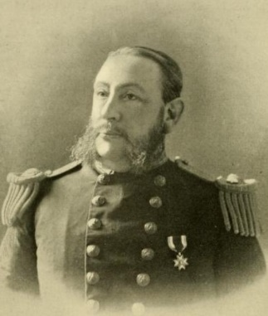
Paymaster’s Clerk Edward St. John Bellows
USS Baltimore, US Navy
(CA#153, NS#3553 December 23, 1895)
Born April 28, 1840 in Newport, Rhode Island
Died May 20, 1903 in Walpole, New Hampshire

Edward Bellows was born in 1840 in Rhode Island. In 1856, he moved with his parents to Walpole, New Hampshire. After high school, he was employed as a clerk in the store of Thomas Buffum in Walpole. In 1860, he went to New York City, and was employed by the dry goods firm of Rushmore, Cone & Company.
In April 1861, he enlisted for three months in the 8th New York State Militia for the Civil War. He served under General Butler at Annapolis, the Relay House, and Baltimore; and he took part in the first Battle of Bull Run in Virginia in July 1861. He was discharged in August 1861.
In June 1862, he was appointed assistant paymaster in the United States Navy. He served on the U. S. steamer Sonoma (1862-63) with Admiral Wilkes’ flying squadron, and on the Osceola (1863- 65) in the North Atlantic squadron. He was in both attacks on Fort Fisher, served on the James River, and was present at the fall of Richmond. He later served on the Shamokin in the South Atlantic squadron. In February 1866, he was promoted to paymaster. He was on duty in San Francisco (1869-80), in the Navy Yard, Mare Island (1880-81), on the Alaska (1881), on the Shenandoah in the Pacific squadron (1883-85), and on the Swatara (1888-90). In July 1889, he was promoted to pay inspector. He served on the Marion, and in the Norfolk Navy Yard (1890-92). He was afterwards on duty in San Francisco (1893-96) as purchasing pay officer for the navy on the Pacific coast, and was stationed at Newport, Rhode Island (1896-97) at the training and torpedo station.
In 1898, he served as fleet pay officer of the Pacific squadron on the protected cruiser USS Baltimore (C-3). He served on the Baltimore at Manila Bay during the Spanish-American War. The Baltimore was the second ship in Dewey’s line of Battle, and engaged in a duel with the Spanish shore batteries.
After the war, he was paymaster of the US Navy at the Portsmouth Navy Yard in Maine. In 1902, he retired after 40 years in the US Navy. He died in 1903, and was buried in the Walpole Village Cemetery in Walpole, New Hampshire.

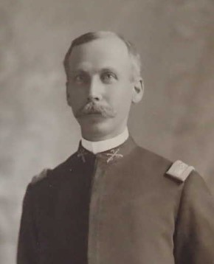
Colonel John Riddell Berry
7th California Infantry, US Volunteers
(CA#77, NS#3477 June 14, 1894)
Born February 2, 1850 in Venice, Pennsylvania
Died December 28, 1930 at the Naval Hospital in San Diego, California

John Berry was born in 1850 in Pennsylvania. In 1869, he graduated from Washington & Jefferson College in Pennsylvania. In 1880, he was a lawyer living in Monmouth, Illinois. He came to San Diego in 1885, and became editor of the San Diego Union newspaper. In 1886, he became the manager of the San Diego Union newspaper. In 1888, he reported on the construction of the Hotel del Coronado in San Diego.
In 1889, he enlisted as a cadet in the 3rd Infantry Regiment, Second Brigade, California National Guard. In 1890, he was appointed collector of customs at San Diego by President Benjamin Harrison. In 1894, he went into business as a mining broker.
John Berry became commanding officer of the Seventh California National Guard, which became the Seventh California Volunteers at the outbreak of the Spanish-American War in 1898. Following the war, he joined the United Spanish-American War Veterans.
In 1918, he applied for a passport, so he could travel to Mexico to purchase a mine. By 1920, he was a lawyer specializing in conveyances. In 1928, he celebrated his 55th wedding anniversary in the pepper grove of Balboa Park. He died in 1930 in San Diego, California, and was buried in the Mount Hope Cemetery in San Diego.

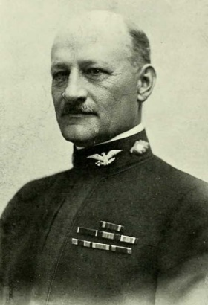
Assistant Surgeon Norman Jerome Blackwood
US Naval Hospital, Philadelphia
(CA#104, NS#3504 February 26, 1895)
Born January 3, 1866 Germantown, Pennsylvania
Died April 2, 1938 Cottage Hospital in Santa Barbara, California

Norman Blackwood was born in 1866 in Pennsylvania, and grew up in Lancaster. He was appointed to the US Naval Academy at Annapolis on May 17, 1883, and he cruised on board the sloop-of-war USS Constellation, the last sail-only US Naval warship. He resigned from Annapolis in February 1886, and attended Jefferson Medical College in Pennsylvania. In June 1890, he was re-appointed to Annapolis as a lieutenant (jg). In October 1890, he was appointed as assistant surgeon on the Receiving Ship Vermont. In December 1891, he was appointed as assistant surgeon on the USS Miantonomoh on North Atlantic Station. In February 1893, he was appointed as assistant surgeon at the US Hospital at Norfolk, Virginia. In July 1893, he was promoted to lieutenant. In October 1894, he was appointed as assistant surgeon on Receiving Ship Independence. In May 1895, he was appointed as assistant surgeon on the sidewheel gunboat USS Monocacy on the Yangtze River on Asiatic Station. In 1897, he became a Master Mason in Union Lodge #1951 in Tientsin, China. In 1898, he was on special service in the Peking, China.
He served during the Spanish-American War of 1898. In November 1898, he was appointed as assistant surgeon at the US Naval Hospital in Philadelphia, Pennsylvania. In April 1901, he was appointed as surgeon on the screw gunboat USS Alliance, in the Atlantic Training Squadron. In May 1904, Lt. Commander Blackwood was appointed as surgeon on Torpedo Station at Naval Station Narragansett Bay, Rhode Island. In May 1906, he was appointed as surgeon on the first-class battleship USS New Jersey. In June 1909, he was appointed surgeon at the Navy Yard in New York City. In April 1910, he was appointed surgeon at the US Naval Hospital in New York City. In November 1911, he was appointed as surgeon in the Asiatic Station. In 1913, he was fleet surgeon for the Asiatic Fleet on the USS Saratoga (formerly the armored cruiser New York, renamed Saratoga from 1911-1917). In 1913, he was promoted to Commander (MC), and placed in command of the US Naval Hospital in Canacao, Philippines. In December 1913, he returned to the United States from Asiatic Station. In May 1914, he was appointed as medical officer for the Navy Yard in Boston. From September 1916 to 1917, he was commander of the US hospital ship Solace. In October 1917, he was promoted to captain (MC), and he was sent to New York to fit out and commission the hospital ship Mercy. He was commanding officer when the Mercy was commissioned in Hoboken, New Jersey, on January 24, 1918, and served as captain until September 1918. He received the Navy Cross for his distinguished service as commanding officer of the US hospital ships Solace and Mercy with the US Atlantic Fleet in World War I. In September 1918, he was commander of the Naval Hospital in Chelsea, Massachusetts. In February 1921, he was promoted to rear admiral. In April 1923, he was appointed as commander of the US Naval Hospital in New York City. In July 1927, he was appointed as commander of the US Naval Hospital in Puget Sound, Washington. He retired from the Navy as a rear admiral on January 3, 1930, and became medical director of Provident Hospital in Chicago. In 1938, he was appointed as superintendent of Cottage Hospital in Santa Barbara, California. He died in April 1938 at Cottage Hospital in Santa Barbara, and his ashes were scattered at sea per his wishes.

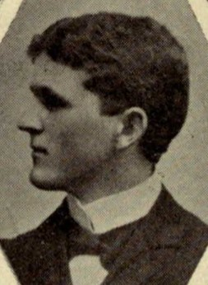
Assistant Engineer Norris King Davis
USS Philadelphia, US Navy
(CA#327, NS#11877 October 8, 1898)
Born June 26, 1876 in San Francisco, California
Died April 17, 1954 in San Francisco, California

Norris Davis was born in 1876 in San Francisco, California. In 1894, he enlisted in Company F, 2nd Artillery Regiment, 2nd Brigade, California National Guard. He graduated from the University of California in 1898, and was a member of the Sigma Nu fraternity.
On June 3, 1898, he enlisted as an ensign in the US Navy as an assistant engineer on the USS Philadelphia during the Spanish-American War, and was honorably discharged on February 7, 1899. In 1900, he was a marine engineer living in San Francisco. In 1901, he graduated from Harvard with a Master of Science degree. In 1904, he was promoted to major and aide-de-camp of the Major General’s Staff in the California National Guard. In 1910, he was a general merchandise engineer living in San Mateo, California. In 1911, he was promoted to 2nd lieutenant in the 11th Company, Coast Artillery Corps, California National Guard. In 1913, he was promoted to captain in the 11th Company, Coast Artillery Corps, California National Guard. In 1917, he entered the Officers’ Training Camp at the Presidio of San Francisco, and was commissioned a captain in the Coast Artillery Corps at Fort MacArthur. In 1918, he was promoted to major, and was assigned to the 52nd Ammunition Train, Coast Artillery Corps.
In May 1918, he was sent to France for World War I, and transferred to the 42nd Coast Artillery. In January 1919, he was attached to the American Commission to Negotiate Peace in Paris as a member of the Allied War Damages Board. In April 1919, he returned to the United States, and was discharged on April 24, 1919. In May 1919, he was commissioned as a major in the Coast Artillery Officers’ Reserve Corps. In 1920, he was a manufacturer living in Hillsborough. He moved to Napa by 1930. He was a member of the American Legion, Reserve Officers Association, Harvard Alumni Association, UC Alumni Association, F&AM, Native Sons of the Golden West, Commonwealth Club of San Francisco, Marine Memorial Association of San Francisco, Napa County Farm Bureau, California Prune & Apricot Growers Association, and the Napa Valley Cooperative Winery. He died in 1954 in San Francisco, California, was buried in the Tulocay Cemetery in Napa, California.

Assistant Surgeon Edward Everts
Fort Apache, US Army
(CA#115, NS#3515 5/25/1895)
Born July 24, 1854 in Bonham, Texas
Died May 17, 1901 in Alameda, California

Edward Everts was born in 1854 in Texas. He moved to California as a child. In 1870, he was an apothecary clerk living in Napa, California. In 1880, he was a teacher living with his mother in Napa.
In 1882, he enlisted in the US Army as an assistant surgeon in the Department of Indiana. In 1882, 1st Lt. Everts was assistant post surgeon at Fort Sherman in the Idaho Territory. In 1883, he was post surgeon at Fort Lapwai in the Idaho Territory. In 1884, he was assistant surgeon at Fort Walla Walla in the Washington Territory. In 1885, he was post surgeon of Benicia Barracks in California. In 1886, he was assistant surgeon at Fort Grant in the Arizona Territory. In April 1887, Captain Everts became post surgeon and post treasurer of Fort Apache in the Arizona Territory. In 1892, Captain Evers was camp surgeon at Camp Bettens in Wyoming. In March 1896, Captain Everts was assistant surgeon at Fort Wingate in New Mexico. In December 1889, Captain Everts was assistant to the surgeon at David’s Island in New York Harbor until June 30, 1892. In 1895, he was an assistant surgeon in the 11th Infantry, US Army, at Whipple Barracks in the Arizona Territory. In January 1898, he was named surgeon of the Whipple Barracks in the Arizona Territory.
With the outbreak of the Spanish-American War, in May 1898, he became post surgeon, librarian and treasurer at Fort Apache in the Arizona Territory. In November 1898, Captain Everts went on sick leave for four months. In March 1899, Captain Everts became post surgeon at Fort Mason in San Francisco. Captain Everts retired from the Army due to ill health on April 28, 1900, at Fort Mason in San Francisco as a major. He died in 1901 in Alameda, California, and was buried in the San Francisco National Cemetery at the Presidio in San Francisco.

Captain Arthur Smith Guthrie
6th California Infantry, US Volunteers
(CA#226, NS#9626 12/23/1896)
Born April 5, 1870 in St. Charles, Minnesota
Died May 28, 1930 San Bernardino, California

Arthur Guthrie was born in 1870 in Minnesota, and was raised in St. Charles. He moved to California around 1887. On October 28, 1887, he enlisted in Company E, 9th Infantry Regiment, 1st Brigade, California National Guard in San Bernardino, California. In February 1891, he was transferred to Company F, 7th Infantry Regiment, 1st Brigade, California National Guard. In November 1889, he was promoted to corporal. In 1896, he was a reporter, and was living in Merced, California. On September 25, 1896, he enlisted in Company H, 6th Infantry, California National Guard. In January 1897, he was promoted to 2nd lieutenant. In April 1897, he was promoted to 1st lieutenant. In May 1897, he was promoted to captain.
On April 21, 1898, the Spanish-American War broke out. On April 28, 1898, Company H was organized at Merced, California, for service in the US volunteers. They proceeded to San Francisco, where on May 8, 1898, Company H was mustered into the service of the United States as the 1st Battalion of US Volunteers at the San Francisco Presidio. On May 11, 1898, Arthur Guthrie was appointed Captain of Company H, 6th California Infantry. There was great disappointment that the 7th Infantry was not selected for any of the Philippine Expeditions during the war. On June 14, 1898, Company H, commanded by Captain Guthrie, was assigned to Fort Point at the San Francisco Presidio. At Fort Point, they were given a course of instruction in heavy artillery and signal service until October 11, 1898, when they were furloughed until November 10, 1898. They mustered out of the California Volunteer Infantry on December 15, 1898, at Fort Point, and they resumed service in the California National Guard.
By 1901, he was sent to Manila to serve during the Philippine Insurrection. Captain Guthrie was appointed to the Philippine Constabulary on July 24, 1903. On February 17, 1905, the Officer’s School of the Philippine Constabulary was founded in Intramuros, Manila. This later became the Philippine Military Academy in 1935. Captain Arthur Guthrie was the first superintendent of the Officer’s School, serving from April 15, 1905 to November 14, 1905. He became adjutant general of the Philippine Constabulary in Manila, Philippines. In 1913, Major Guthrie was assistant superintendent of information division of the Philippine Constabulary. In July 1914, Major Arthur Guthrie traveled from Manila to California to visit relatives, before returning to Manila. He was discharged from the military in July 1919 in San Bernardino, California. He died in 1930 in San Bernardino, California, and was buried in the Pioneer Memorial Cemetery in San Bernardino.

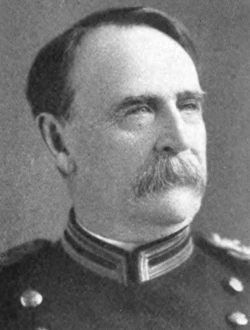
Lt. Colonel Edward Hunter
Judge Advocate General’s Department, Puerto Rico
(CA#44, NS#3444 3/24/1891)
Born November 22, 1839 in Gardiner, Maine
Died October 12, 1929 in Mount Vernon, New York

Edward Hunter was born in 1839 in Maine. In July 1860, he was appointed to West Point Military Academy as a cadet. He graduated from West Point on June 23, 1865, and was commissioned as a 2nd lieutenant. He was immediately promoted to 1st lieutenant of the 12th Infantry Regiment, US Army. He participated in campaigns against the Cheyenne, Arapahoe, Kiowa, and Comanche tribes in 1868. In Feb 1870, he was transferred to the 1st Cavalry. He served in the Nez Perce War in 1877, and the Bannock War in 1878. In August 1879, he was promoted to captain of the 1st Cavalry Regiment. He was transferred to the Department of California in San Francisco as adjutant of the 12th Infantry. He was then transferred to the 1st Cavalry Regiment and appointed first quartermaster and then adjutant of the regiment. He read law, and in December 1888, he was promoted to major and judge-advocate for the Department of California, and was admitted to the California Bar. In 1895, he was president of the California Sons of the American Revolution. In January 1895, he was promoted to lieutenant colonel and deputy judge-advocate and adjutant general in the Department of Dakota at Fort Snelling in St. Paul, Minnesota.
During the Spanish–American War of 1898, he served at Chickamauga as the mustering officer, and then served under General Brooke as judge-advocate in Puerto Rico. Due to ill health, he returned to the United States.
In May 1901, he was promoted to colonel and judge advocate general for the Department of the East at Governors Island, New York. On November 22, 1903, he retired on half pay at the mandatory retirement age of 64. He lived in Manhattan, New York, and moved to Mount Vernon, New York, between 1915 and 1920. He died in 1929 in Mount Vernon, New York, and was buried in Arlington National Cemetery.

Captain John Alexander Lockwood, Sr.
4th US Cavalry
(CA#165, NS#3565 12/23/1895)
Born October 31, 1856 in Dresden, Kingdom of Saxony
Died February 2, 1941 in Washington, DC

John Lockwood was born in Dresden, Saxony, while his parents were traveling in Europe. He moved from Saxony to New York in 1858 with his parents. In 1879, he graduated from the United States Coast Guard Cadet Schoolship Chase.
In November 1880, he enlisted in the US Army, and was commissioned as a 2nd lieutenant in the 17th Infantry. In 1883, he graduated from the Fort Leavenworth Infantry and Cavalry Army School. From 1884 to 1887, President Chester A. Arthur detailed him to serve as professor of Military Science and Tactics at Michigan Agricultural College in East Lansing. At the conclusion of his teaching duties, he was awarded an honorary Master of Science degree. In June 1889, he was promoted to 1st lieutenant. From 1890 to 1891, he campaigned against the Sioux Indians in South Dakota, and was awarded the War Department Service Medal. In October 1891, he was transferred to the 4th Cavalry in California, where his regiment patrolled the National Parks, built roads, and repaired trails.
During the Spanish-American War, he mustered three regiments of Mississippi Volunteers into the US Army. In November 1898, he was promoted to captain. In Spring 1899, his regiment was sent to the Philippine Islands to campaign against the insurgents. He participated in the Lawton Expedition in Northern Luzon, and was awarded a service medal from the War Department. He contracted an illness in the Philippines, and was sent to Japan to recuperate before returning to the United States. In November 1900, he retired from the US Army due to the illness he contracted in the line of duty.
He was a lecturer at Fordham University in New York City, where he instructed on the Philippine Islands. In 1917, Major Lockwood was sent by the War Department on a mission to the West Coast of South America in connection with the US possibly entering World War I. In 1918, he was promoted to colonel, and was a field officer at the camp for college students at Plattsburg, New York. In September 1918, he was ordered to serve as commanding officer of the Hahnemann Medical College Unit. In 1930, he was living at the Army & Navy Club in Washington, DC. In 1940, he was a patient at St. Elizabeth’s Hospital in Washington, DC. He was a member of the Order of Indian Wars, and the Loyal Legion. He died in 1941 in Washington, DC, and was buried in Arlington National Cemetery.

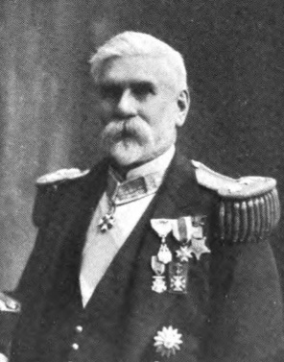
Commodore John White Moore
Chief Engineer, US Navy Yard, Brooklyn
(CA#33, NS#3433 11/29/1892)
Born May 24, 1832 Plattsburgh, New York
Died March 30, 1913 Ridgewood, New Jersey

John Moore was born in 1832 in New York. In 1853, he joined the US Navy as a third assistant engineer. He served on the steamship USS Niagara, a warship converted to a cable-laying vessel, in the failed Atlantic Cable Expedition of 1857.
During the Cili War, from 1861 to 1862, he served in the west Gulf of America in the blockade of the Confederate States of America. He originated the method of protecting the wooden sides of ships with anchor chains. He was the first to cover ships with muddy paint to make them less conspicuous. He fought at Forts Jackson and St. Philip (1862), the capture of New Orleans (1862), the siege of Vicksburg (1863), and against the Confederate ironclad CSS Arkansas.
In 1867, he was on the frigate USS Franklin on the staff of Admiral David Farragut. In 1892, he was president of the California Sons of the American Revolution. He served on the USS Hartford, and retired as a chief engineer with the rank of commodore in May 1894. After his retirement, he lived in Brooklyn, New York.
During the Spanish-American War, he served at the Navy Yard in New York, New York. In 1906, he was promoted to rear-admiral in recognition for his service in the Civil War. He was a member of the Massachusetts Society of the Cincinnati, the Military Order of the Loyal Legion, the Grand Army of the Republic, and the Veteran Corps of Artillery. He died in 1913 at his summer home in New Jersey, and was buried in the Bolton Rural Cemetery in Bolton, New York.

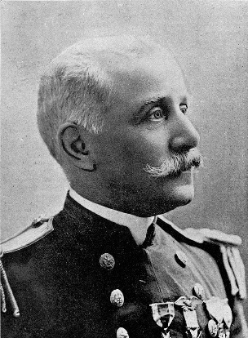
Lt. Commander Thomas Stowell Phelps, Jr.
USS Raleigh, US Navy
(CA#46, NS#3446 3/14/1892)
Born November 7, 1848 in Portsmouth, Virginia
Died November 3, 1915 in Oakland, California

Thomas Phelps was born in 1848 in Virginia. His father secured an appointment to West Point for his son, but he desired to join the Navy. He was friends with President Lincoln’s sons, and he asked President Lincoln to appoint him to Annapolis, which he did. He graduated from Annapolis in 1869.
During the Spanish-American War, he was captain of the cruiser Raleigh at the Battle of Manila Bay in 1898. In February 1900, he became equipment officer at the Mare Island Navy Yard. In November 1902, he was placed in command of the unprotected cruiser USS Marblehead (C-11) until February 1904. The Marblehead was recommissioned to patrol the west coast of North and South America from Alaska to Chile on training and protocol missions. In January 1903, the Marblehead collided with the SS Pomona in San Francisco Bay. In October 1903, the Marblehead was the flagship of Rear Admiral Henry Glass, the Commander of the Pacific Squadron. In October 1907, he was appointed commandant of Mare Island Navy Yard, and became a rear admiral. He retired from active duty on November 7, 1910. He died in 1915 in Oakland, California, and was buried in Arlington National Cemetery.

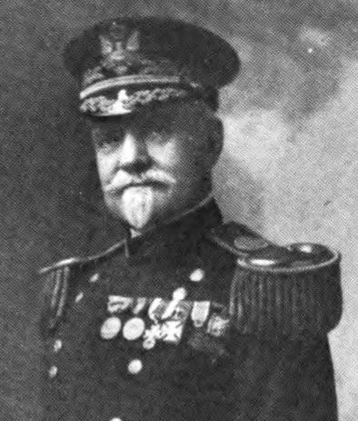
Major (James) Estcourt Sawyer
Quartermaster of the US Volunteers
(CA#38, NS#3438 4/6/1891)
Born July 3, 1846 in Washington, DC
Died May 29, 1914 in Glens Falls, New York

Estcourt Sawyer was born in 1846 in Washington, DC. In 1860, he was living with his stepmother in Plattsburgh, New York. He served during the Civil War in the US Navy as captain’s clerk from 1865 to 1866. In 1867, he was appointed a 2nd lieutenant in the 5th Artillery Regiment, US Army. In 1871, he graduated from Artillery School. In 1874, he was promoted to 1st lieutenant. In 1884, he was acting judge advocate of the Division of the Atlantic and Department of the East. In 1886, he became the aide-de-camp to General John M. Schofield, the Commander of the Department of the Atlantic, until 1888. In 1893, he was president of the California Sons of the American Revolution. In December 1893, he was promoted to captain, and transferred to the Quartermaster Department.
In May 1898, with the outbreak of the Spanish-American War, he was transferred to the Army Volunteers as a major in the Quartermaster Department. He served at Camp Wyckoff in New York, and Camp Meade in Pennsylvania. From December 1898 to October 1899, he was special disbursing officer to the Philippine Commission. He was sent to Washington, DC, as a member of the Spanish War Claims Board.
In February 1901, he transferred back to the regular Army, and retained his rank as major. In July 1904, he was promoted to lieutenant colonel. In April 1910, he was promoted to colonel. He was the chief quartermaster of the Department of Dakota. He was discharged from the US Army on July 3, 1910 as he reached the age of 64, and retired with the rank of brigadier general. He was a member of the General Society of the War of 1812. He died in 1914 in Glens Falls, New York, and was buried in the Lakeview Cemetery in Burlington, Vermont.

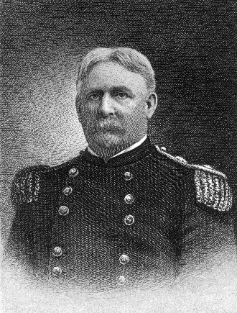
Brigadier General William Rufus Shafter
Cuban Expedition, US 5th Army
(CA#101, NS#3501 2/26/1895)
Born October 16, 1835 in Galesburgh, Michigan
Died November 12, 1906 in Bakersfield, California

William Shafter was born in 1835 in Michigan, and was raised in Galesburgh. During the Civil War, he enlisted as a 1st lieutenant in the 7th Michigan Volunteer Infantry Regiment of the US Army in June 1861 at Fort Wayne, Michigan, and fought in the Battle of Ball’s Bluff (1861) and the Battle of Fair Oaks in Virginia (1862). He was wounded at Fair Oaks, and received the Medal of Honor for his heroism in the battle. He was wounded at the end of the first day, and concealed his wounds so he could fight on the second day. In August 1862, he mustered out of the 7th Michigan Volunteers, and became a major in the 19th Michigan Volunteer Infantry Regiment. In March 1863, he was captured during the Battle of Thompson’s Station in Tennessee, and spent three months in a Confederate POW camp. He was released in April 1864, and was appointed colonel of the 17th US Colored Infantry, and led the regiment in the Battle of Nashville. By the end of the war, he was promoted to brevet brigadier general of volunteers.
He joined the regular Army after the war, and fought in the Indian Wars, where he received the nickname “Pecos Bill.” He led the 24th US Colored Infantry in campaigns against the Cheyenne, Comanche, Kickapoo and Kiowa tribes. In 1897, he was appointed as brigadier general, and became commander of the Department of California.
With the outbreak of the Spanish-American War of 1898, he was promoted to major general of volunteers, and given command of the 5th Army Corps in Tampa, Florida, for the Cuban Expedition. He landed at Daiquiri on the southern coast of Cuba, and he took the surrender of the city of Santiago. He retuned to the United States in September 1898, and returned to California to resume his command of the Department of California. He oversaw the supplying of the Army during the Philippine Insurrection which broke out in 1899. In 1901, he retired from the US Army, and settled on a farm in Bakersfield. He died in 1906 in Bakersfield, and was buried at the San Francisco National Cemetery at the Presidio of San Francisco.

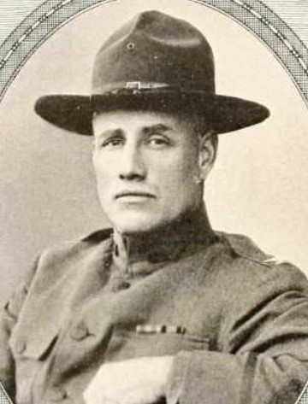
Lieutenant William Renwick Smedberg, Jr.
4th US Cavalry
(CA#64, NS#3464 11/2/1893)
Born January 3, 1871 in San Francisco, California
Died October 9, 1942 in Walter Reed Hospital in Washington, DC

William Smedberg was born in 1871 in San Francisco, California. He attended Lowell High School in San Francisco, and joined Company K, California National Guard. He was appointed to West Point in 1889, and graduated in 1893, being commissioned as a 2nd lieutenant of cavalry. He was assigned to the 4th Cavalry Regiment at Fort Bidwell and the Presidio of San Francisco. In 1896, he was assigned to the staff of West Point as a cadet tactical officer.
During the Spanish-American War of 1898, he was aide-de-camp to Brigadier General Samuel Baldwin Marks Young. He was on the Cuban Campaign, and fought in the Battle of Las Guasimas and the Battle of San Juan Hill. He received the Citation Star for gallantry in action (which was converted to the Silver Star, when that award was created in 1932).
During the Philippine Insurrection of 1899 to 1901, he continued to serve as aide-de-camp to Brigadier General Young. Smedberg worked to prevent soldiers from looting Filipino homes and property. In 1901, he returned to California, was promoted to captain, and was assigned to the 14th Cavarly Regiment, serving in the Department of California (1901 to 1902), and the Department of Colorado (1902 to 1903). In 1903, he served in the Department of Mindinao in the Philippines. From 1905 to 1907, he served in the Department of the Columbia (formerly the District of Oregon), and from 1907 to 1909 in the Department of California. From 1910 to 1912, he commanded a troop of the 14th Cavalry at Fort Stotsenburg in the Philippines. In 1912, he was posted to Fort Clark in Texas. From 1912-1913, he served as an instructor at the School of Musketry at the Presidio of Monterey. From 1913 to 1917, he was assigned to Fort Ethan Allen in Vermont, where he trained soldiers in the use of machine guns. In July 1916, he was promoted to major, and in June 1917 to lieutenant colonel.
In August 1917, he was promoted to colonel, and assigned to command the 305th Infantry Regiment at Camp Upton in New York. The unit was sent to France for World War I, and he fought in the Oise-Aisne and Meuse-Argonne offensives. In October 1918, he was promoted to temporary brigadier general, and commanded the 77th Division’s 153rd Brigade. In November 1918, he assumed command of the 63rd Brigade, 32nd Division. He participated in the occupation of the Rhineland, and returned to the United States in May 1919. He received a second award of the Citation Star (Silver Star) for his wartime heroism.
After the war, he commanded the District of Arizona, to maintain security on the border with Mexico, and he reverted to the rank of colonel. In 1921, he graduated from the Command and General Staff College, and completed courses at the Army War College. He served as inspector general of the Ninth Corps Area, assistant to the deputy chief of staff for personnel (G-1) on the Army general staff, commander of the 8th Cavalry Regiment, and commander of the 2nd Cavalry Brigade. His final assignment was chief of the administrative division at the National Guard Bureau (1932 to 1935). In January 1935, he retired from the US Army as a colonel, and was promoted to the highest rank he held in World War I – brigadier general. He retired to Washington, DC, where he died in 1942. He was buried in Arlington National Cemetery.

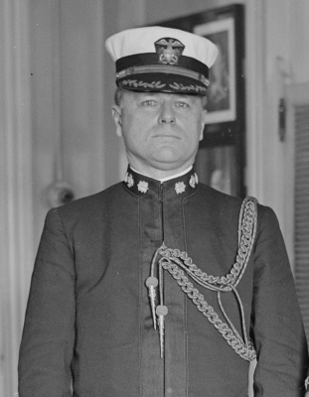
Ensign Frank Brooks Upham
USS Olympia, US Navy
(CA#141, NS#3541 10/3/1895)
Born September 7, 1872 in Camp Yache (Fort Apache), Arizona Territory
Died September 15, 1939 in San Francisco, California

Frank Upham was born in 1872 in the Arizona Territory. In 1889, he was appointed to Annapolis as a Naval cadet. He graduated from Annapolis on June 2, 1893. He served for two years at sea on the USS Philadelphia. In July 1895, he was promoted to ensign. In July 1895, he was assigned to the USS Olympia, the flagship of Admiral George Dewey, the Commander of the Asiatic Fleet. As a junior member of his staff, he met Emperor Meiji of Japan in January 1898.
In May 1898, he participated in the Battle of Manila Bay during the Spanish-American War on the USS Olympia. In January 1900, he was transferred to the USS Pensacola, and later served on the USS Mohican and USS Oregon.
In December 1904, he was assigned as inspector of ordnance at the Fore River Shipbuilding Company in Quincy, Massachusetts. In March 1906, he served as ordnance officer in the newly commissioned battleship USS New Jersey. In June 1908, he was assigned as navigator on the USS South Dakota. From July to September 1909, he attended the Naval War College, Newport, Rhode Island. He then served in the Bureau of Ordnance, Navy Department, Washington, DC. In August 1911, he was assigned as Assistant Naval Attaché , Tokyo, Japan and Peking, China. From February 1912 to April 1913, he commanded USS Scorpion. In June 1913, he was promoted to commander. Then he served on the USS Nebraska. In January 1915, he commanded the USS Olympia until it was decommissioned on June 5, 1915. He then reported for duty as aide to the commandant, Navy Yard New York, New York. In June 1915, he was assigned to the Navy Yard in New York City.
In August 1917, he was transferred from the Navy Yard, promoted to captain (temporary), and assumed command of the USS Columbia. He was awarded the Navy Cross for distinguished service as commanding officer of the USS Columbia, which transported troops and supplies to European ports through waters infested with enemy submarines and mines. In September 1918, he transferred to the USS Pueblo, and assumed command of the ship. He received a special Letter of Commendation from the War Department for his World War I service in command of the Columbia and the Pueblo. He was awarded the Legion of Honor by the President of the French Republic, and later promoted him to the rank of commander of the order. He received his permanent promotion as captain in December 1918. In July 1919, he was relieved as commander of the USS Pueblo. He was then assigned as chief of staff to Commander, Squadron TWO, Division 3, Atlantic Fleet, USS Connecticut.
He returned to the United States, and was transferred to duty on the staff of Commander, Battleship Force, Atlantic Fleet, on USS Utah. In 1921, he was a Naval officer living in Washington, DC, and he applied for a passport to travel to France via Belgium. In July 1921, he was appointed as Naval attaché to the American Embassy in Paris, France. In January 1923, he received the additional duty as Naval attaché to the American Embassy in Madrid, Spain. In July 1924, he returned to the Navy Department, and had temporary duty in the Office of Naval Intelligence, before assuming command of USS Tennessee, serving from September 1924 to March 1926. He served as Commandant of the Naval Air Station, Pensacola, Florida, until June 1928. In June 1927, he was promoted to rear admiral. From June 1928 until May 1930, he served as commander of Battleship Division 3, Battle Fleet, and Commander Control Force. In May 1930, he served a four-year term as Chief of the Bureau of Navigation, with the rank of rear admiral. In July 1933, he transferred to Naval Operations for temporary duty, and was appointed commander in chief, Asiatic Fleet, with the rank of admiral, serving from August 1933 to October 1935. During that time his flag was on USS Houston, and later on USS Augusta.
In October 1935, he retired as a rear admiral having reached the statutory age for retirement. He was awarded the Dewey Medal, Spanish Campaign Medal, Philippine Campaign Medal, Mexican Service Medal (1914), World War I Victory Medal, and Atlantic Fleet Clasp (World War I) with star denoting special commendation. He died in 1939 in San Francisco, California, and was buried in Arlington National Cemetery. The high-speed transport USS Upham (APA-99) was named in his honor.

