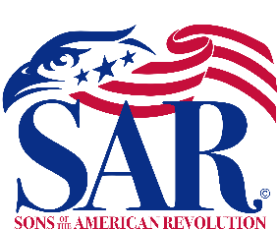
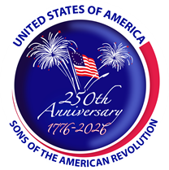
Sons of the American Revolution
California SAR
Kern Chapter

For Immediate Release:

In the Spirit of ’76, the Kern Chapter of the Sons of the American Revolution (SAR) is hosting a community ceremony as part of a nationwide endeavor of the National SAR celebrating the American 250 Project, honoring the 250th anniversary of our nation this July 4th. The SAR Liberty Tree Project’s goal is to dedicate a tree in all 50 states and 250 trees by July 4th. We will be rededicating a Liberty Tree that was previously commemorated near the Visitors’ Center by the Veteran’s Memorial on Truxtun Ave. and installing a bench commemorating the original Liberty Tree in Boston, Massachusetts.

The ceremony will take place Saturday, April 11, 2026, at 1:30 pm. at 515 Truxtun Ave, Bakersfield, CA. Elected leaders will be in attendance. The order of events includes a musket volley, remarks from elected officials, and the dedication of the bronze plaque and granite bench. We would be honored to have you attend. Below is some information about the original Liberty Tree.

The Liberty Tree (1646–1775) was a famous elm tree that stood in Boston near Boston Common, in the years before the American Revolution. In 1765, colonists in Boston staged the first act of defiance against the British government at the tree. The tree became a rallying point for the growing resistance to the rule of Britain over the American colonies, and the ground surrounding it became known as Liberty Hall. In 1775 the British had enough of these rebellious rallies at the Liberty Tree and had it cut down.

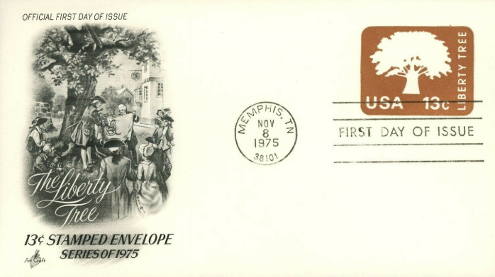
Sincerely,

Bruce Wearda
Kern Chapter SAR Vice President
Kern Chapter SAR America 250 Chair
CA SAR Youth Video Chair
CA CAR Sr. Chaplain
CAR Betsy Ross Vice President

