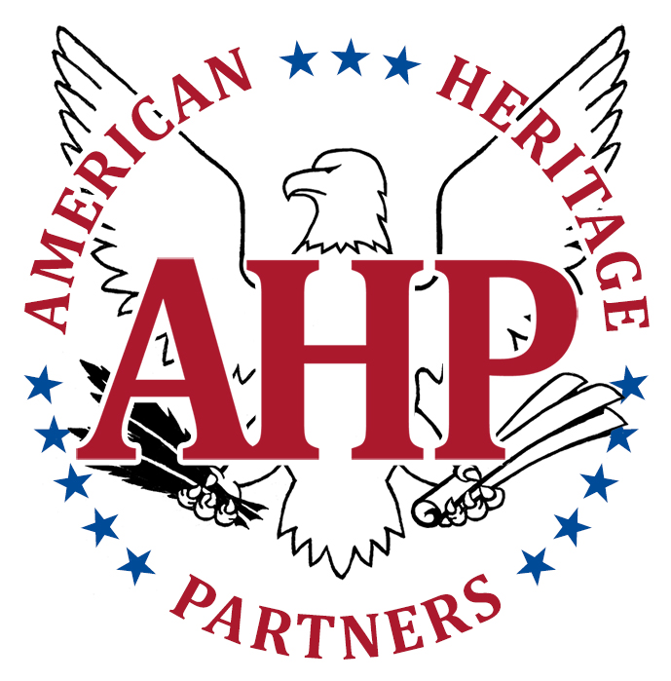

American Heritage Partners Invites You to a Special Luncheon

A Celebration of the 250th Anniversary of The Second Continental Congress, and the Beginnings of an Independent Nation of Free People

With Our Special Guest: Founding Father John Adams

Where: North Tahoe Events Center, Kings Beach, California
When: May 10, 2025

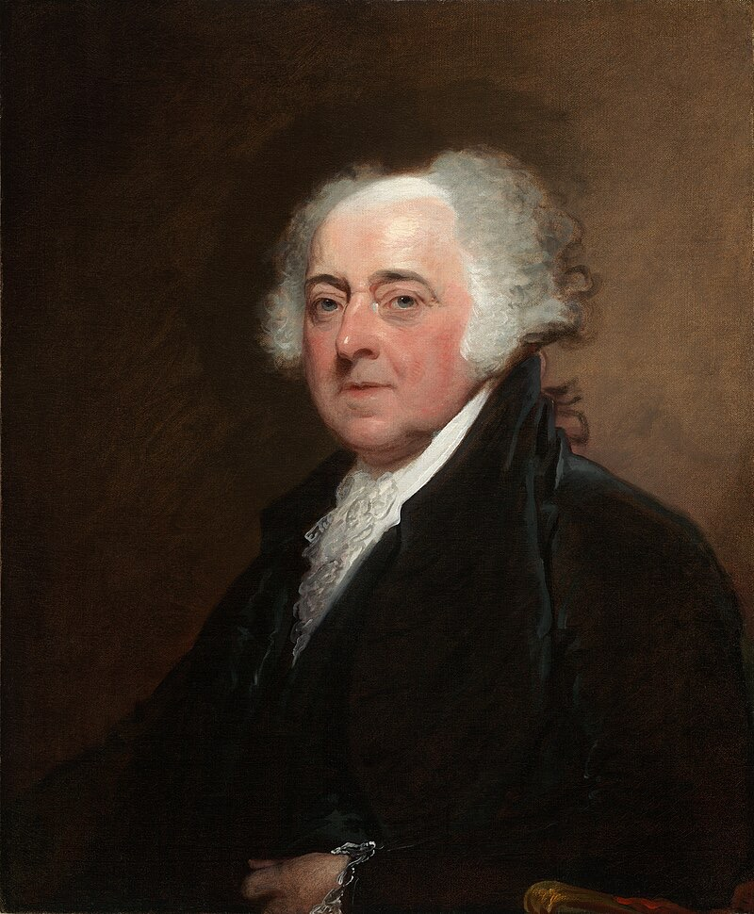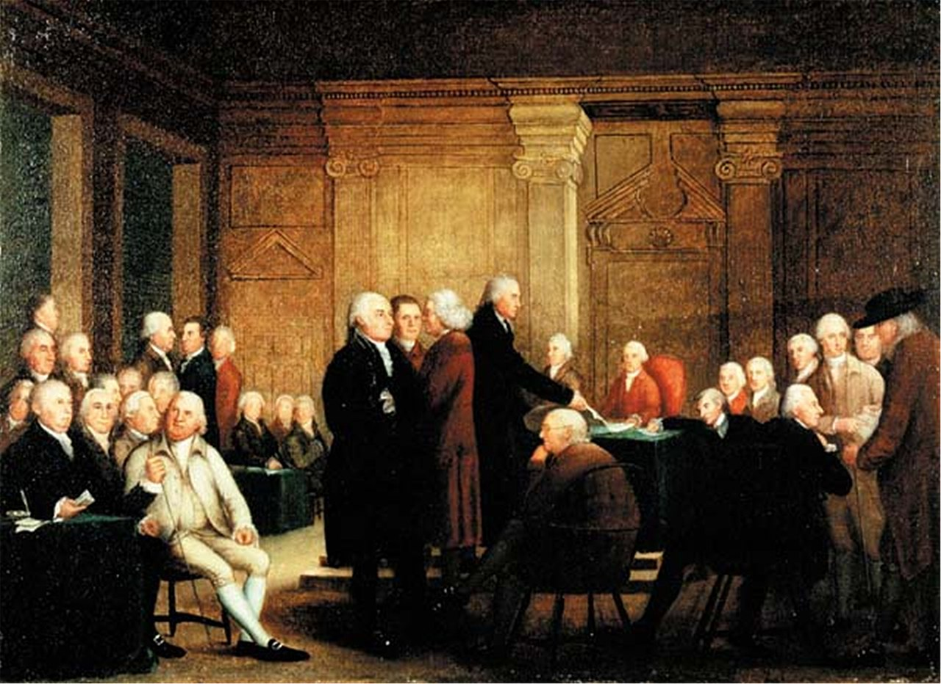

Join American Heritage Partners for a special luncheon on May 10, 2025 in Lake Tahoe, California, featuring a performance by noted impersonator Mike Lebsock. Mr. Lebsock will appear as John Adams, speaking to us after the end of the Revolutionary War. Mr. Adams will share with us his recollections of the momentous events that took place in Philadelphia in May 1775, following the outbreak of the American Revolution in April 1775 at Lexington & Concord. It was on May 10, 1775 that the Second Continental Congress convened at Carpenter Hall to begin deliberations over the way forward: to seek peace with Great Britain, or to seek independence? Congress decided to do both. John Adams was at the center of these sessions, and was a guiding force in the drafting of the “Declaration of the Cause and Necessity of Taking Up Arms.” Mr. Adams will recall for us the sometimes-heated debates that took place at Carpenter Hall, and the behind the scenes negotiations that took place in nearby taverns by the likes of Samuel Adams, John Hancock, Benjamin Franklin, Thomas Jefferson, Patrick Henry, and other famous Founding Fathers.

You won’t want to miss this stirring performance, and help us celebrate the 250th anniversary of the Second Continental Congress! Registration for our May 10 event will open in mid-March.

