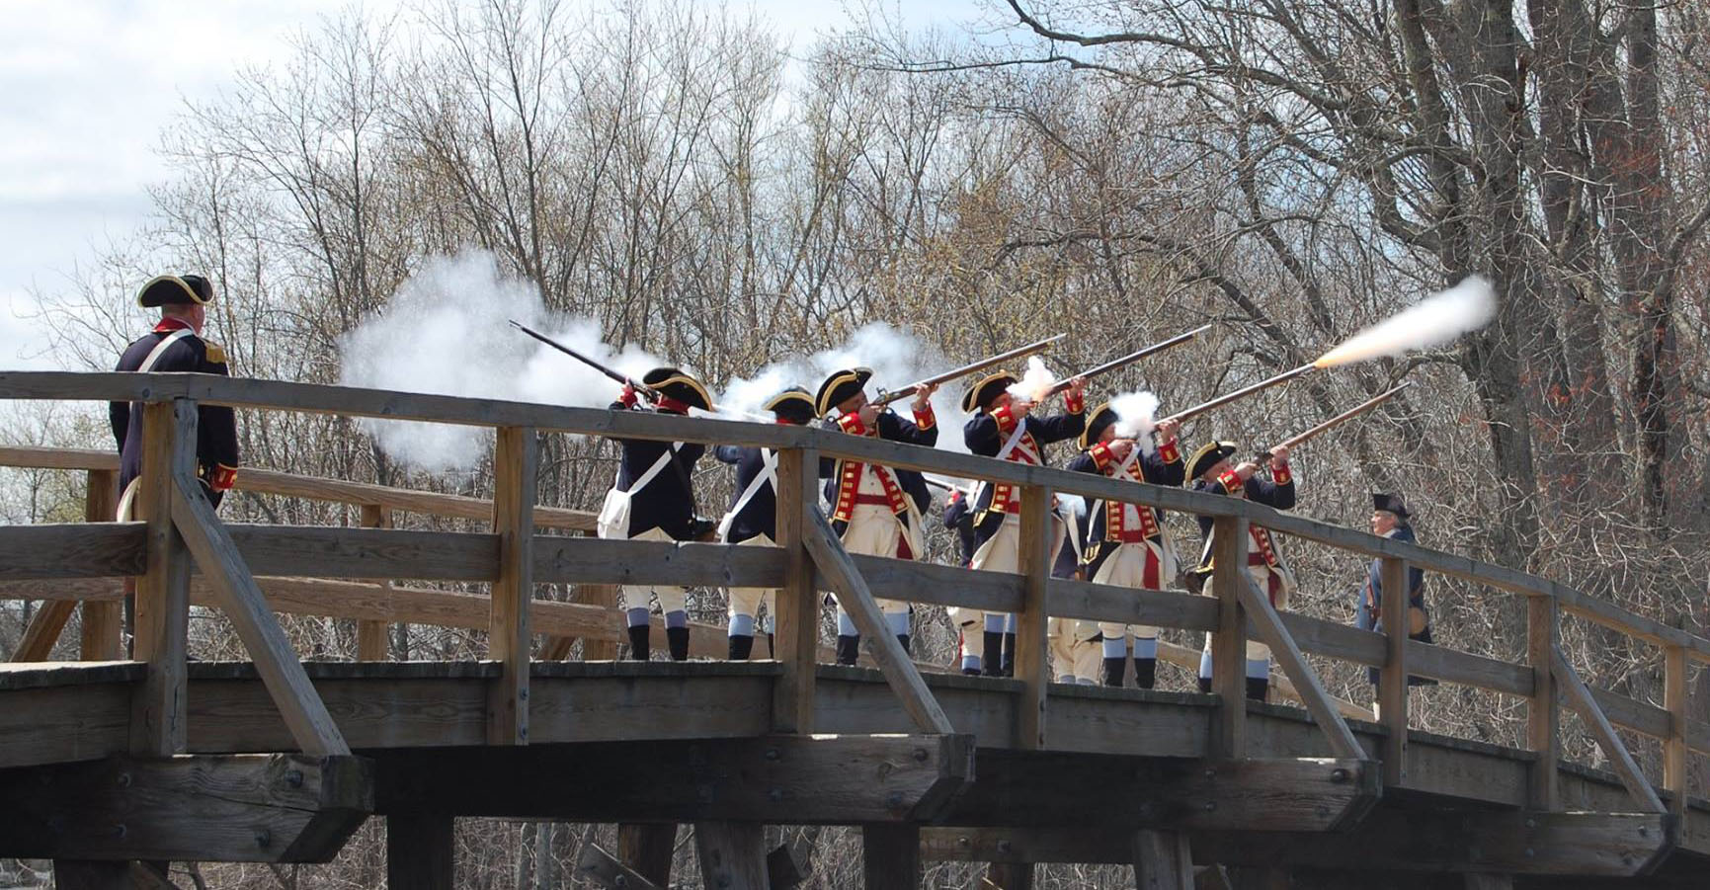

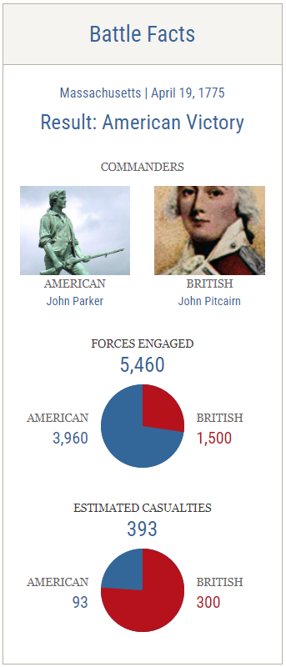
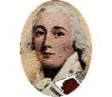
The “shot heard 'round the world”, a phrase long associated with the Battles of Lexington and Concord on April 19, 1775 (now commemorated as Patriots' Day), marks the beginning of the American Revolutionary War.
On the night of April 18, 1775, the Sons of Liberty learned of the plan to send the Grenadier and Light Infantry companies from General Thomas Gage’s army to Concord to capture and destroy munitions hidden in Concord. Dr. Joseph Warren ordered Paul Revere to cross over to Charlestown by water and William Dawes to ride out by Boston Neck at 10:00 PM to spread the alarm. They had arranged a signal to be shown in the tallest church steeple in Boston to inform them of the army’s route of march. Two lanterns are seen in the in the Old North Church steeple signifying the regulars will be coming across Boston Harbor (“one if by land, two if by sea”). As Revere and Dawes rode through the surrounding towns others set out to join in the alarms along with church bells ringing and warning shots fired. Minutemen assembled on town greens along with other militia companies and by the time the regulars crossed Boston Harbor to Lechmere Point, word of their mission had already reached Concord.
British Light Infantry arrived in Lexington during the pre-dawn hours, where they encountered Captain John Parker and 70 men of the local militia. The militia quickly dispersed under pressure. A shot was fired—though it remains unknown whether by the British or the colonists—prompting the British regulars to fire a volley, killing seven and wounding one of the retreating militiamen. The regulars then proceeded to Concord, arriving at 8:00 AM. British commanders Lt. Colonel Francis Smith and Major John Pitcairn established their headquarters at Wright Tavern. While part of the British force searched the town for military supplies, several companies were ordered to secure the North Bridge across the Concord River, while others continued to Barrett Farm, where more munitions and powder were believed to be stored.
Col. James Barrett and Major John Buttrick organized their minute men and militia on a hill overlooking North Bridge. Upon seeing smoke rising from the center of Concord, they believed the British soldiers were setting the town on fire. Determined to come to the town's aid, Col. Barrett and his officers formed a column, with the Acton minute men leading, and marched toward North Bridge. When the British regulars saw this, they retreated and prepared to defend themselves. The regulars opened fire, instantly killing Captain Isaac Davis, Private Abner Hosmer, and Fifer Luther Blanchard, while wounding three more Acton men. Standing just feet from his home, Major Buttrick gave the immortal command: 'Fire, for God’s sake, fire!' The American minute men and militia returned fire, killing three British regulars and wounding nine others. This exchange is considered the 'shot heard 'round the world.'
By noon, Lt. Colonel Smith ordered his soldiers to retreat to Boston. They had been on the move for more than 12 hours and still faced a 17-mile march to the safety of the city. Along what is now known as Battle Road, the British column was attacked on all sides by thousands of angry minutemen. Just before reaching Lexington, Massachusetts forces, seeking revenge for the morning’s bloodshed, launched a series of devastating assaults. Exhausted and low on ammunition, food, and water, the British soldiers were routed.
In Lexington, they were met by a relief force under British Brigadier General Hugh, Lord Percy. Under the cover of Percy’s fresh troops, Lt. Colonel Smith's men rested for half an hour and tended to their wounded. For the next 12 miles, which took over four hours to march, the regulars were continuously fired upon by minute men taking cover. The heaviest casualties for both sides occurred during the march through Menotomy (now Arlington), where the fighting became 'house-to-house.' At the Jason Russell House, 12 militiamen were killed in a single room.
Lord Percy saved the remainder of the British column by marching them to Charlestown instead of Boston, as the bridge over the Charles River was held by American militia forces. By the end of the day, British casualties numbered 73 killed, 174 wounded, and 26 missing. American casualties were 49 killed, 41 wounded, and 5 missing.
Sources: American Battlefield Trust (https://www.battlefields.org/learn/revolutionary-war/battles/lexington-and-concord); Minute Man National Historic Park (https://www.nps.gov/mima/learn/historyculture/april-19-1775.htm)
Itinerary of Events
Date | Time | Location | Event
April 18 | TBD | Boston | 250th Reenactment of Paul Revere’s Ride at Old North Church
 | TBD | Lexington, MA | 250th Anniversary Reenactment of Paul Revere’s Midnight Ride
April 19 | 5:30 AM | Lexington, MA | 250th Anniversary Battle of Lexington Green (Reenactment)
 | 6:00 AM | Concord, MA | Dawn Salute @ Old North Bridge
 | 7:30 AM | Concord, MA | *MASSAR Color Guard Wreath Laying at Old Hill Burying Ground
 | 8:30 AM – 12:00 PM | Concord, MA | Concord Parade Step-off
 | 2:00 PM – 4:00 PM | Lexington, MA | Lexington Patriot’s Day Parade
 | 5:00 PM | Concord, MA | Freedom Fest ’25 (Music Festival & Light Show)
 | 6:00 PM – 10:00 PM | Boston Marriott Burlington | *MASSAR Patriots Day Banquet
April 20 | TBD | TBD | Church Service
 | 2:00 PM | Arlington, MA | Battle of Menotomy Reenactment at Jason Russell House
 | TBD | Lexington & Concord | *Tour historic Lexington and Concord
 | TBD | Lexington, MA | Lexington, MA
April 21 | AM | Concord, MA | North Bridge Programs (NPS)
 | PM | Lincoln & Concord | Concord & Lincoln, MA PM - Battle Road Hike
* SAR / MASSAR / NEDC hosted event
Boston Marriott Burlington is offering your special group rate for 169.00 USD per night (April 18-20, 2025)
- Last Day to Book : Friday, March 28, 2025

Use the URL to receive the special SAR Rate:
https://www.marriott.com/event-reservations/reservation-link.mi?id=1727457730455&key=GRP&guestreslink2=true

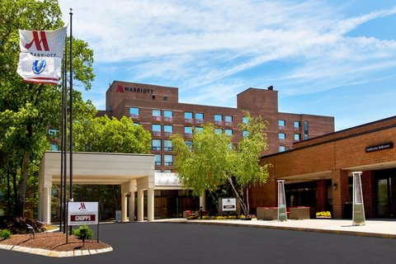
One Burlington Mall Road
Burlington, MA 01803
(781) 229-6565

https://www.marriott.com/en-us/hotels/bosbu-boston-marriott-burlington/overview/
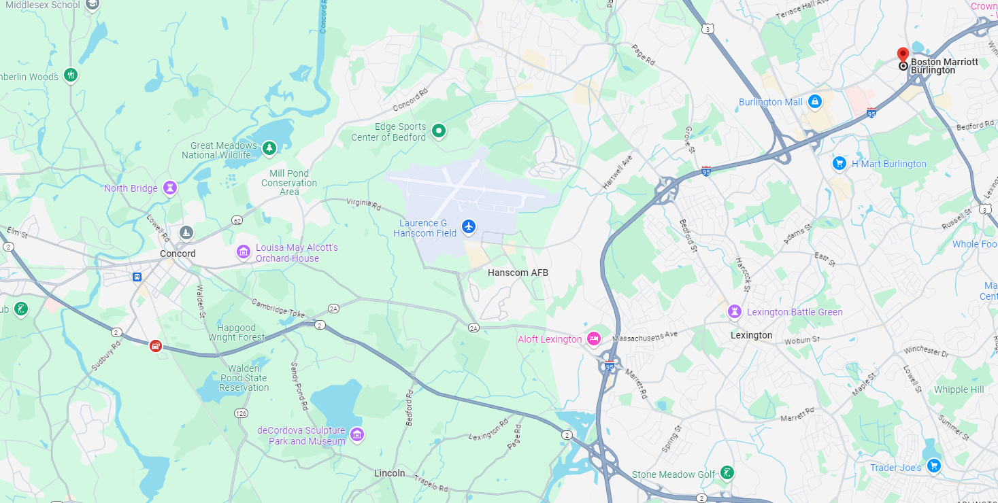
Double-click to open in browser.
Recommended Airport: Boston Logan
Places / Points of Interest in the greater Boston area: (All free unless otherwise noted)

Lexington
The Belfry (https://www.tourlexington.us/listing/the-old-belfry/)
Buckman Tavern (https://www.tourlexington.us/listing/buckman-tavern-1710/)
Hancock-Clarke House (https://www.tourlexington.us/listing/hancock-clarke-house-2/)
Lexington Battle Green (https://www.tourlexington.us/tours/battle-green-tour/)
Munroe Tavern (https://www.tourlexington.us/listing/munroe-tavern-1735/)
Scottish Rite Masonic Museum & Library (https://www.srmml.org/)

Concord
Battle Road Trail (https://www.nps.gov/mima/planyourvisit/the-battle-road-trail.htm)
Concord’s Colonial Inn (https://www.concordscolonialinn.com/)
Hartwell Tavern (https://www.nps.gov/thingstodo/visit-hartwell-tavern.htm)
Louisa May Alcott's Orchard House (https://louisamayalcott.org/) [$15/person]
Minute Man National Historical Park (https://www.nps.gov/mima/planyourvisit/minute-man-visitor-center.htm)
The Old Manse (https://thetrustees.org/place/the-old-manse/)
Old North Bridge (https://www.nps.gov/mima/planyourvisit/north-bridge-visitor-center.htm)
Walden Pond (https://www.mass.gov/locations/walden-pond-state-reservation) [$30/person non-MA residents]

Boston
Site of the Boston Massacre (http://www.bostonmassacre.net/)
Boston Tea Party Ships & Museum (https://www.bostonteapartyship.com/) [$35/person]
Bunker Hill Monument (https://www.nps.gov/bost/learn/historyculture/bhm.htm)
Dorchester Heights Monument – Siege of Boston (https://www.nps.gov/bost/learn/historyculture/dohe.htm)
Faneuil Hall Marketplace (https://faneuilhallmarketplace.com/)
Freedom Trail (https://www.thefreedomtrail.org/)
Granary Burying Ground (https://www.boston.gov/cemeteries/granary-burying-ground)
Green Dragon Tavern (https://www.greendragonboston.com/)
Longfellow House-Washington's Headquarters National Historic Site (https://www.nps.gov/long/index.htm)
Old North Church (https://www.oldnorth.com/) [$5/person]
Old South Church in Boston (https://www.oldsouth.org/)
Old South Meeting House (https://www.nps.gov/bost/learn/historyculture/osmh.htm) [$15/person]
Old State House (https://revolutionaryspaces.org/discover/old-state-house/?gad_source=1)
Paul Revere House (https://www.paulreverehouse.org/) [$6/person]
USS Constitution (https://www.navy.mil/USS-CONSTITUTION/)
USS Constitution Museum (https://ussconstitutionmuseum.org/) [$10/person]
Grand Lodge of Masons of Massachusetts (https://massfreemasonry.org/grand-lodge/)

Greater Boston
Adams National Historical Park (https://www.nps.gov/adam/index.htm)
Longfellow's Wayside Inn (https://www.wayside.org/)
JFK Presidential Library (https://www.jfklibrary.org/)
Plymouth Rock (https://seeplymouth.com/listing/plymouth-rock/)

