To Sleep, Perchance to Dream
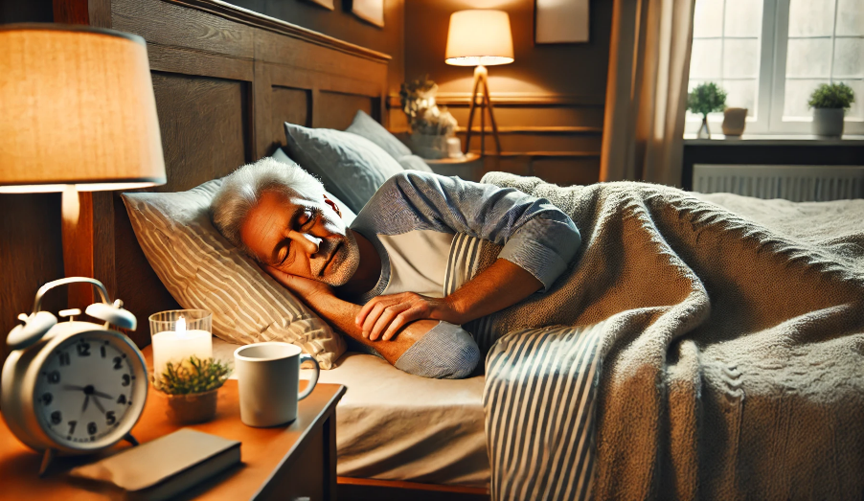

Last night, around 3:00 AM, I was lying in bed, wide awake…. thinking about sleep. It’s ironic how much we think about sleep when it eludes us.
I've dealt with intermittent insomnia my entire adult life. Some nights, I barely get two or three hours of sleep, while other nights, I manage six, seven, or even eight. What causes insomnia one night but not another? I still don't have a clear answer.
Like many people, I’ve spent a lot of time thinking about how to get to sleep. I’ve read about sleep hygiene, tried herbal remedies and prescription medications, and experimented with different techniques. Lately, I’ve been using a sleep mask with some limited success—since I’m easily awakened, it helps block out disruptions.
But in one of those middle-of-the-night revelations, I realized that while I’ve spent years thinking about sleep, I’ve never really stopped to ask: What exactly is sleep, and why do we need it?

What Is Sleep?
We spend about 25–30% of our lives asleep, yet how often do we stop to consider what sleep really is?
Merriam-Webster defines sleep as:
"The natural, easily reversible periodic state of many living things that is marked by the absence of wakefulness and by the loss of consciousness of one's surroundings, is accompanied by a typical body posture (such as lying down with the eyes closed), the occurrence of dreaming, and changes in brain activity and physiological functioning…."
That’s a bit of a mouthful. Put simply, sleep is a natural state in which the body and mind take a break—but the brain remains surprisingly active.
Our bodies crave sleep just as they crave food. The difference? You can choose not to eat, but eventually, your body will force you to sleep.
Scientists still don’t fully understand why we sleep. It was once thought to be a passive state where the brain simply shut down, but neurologist and sleep specialist Mark Wu, MD, explains otherwise:
"Sleep is a period during which the brain is engaged in a number of activities necessary to life, which are closely linked to the quality of life."
In other words, sleep isn't just a pause—it’s an active and vital process.

The Cycle of Sleep
Most people have heard of sleep cycles, but they’re worth revisiting because they explain why some sleep feels restorative and some doesn’t.

There are two main types of sleep:
- Non-REM (NREM) sleep, which has three stages
- Rapid Eye Movement (REM) sleep, where most dreaming occurs
The Three Stages of Non-REM Sleep
- Stage 1: The lightest stage, as your brain waves begin to slow and your body transitions into sleep.
- Stage 2: A deeper stage where heart rate and breathing slow, body temperature drops, and muscles relax. This is where we spend most of our sleep time.
- Stage 3: The deepest sleep stage, crucial for feeling rested. Heart rate and breathing are at their slowest, and brain waves are at their lowest activity level.
REM Sleep
About 90 minutes after falling asleep, REM sleep begins. In this stage:
- The brain becomes more active—closer to wakefulness.
- Breathing speeds up, and heart rate and blood pressure rise.
- The eyes move rapidly under the eyelids (hence the name “Rapid Eye Movement”).
- Most dreams occur.
- The body experiences temporary paralysis thought to prevent acting out dreams.
As we age, we spend less time in REM sleep, which may be why older adults sometimes experience fragmented sleep.

What Happens When We Sleep?
If we spend nearly a third of our lives sleeping, there must be a good reason, right? Surely, sleep isn’t just a way to pass the time until we have something better to do.
Historically, scientists proposed several theories:
- Evolutionary Theory: Animals sleep during vulnerable periods (e.g., at night) to avoid predators. But this seems counterintuitive—wouldn’t it make more sense to be alert during periods of danger?
- Energy Conservation Theory: Sleep reduces energy demands, meaning less frequent need for food. This makes sense for species living in food-scarce environments.
More recent research suggests that sleep serves a far more critical role: it allows the brain to clear out waste products that accumulate while we’re awake, making it function more efficiently.
Beyond that, sleep is vital for:
- Memory Consolidation: Sleep helps convert short-term memories into long-term ones, making learning more effective. This may explain why a good night’s sleep is often better than an all-night cram session before an exam.
- Cognitive Performance: Sleep improves concentration, problem-solving, and decision-making.
- Physical Health: Sleep regulates hormones related to metabolism, appetite, and growth. Poor sleep has been linked to conditions like obesity, diabetes, and hypertension.
- Immune Function: Sleep strengthens our immune system, helping to fight infections. Prolonged sleep deprivation increases vulnerability to illness.
- Emotional Well-Being: Chronic poor sleep is associated with anxiety, depression, and mood instability.

Final Thoughts
Sleep isn’t just rest—it’s an investment in memory, health, and overall well-being. The more we understand its role, the more we can appreciate its importance.
I’ll leave you with two quotes that capture the essence of why sleep matters:
"Sleep is an investment in the energy you need to be effective tomorrow."
—Tom Rath, American author and consultant
"Sleep is the golden chain that ties health and our bodies together."
—Thomas Dekker, 17th-century English poet and playwright

