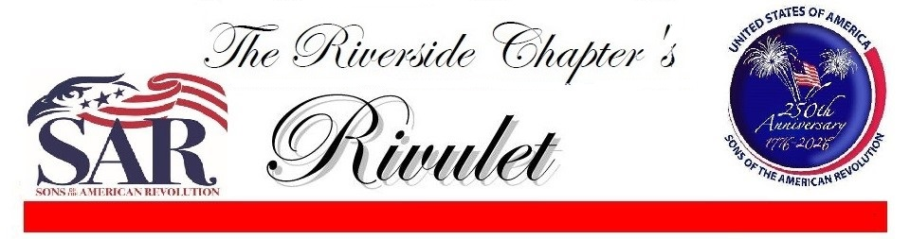February 2025
Dear Compatriots:

Nearly 250 years ago our founding fathers outlined in the US Constitution how the United States was to be governed. One of those was the peaceful transition of power. We just witnessed this event. It proves just how wise the Founding Fathers were, and what our Patriot ancestors fought for in the Revolutionary War.

We have completed another successful year. Last year we had 2 major accomplishments. The Riverside Chapter has provided programs to celebrate the American 250th Anniversary. Chapter members have been awarded 13 Bronze, 11 Silver and 4 Gold Medals. Roger Cooper continues to provide excellent programs at our meetings. Our other major accomplishment was A Salute to Veterans Parade in Riverside. Led by David Leonard, with assistance from other SAR Chapters, the SAR provided live musket fire during the parade, contributing to a successful event. I had the pleasure of attending an Eagle Scout Court of Honor for one of our Junior Members, Edward Cahill.
.

Michael Mann, President

President’s Message
February Meeting
(Note Special Date)
Date: February 18, 2025
Tuesday 11:30 AM

Location: Cactus Cantina
Mission Grove Center
151 E. Alessandro Blvd
Riverside, CA

Program: The Southern Campaign
Part 2 Savannah, GA

RSVP Not Required



Steve Stallings February 10
Reed Roberts February 18
John Myers III February 20
Greg Couch February 22
James Breker February 25

We start the new year with largely the same officers as last. Thank you those who are staying on for another year.
President’s Message, Continued

Riverside Chapter Officers for 2025
President
Michael Mann
mikeronie@earthlink.net

1st Vice President
William Vining
viningb@gmail.com

2nd Vice President
Roger Cooper
crogercooper@gmail.com

Secretary
Gene Justin
genejustin01@aol.com

Treasurer
John Matulich
johnmmatulich@gmail.com

Registrar
David Leonard
leonarddla@earthlink.net

Appointed Positions

Chaplain
Wayne Rogers
roger-wayne1@hotmail.com

Historian/Newsletter Editor David Leonard
leonarddla@earthlink.net

Color Guard Commander
Brian Stephens
briandi777@aol.com

Scout Coordinator
Mike Heckenlaible
CALegionEagle@gmail.com

JROTC/Sea Cadets Coord.
John Matulich
johnmmatulich@gmail.com

Roger Cooper 2nd VP, Gene Justin Secretary, John Matulich Treasurer, Brian Stephens Color Guard Commander, David Leonard Historian, and Wayne Rogers Chaplain. We welcome those in new positions They include Bill Vining 1st VP, David Leonard Registrar and Henry Lucas Genealogist. A big thank you to Hal Cardwell as 1st VP, and Henry Lucas as Registrar, for your work with the board.
My goal for the year is to have all of our America 250 participants receive Gold Medals. I am also looking forward to the Veterans Parade in November.
Michael Mann, President
Meeting Program for February

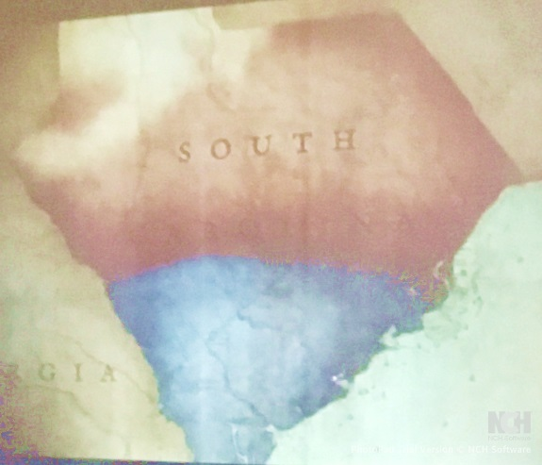
Compatriot Roger Cooper has announced a ten-month program covering on the southern campaign of the American Revolution. The ultimate success of this campaign would lead to an American victory and Independence. The February meeting will focus on the invasion of Savannah, GA by British forces on 28 December 1776.

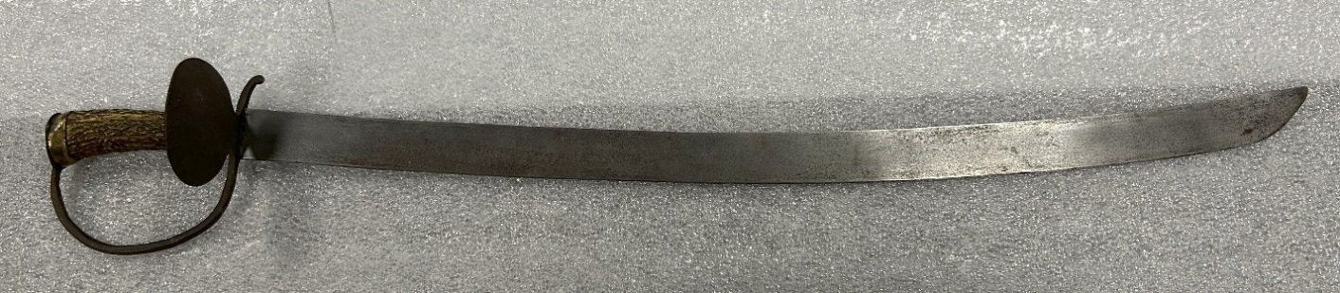
The Riverside Chapter honored the memory of former member Chuck Lampman with the purchase of an artifact, sought by the National Society SAR, to be displayed in the SAR Museum in his memory. The artifact is an American Cutlass sword, c 1760-1780, (shown below). Chuck was born on 5 October 1936 in Catskill, NY, and developed a distinguished career in the US Navy, rising to the rank of Commander. His last duty assignment was serving as the Commander of the Naval Weapons Station in Norco, CA, in the vicinity of Riverside CA. It is fitting that Chuck died on July 4, 2024. He remained a Riverside Chapter member until his death.

Riverside Chapter SAR Honors Commander Charles ‘Chuck’ Lampman Jr.

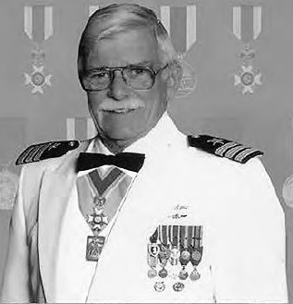
Chuck had joined the Empire State SAR in 1993, but transferred to the Riverside Chapter SAR in 1997. Chuck became a Life Member. He was a charter member of the Riverside Chapter Color Guard. He was elected President of the Chapter in 1998. Riverside won a Best Chapter award that year. Chuck was awarded the prestigious Patriot Medal by the California Society in 1999. He was awarded the Liberty Medal the following year. He was elected Executive Vice President California Society in 2000, and became State President in 2001.

Chuck was a scholar and public speaker on subjects associated with the American Revolution. These included the Causes, Declaration of Independence, Constitution and Federalist Papers, and Spain’s Role during the American Revolution.

Chuck performed extensive service as a color guardsman. He performed services at numerous chapter and state events. He served as the National Society Color Guard Commander in 2006-2007. He was a co-author of the National Society Color Guard Manual. He received the National Society Gold Color Guard Medal in 2004.

Other awards Chuck earned were the Viet Nam Service Medal (1996), DAR Founders Medal (1999), California Society Distinguished Service Medal (2003), and the National Minutemen Award (2006).
Commander ‘Chuck’ Lampman Jr Continued
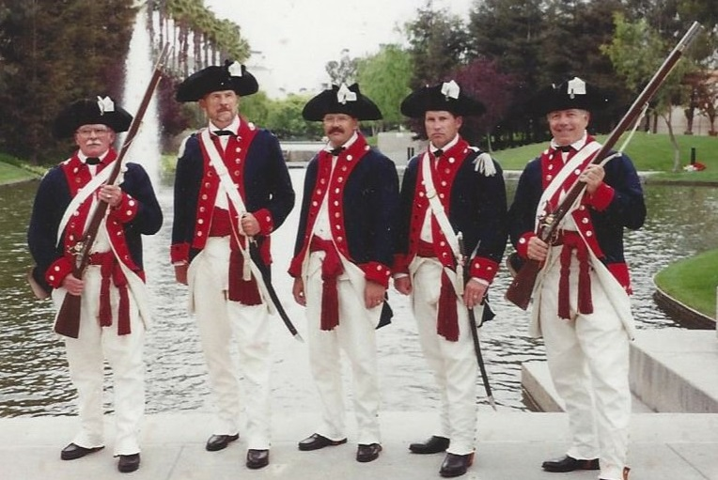

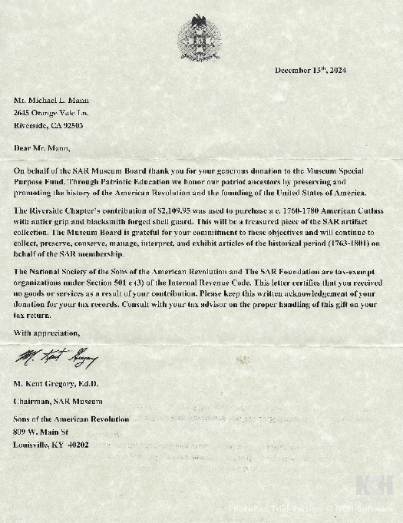

Original Riverside Chapter Color Guard 1997.

L-R Chuck Lampman, Hal Ramser, David Leonard, Bill Vining, Ed St. Germain

Letter of thanks from Dr. M. Kent Gregory, Chairman, NSSAR Museum for Riverside Chapter’s donation of an American Cutlass Sword for the NSSAR Museum. This was done in memory of Charles ‘Chuck’ Lampman.

January 2025 Meeting Highlights
for 2025
Induction of 2025 Officers

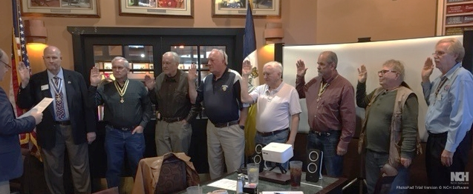
CASSAR Vice President South Brandon Villardi (left) administers the oath of office to the incoming Riverside Chapter officers. From left: Mike Mann, President; Bill Vining 1st VP; Roger Cooper 2nd VP; John Matulich, Treasurer/Scout Coordinator, Gene Justin, Secretary; David Leonard, Registrar; Wayne Rogers, Chaplain; and Brian Stephens, Color Guard Commander. Not shown: Mike Heckenlaible, Scout Coordinator

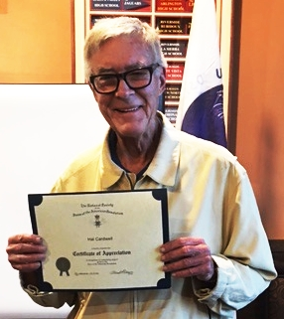
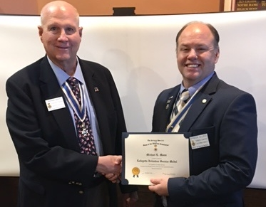
Mike Mann received the Lafayette Service Medal and Certificate for volunteer work Hal Caldwell received a Certificate of performed at the NSSAR Headquarters in Appreciation for his assistance at
Louisville, KY or other significant volunteer the Salute to Veterans Parade in
work as determined by the President General. November
Mission Statement
The Riverside Chapter was chartered by the California Society, Sons of the American Revolution in 1943 under the guidelines of the National Society, Sons of the American Revolution. The Mission Statement of the National Society states that The Sons of the American Revolution honors our Revolutionary War patriot ancestors by promoting patriotism, serving our communities, and educating and inspiring future generations about the founding principles of our country.
Upcoming Events

February 16 Massing of the Colors and Salute to Our Armed Forces, Forest Lawn Cemetery Hollywood Hills, 3:00 PM
February 22 George Washington’s Birthday Dinner, Green Dragon Tavern and Museum, Carlsbad, CA, Military Parade and Musket Volley. Business attire, 5:00 PM
$90.00 per person before Feb. 12. $100 per person after February 12.
Reservations: https://www.sarsandiego.org/2025/01/18/george-washington- birthday- dinner-signup-open/

_____________________________________________________________________________
The Riverside Chapter’s
Rivulet
David M. Leonard, Editor
3375 Pachappa Hill
Riverside, CA 92506
Email: leonarddla@earthlink.net

