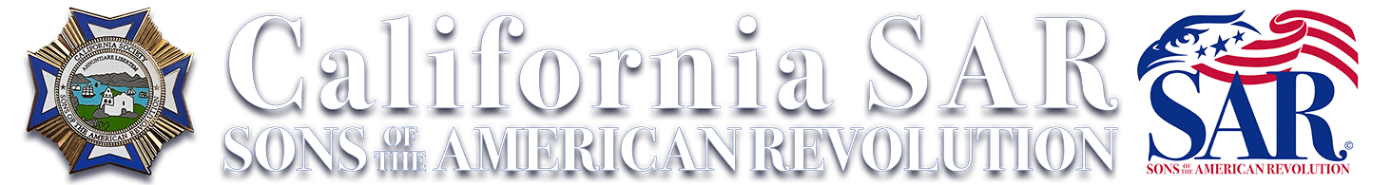 | 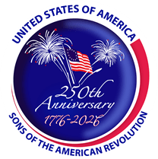

Fall Board of Managers Meeting
151st MEETING · CALIFORNIA SOCIETY · SONS of the American Revolution
November 5–7, 2026 | The Westin San Francisco Airport · Millbrae, CA

HOTEL Special group rate $149/night until October 16. Parking onsite · Free Wi-Fi.
Reserve online: Westin group booking link or call (650) 692-3500.

Registrant Information

Name | Spouse / Guest
Chapter | Title
Address | Phone
City / State / Zip | Email
Arriving: ☐ Thu, Nov 5 ☐ Fri, Nov 6 ☐ Sat, Nov 7
First-time attendee at a CA SAR meeting? ☐ Yes ☐ No

REGISTRATION $310 per person by Oct 16 · $325 after
Includes the Friday Meeting, Saturday Luncheon, and Gala Banquet.
Registrants: _____ @ $310 Late: _____ @ $325 Total $__________

Meal Selections

Saturday Youth Awards Luncheon | # Meals | Saturday Gala Banquet | # Meals
Grilled Beef Flat Iron | ______ | Beef Short Ribs | ______
Grilled Chicken Breast | ______ | Tomahawk Pork Chop | ______
Vegetarian Dish | ______ | Vegetarian Dish | ______
Non-registered guest meals: Saturday Luncheon $100 #___ = $______ Gala Banquet $125 #___ = $______

Optional Activities — Explore San Francisco

Space is limited, reserve early
Alcatraz Civil War Tour · Alcatraz Island | $50 / person #___ = $______
Friday Night SF Bay Dinner Cruise · plated dinner · 2.5 hrs | $150 / person #___ = $______

TOTAL ENCLOSED $________________

PAYMENT Make checks payable to Yosemite Chapter SAR and mail with this form to Randy Dhindsa, 1771 N Twinberry Ave., Clovis, CA 93619.
Or register and pay online at fallbom.cheddarup.com. Registration & meal reservations close October 20.
Questions? Contact Randy Dhindsa — genealogy@dhindsafamily.com

