Knights of Columbus Easter Season Wrap-up
The Knights of Columbus would like to thank all who joined us for friendship, fellowship and community during this Lenten Season and now into the Easter season.
The season started with a Mardi Gras potluck dinner held on Shrove Tuesday, February 17, and will continue through a Burger Night Dinner, following the 5:00 p.m. Vigil Mass on April 18 and our Pancake Breakfast following all Masses on Sunday, April 19.
The Mardi Gras dinner was an evening of fun, fellowship, and community in a festive atmosphere. Attendees dined on gumbo, jambalaya, and red beans and rice. After dinner they feasted on a king cake for dessert. King cakes, a New Orleans tradition, are covered with icing representing Mardi Gras colors, green, purple, and gold. A small trinket, in this case a tiny plastic baby, was hidden inside the cake. Tradition holds that whoever finds the trinket in their cake slice will have luck and prosperity in the coming year.
The Mardi Gras dinner was followed by 6 Lenten Soup Dinners held on Fridays in Lent, where the average attendance was over 150 people each night. The Knights supplied grilled cheese sandwiches, Mac and Cheese, pierogies, pizza, salad and desserts. Many of our attendees also brought a dish to share, including favorite salads, homemade soups, salmon cakes, Mac and Cheese, and pizza. The Knights are very grateful for the monetary donations from our participants. The donations will be used to support Knights of Columbus charitable activities.
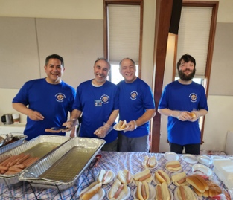
Easter Sunday saw the arrival of the Knights Easter Egg Hunt. Keen observers heard the hippity hop of bunnies bouncing through the area as the Easter Bunny readied himself to join the Knights for an afternoon of fun. The hunt was open to children in age groups 0-2, ages 3-5, ages 6-8, & ages 9-10.
The Hunt was held inside Seton Hall, due to a downpour of rain. We had over 300 participants who enjoyed hot dogs, chips and a drink before being released to lower Seton Hall to hunt for eggs. Thanks to our Knights of Columbus chefs and servers, from left to right, Jeff Carrera, Joseph Hocine Hadj-Ali, Kevin Tamai, and Daniel McGrail.
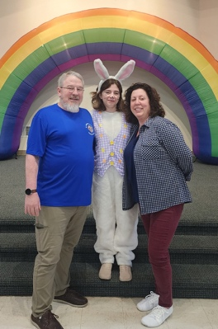
The Easter bunny joined the celebration and posed for pictures with our child attendees. The children were universally entranced by the very friendly Easter Bunny. Shown here is our Easter Bunny, Laurel Heath, along with her parents, Libby and Steve. Steve chairs the Knight’s Charity committee. Many thanks to Laurel for being such a happy and friendly Easter Bunny.
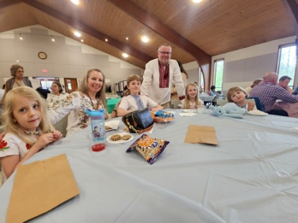
Among those enjoying Easter Egg Hunt were Tanner and Natalya Johnson and family. The family energized themselves with cookies and chips as they gathered their paper bags to collect Easter Eggs during the hunt.

Wrapping up the season is a Knights of Columbus Burger Dinner after the Saturday 5:00 p.m. Vigil Mass and a Pancake Breakfast after each of our Sunday Masses.
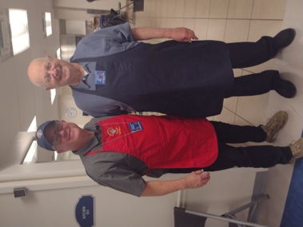
On Saturday the Knights chefs will provide a relaxing evening for family and friends with a delicious Saturday evening meal of burgers, Nathan’s Hot Dogs, potato salad, Mac and Cheese, chips and sodas. Sunday will find the Knights chefs once again tying on their aprons and preparing a pancake breakfast to bring friends and family together. Patrons will have a choice of blueberry or plain pancakes as well as our ever popular chocolate chip pancakes. Sausage, mixed fruit, coffee, tea, and juice will also be served. Our younger patrons can delight by adding colorful sprinkles and mountains of whipped cream to their breakfast creations. Show here are, from left to right, are Knights chefs John Loftus and Hector Dittamo.

The Knights would like to thank all those who joined us and enjoyed spending time with family and friends. Lastly, for any young Catholic Man, 18 years and older who wishes become a member of the Knights of Columbus, please reach out to Joe Pevarnik at 703-608-2050 or contact Joe through email@ joepevarnik@gmail.com.

