Welcome to the United Parish of Carver!
50th Anniversary
We're glad you came to visit. The full legal name of the church is the United Protestant Parish of Carver, however we refer to it simply as the United Parish. Our sanctuary dates back to 1824 and was originally the Baptist Church of Carver. In 1970 the Baptist, Congregational, and Methodist Churches combined to form the United Parish of Carver. Our church is a unique blend of people with different Christian backgrounds; American Baptist, United Church of Christ, United Methodist, and several others.
The sanctuary was the original building and our fellowship hall, where we have many potluck dinners, was a separate building, constructed in the mid 1950's. The formal name of the hall is the Annie Shurtleff Fellowship Hall and was dedicated in her memory on June 7, 1959. The addition connecting the sanctuary and fellowship hall was constructed in two stages during the 1980's. Our most recent addition is the Memorial Garden that graces the front of the building. Please stop there and enjoy this lovely spot.
It was a pleasure to have you with us and trust that your tour was a pleasant experience. We invite you to return on a Sunday morning for worship at 9:30 AM. We'd love to have you join us.
Thank you and God bless.

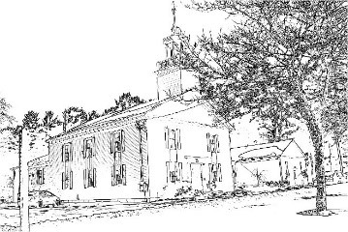

115 Main St. P.O. Box 980
Carver, MA 02330-0980
(508) 866-4493
unitedparishofcarver@gmail.com

