United Parish of Carver
We agree to Differ; Resolve to Love; Unite to Serve!
115 Main St. P.O. Box 980
Carver, MA 02330-0980
(508) 866-4493
unitedparishofcarver@gmail.com

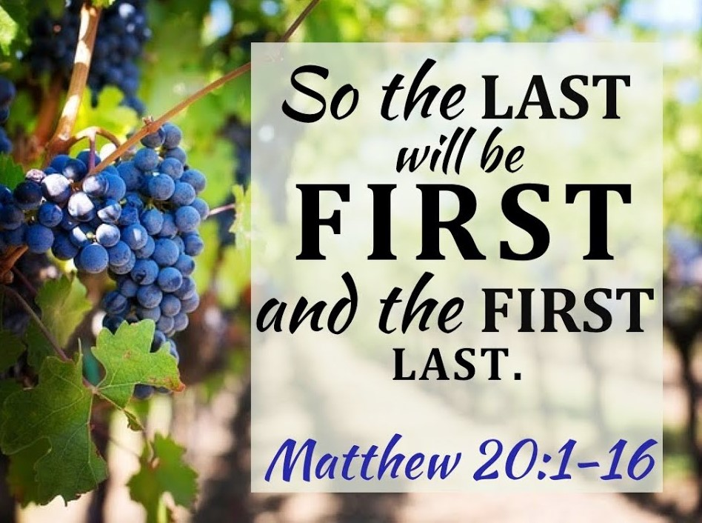

Sunday September 20, 2020

Words for Meditation: “God grant me the serenity to accept the things I cannot change, the courage to change the things I can and the wisdom to know the difference.” Reinhold Niebuhr’s “Serenity Prayer.”
Gathering Music:
Welcome and announcements
Invocation: (pastor)
Call to Worship
Leader: Rejoice, people of God! Celebrate the life within you, and Christ’s presence in your midst!
All: Our eyes shall be opened! The present will have new meaning, and the future will be bright with hope.
Leader: Rejoice, people of God! Bow your heads before the One who is our wisdom and our strength.
All: We are here to challenge and support one another.
Leader: We are here because we want to be God’s people.
All: Let us open our hearts to the moving of the Spirit, and prepare to leave this place as true disciples of Christ. Amen
Opening Music: #593 “Here I am Lord”
Call to Confession: (pastor)

Prayer of Confession: (unison)
There have been times when we’ve felt scattered about, disjointed, dried up, all our energy gone. There have been times when we been out of joint with your Spirit, unable to move, and unable to respond to your call Lord. Not trusting in your forgiveness or your power, we trust only in ourselves and our lives become selfless. May what was out of joint and incomplete become alive and may we become one body in Christ. Amen
Prayer of Assurance: (Pastor)
*“Glory Be to the Father” #70
Invitation to the offering (pastor)
Musical Offering
*Presentation of the offering and the Doxology
*“Praise God from Whom all Blessings Flow” #95
*Prayer of Dedication
Prayers of the People
Joys and Concerns
Silent Prayer
Morning Prayer followed by The Lord’s Prayer
Music: #402 “Lord I Want to Be a Christian”
Scripture: Exodus 16: 2-15; Matthew 20: 1-16
Closing Hymn: # 251 “Go Tell it on the Mountain”
Benediction
Postlude

Welcome!
We are glad you chose to worship with us and hope you sense the Spirit of Christ here. If you are visiting, please sign our guest book. If you are without a church home, we invite you to consider United Parish.

Thrift Shop
Open: Wed., & Sat. 10 AM -1 PM
9/13
Last Sunday in Worship: 35
On Zoom (11)
In Person (24)
Offering for Last Sunday: $1,227
Thrift Shop Weekly Receipts: $143

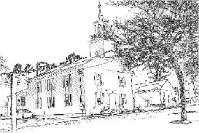
Ministry Team

Reverend William Ketchum, Pastor
Reverend Sharon Weber, Associate Pastor
Jenn Toomey, Administrator
Judy Sirrico, Organist
Jack Angley, Choir Director
Doreen Marando, Sexton
Rev. Robert Merritt and Rev. Dr. Charles Syverson, Pastors Emeriti

