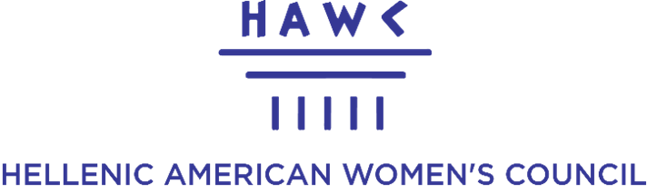
PRESENTS VARVARA ATHANASIOU-IOANNOU, AUTHOR OF ‘HER VOICE’
Workshop: The Five HER VOICE Questions
We will answer these questions and discuss in a safe space to reflect and give your experience a voice.
QUESTION 1 – Who are you?
My name is… I am … years old. I am a first/second/third-generation Greek American. My parents were born in… I was born in… I am married to a Greek/non-Greek… I am single/divorced… What else would you like us to know about you?

QUESTION 2 – What was it like growing up in America? Australia? Canada? Europe? Elsewhere?
What was it like growing up Greek and American or Other as a child and teenager? What did you love? What was difficult? Did you feel that you belonged to both worlds?

QUESTION 3 – What challenges did you face, and how did you overcome them?
Think about personal, cultural, family, educational, professional or identity-related challenges. How did you overcome them, and what did you learn from the experience?

QUESTION 4 – What are you proud of?
What achievement, decision, contribution, relationship or aspect of your life makes you proud?

QUESTION 5 – What advice would you give to a young woman today?
If you could speak to your younger self—or to the next generation of Greek-American women—what would you tell her?

