
TRIP Program

October is here! Time to start shopping for costumes and candy, along with cooler weather clothing! If you just plan on dining out or treating yourself, take time to evaluate your shopping needs and order your TRIP cards! If you are hosting or attending any fall gatherings start, your shopping with TRIP cards. There are many choices to…
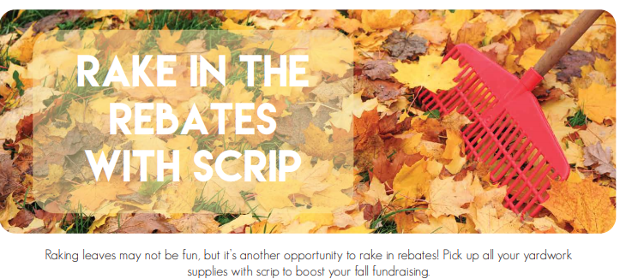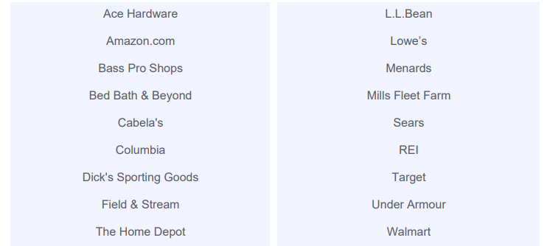
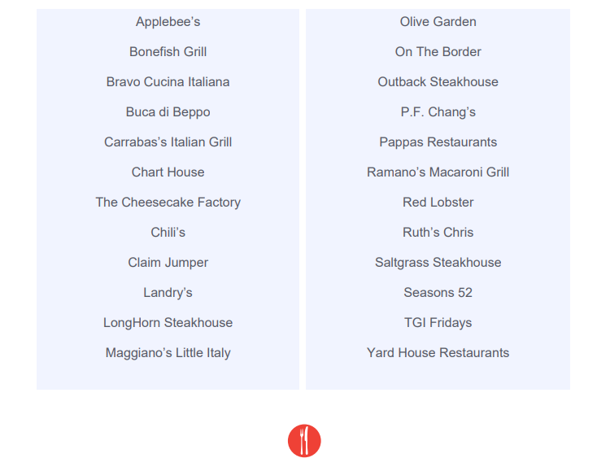

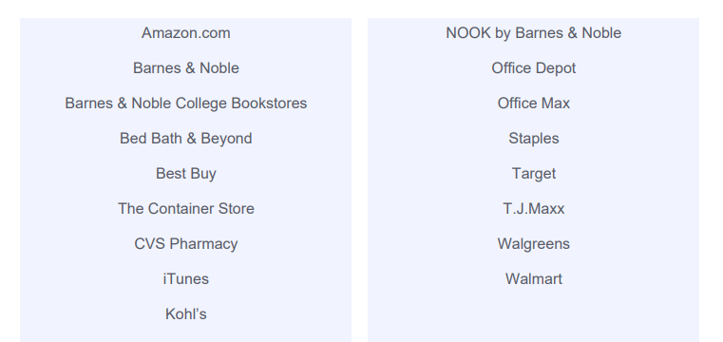

Why not receive a tuition reimbursement and take care of your household shopping needs at the same time? Remember to check the website www.shop.shopwithscrip.com for any special promotions, retailers may be running. Follow GLSC to get the most up-to-date promotions.
Great Lakes Scrip Center offers PrestoPay, a method we are currently enrolling school families and others interested in supporting the AH Miller Scholarship Program here at St Johns. The steps to get setup for PrestoPay to get scrips sent to your device for immediate use or to a computer to print out bar codes for use at restaurants, retailers or other providers are on the website. Also on the website are GLSC videos and more information about the process.
To learn more, pick up information in the school office or church narthex wall file folders or ask us: Amy Buonassisi (630-290-0268) and Sandra Pauley (708-362-2197). Here’s how it works you buy a $25 gift card or $100 gift card for the retailer of your choice and receive that gift card AND it’s easy! You can take advantage of this program for your own family or you can donate it for another family - - it’s simple.
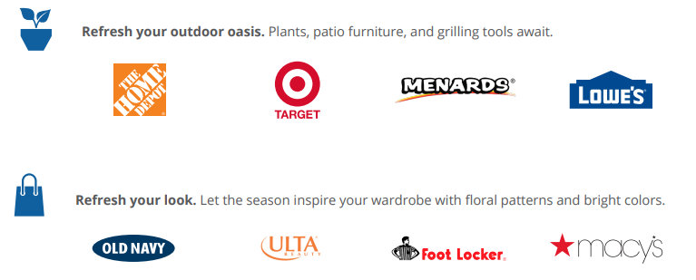

More information about the Back-to-School- Shopping Guide is on their website www.shop.shopwithscrip.com.



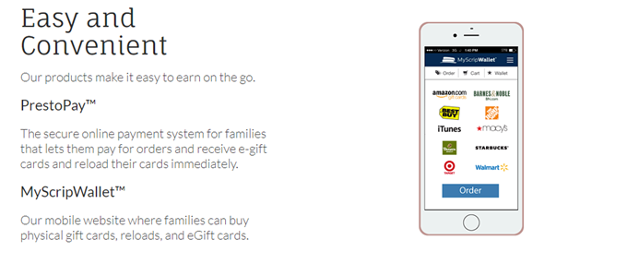


We will be placing TRIP orders for your shopping needs on these upcoming dates:
- September 30th
- October 7th
- October 15th (Tues)
- October 21st
- October 28th
Have your order in the green order boxes, in either the school office or church narthex by the Sunday prior to the order date to participate.
ORDER DATES
(Acquired funds apply toward 2020-2021)
AUGUST 26
SEPTEMBER 3 (TUES), 09, 16, 23 and 30
OCTOBER 07, 15 (TUES), 21 and 28
NOVEMBER 04, 12 and 18
DECEMBER 02, 09, and 16
(NOTE: The schedule changes to TWICE MONTHLY after Christmas)
JANUARY 13 and 27
FEBRUARY 10 and 24
MARCH 02 and 16
APRIL 06 and 20
MAY 04 and 18

Digital cards (eScrips, Reloads, ReloadNow)
After Saturday – May 25th, 2019
With your PrestoPay account – – Any time!!!

