TRIP Program

Whether you are starting your Christmas shopping, or updating your wardrobe for the Holiday season, don’t forget to order your TRIP cards! If you just plan on dining out or treating yourself, take time to evaluate your shopping needs and order your TRIP cards! If you are hosting or attending any gatherings, start your shopping with TRIP cards. There are many choices to…
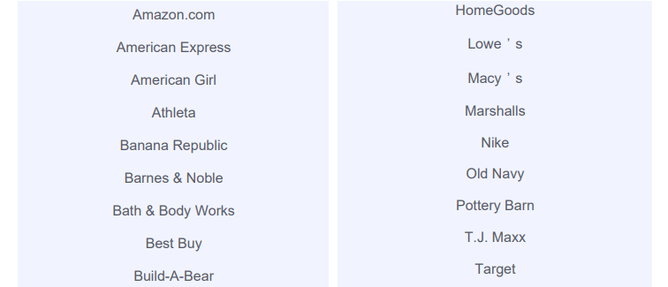
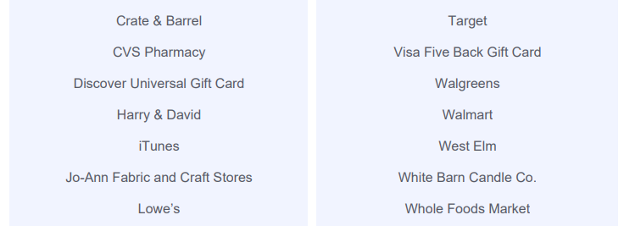
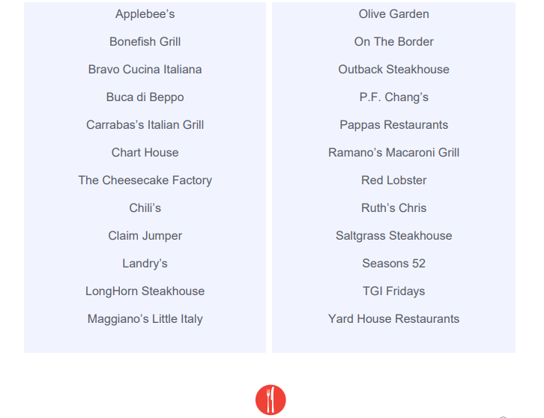

Why not receive a tuition reimbursement and take care of your household shopping needs at the same time? Remember to check the website www.shop.shopwithscrip.com for any special promotions, retailers may be running. Follow GLSC to get the most up-to-date promotions.
Great Lakes Scrip Center offers PrestoPay, a method we are currently enrolling school families and others interested in supporting the AH Miller Scholarship Program here at St Johns. The steps to get setup for PrestoPay to get scrips sent to your device for immediate use or to a computer to print out bar codes for use at restaurants, retailers or other providers are on the website. Also on the website are GLSC videos and more information about the process.
To learn more, pick up information in the school office or church narthex wall file folders or ask us: Amy Buonassisi (amybuonassisi@gmail.com) and Sandra Pauley (smp2319@icloud.com). Here’s how it works you buy a $25 gift card or $100 gift card for the retailer of your choice and receive that gift card AND it’s easy! You can take advantage of this program for your own family or you can donate it for another family - - it’s simple.
We will be placing TRIP orders for your shopping needs on these upcoming dates:
- December 3rd
- December 10th
- December 17th
- January 14th
- January 28th

Have your order in the green order boxes, in either the school office or church narthex by the Sunday prior to the order date to participate.

ORDER DATES
(Acquired funds apply toward 2019-2020)
AUGUST 27
SEPTEMBER 4 (TUES) 10, 17 and 24
OCTOBER 01, 09 (TUES) 15, 22 and 29
NOVEMBER 05, 12 and 26
DECEMBER 03, 10, and 17
(NOTE: The schedule changes to TWICE MONTHLY after Christmas)
JANUARY 14 and 28
FEBRUARY 11 and 25
MARCH 04 and 18
APRIL 01 and 15
MAY 06 and 20

