TRIP Program

Please text me if you have an order & are coming 630-290-0268
OR
if you would like to connect with me somewhere before the order is due
OR
Place your order online with the new RaiseRight mobile app.
Start the year with a resolution to use TRIP cards in your household budget! When updating your wardrobe for the winter season, or just plan on dining out or treating yourself, take time to evaluate your shopping needs and order your TRIP cards! If you are hosting or attending any gatherings, start your shopping with TRIP cards. There are many choices for a…

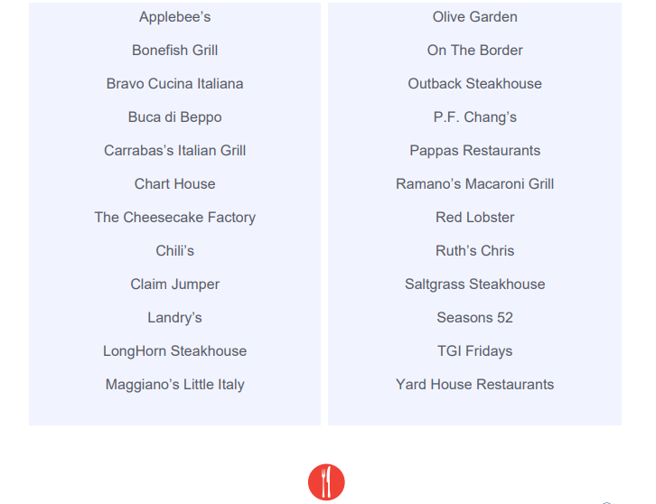

Why not receive a tuition reimbursement and take care of your household shopping needs at the same time? Remember to check the website https://www.shop.shopwithscrip.com for any special promotions, retailers may be running. Follow GLSC to get the most up-to-date promotions.
Great Lakes Scrip Center offers PrestoPay, a method we are currently enrolling school families and others interested in supporting the AH Miller Scholarship Program here at St Johns. The steps for setting up PrestoPay, to get the scrips sent to your device (for immediate use) or to a computer (to print out bar codes) for use at restaurants, retailers or other providers are on the website. Also on the website are GLSC videos and more information about the process.

To learn more, pick up information in the school office or church narthex wall file folders or ask me: Amy Buonassisi (TRIP@stjohnslagrange.org). Here’s how it works you buy a $25 gift card or $100 gift card for the retailer of your choice and receive that gift card AND it’s easy! You can take advantage of this program for your own family or you can donate it for another family - - it’s simple.
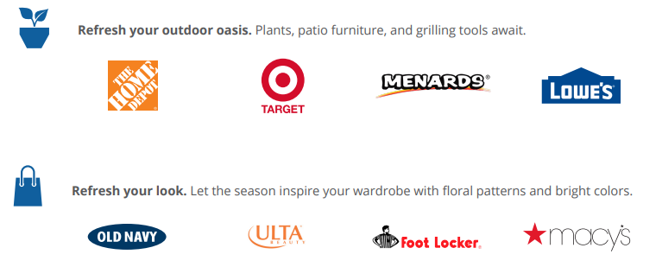
More information about this is on their
website https://www.shop.shopwithscrip.com.

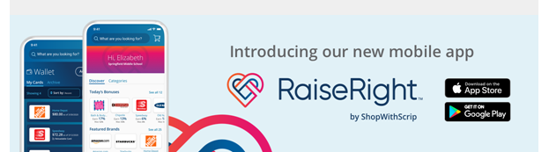
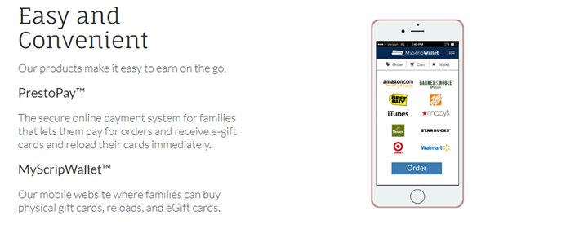
We will be placing TRIP orders for your shopping needs on these upcoming dates:
- January 11th
- January 25th
- February 8th
- February 22nd

Have your order in the green order boxes, in either the school office or church narthex by the Sunday prior to the order date to participate.
ORDER DATES
(Acquired funds apply toward 2021-2022)

AUGUST 17 and 31
SEPTEMBER 8 (TUES), 14, 21 and 28
OCTOBER 05, 13 (TUES), 19 and 26
NOVEMBER 02, 09, 16 and 30
DECEMBER 07, and 14
(NOTE: The schedule changes to TWICE MONTHLY after Christmas)
JANUARY 11 and 25
FEBRUARY 08 and 22
MARCH 01, 15 and 29
APRIL 12 and 26
MAY 10 and 24

Digital cards (eScrips, Reloads, ReloadNow)
After Saturday – May 23rd, 2020
With your PrestoPay account - - Any time!!!

