Church Yearbook Instructions

New this year!
We have made two changes to the Yearbook process this year. Further details appear below.
- We are asking churches to answer a few supplemental research questions after they complete their annual report.
- For the first time ever we will be offering over 25 prizes for churches that complete their annual report and answer the research questions. See below for complete details.

Accessing the Data Hub
- To log into the UCC Data Hub please go to https://datahub.ucc.org/. Alternately, you will find a link to the Data Hub at http://www.ucc.org/research_yearbook .
- Your username is your five or six digit conference church ID#. Please do not use leading zeros for the conference portion of the login. However, leading zeros should be used for the church portion of the number. (For example, the login for church #10 in the California Nevada Northern Conference is 20010.)
- Your conference or association is able to provide your correct login. If you are a new church within the past year and your login does not work, please contact your conference for assistance.
- Your default password is password.
The Data Hub will be available January 2, 2019 at noon until March 6, 2019 at midnight. Please submit your data as early as possible to avoid potential delays if you should need assistance. If your conference has asked you to submit your data prior to March 6th, please follow their guidelines.

Data Hub Help
- The Data Hub contains many help tips. If you are unsure of the information a particular data entry field is requesting, simply hover your mouse over the for additional information. You can also find these tips in the file “Annual Yearbook Reporting: Definitions Tip Sheet for Local Churches” at http://www.ucc.org/research_yearbook.
- Several brief video tutorials have been posted at http://www.ucc.org/research_yearbook to assist you. Please view these videos before calling your conference or association for assistance.

Changing your password
- After you log in to the system for the first time, you should change your password. If you are not prompted to change your password upon logging in, your screen will look similar to the picture below. Click on Change Password at the upper right corner to update your password.
- Please make note of your updated password.
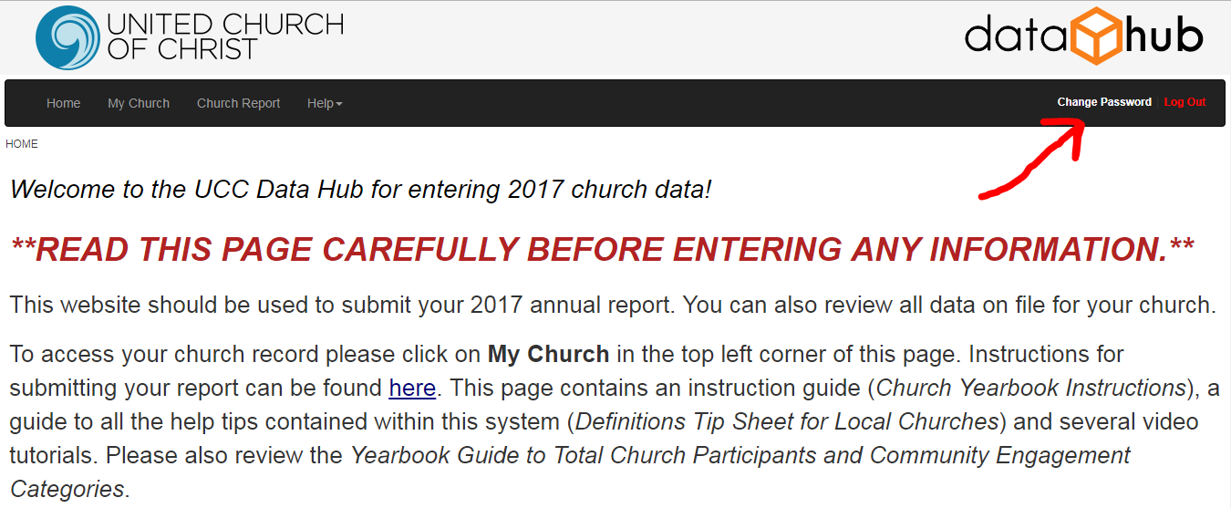

If you need assistance logging in, please contact your conference or association.

My Church
- This section provides you access to all of your church’s information that is maintained by your Conference in the Data Hub. You will be interacting with the real-time database that national staff and conference/association staff of the UCC use.

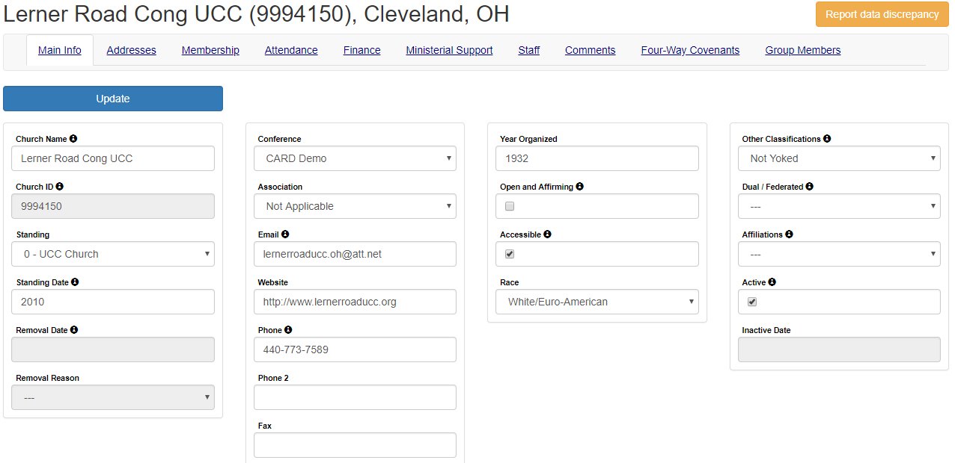

Main Info
- The Main Info tab contains basic church biographic & demographic information. Please update any incorrect information and provide any missing information.
- After ensuring all changes you made are correct, please click the Update button. You must click the Update button for the data to be saved.
- Please note you are not able to update any of the fields that are gray; only your conference or association has the ability to edit this information. If there are any errors in those fields please notify your conference or association immediately.

Addresses
We currently track three types of addresses for churches: mailing, location and campus.
- Mailing is the address that is used for all church mailings and other general mailings.
- Location is the physical location of the church. This address is used on www.ucc.org/find to provide a map of your church location. Please note that this address is required and you must provide the County when selecting this address type.
- Campus is the physical location of an additional campus of your church. This address is also used on www.ucc.org/find.
- If you enter a new location or campus address, please also update the latitude and longitude. View the video Updating Church Contact Info at http://www.ucc.org/research_yearbook to learn how to look up a latitude and longitude. (Please note, when mailing and location address are the same, both addresses must be entered.)

Providing an Address Change
- Click the Add New Address button. Please provide all required information: Address, City, State, Zip and Address Type. (If you select Location as the address type, County will also be required.)
- Please only click the Add button once to prevent duplicate entries from being recorded. The system may take a few seconds to process after you click the button.
- Adding a new address will automatically mark the old address as inactive.
- Please only use United States Postal Service approved abbreviations in all addresses. Please do NOT use any punctuation. The abbreviation guide can be accessed at:
http://pe.usps.gov/text/pub28/28apc_002.htm

Membership
(Video entitled Updating Annual Church Membership is available at http://www.ucc.org/research_yearbook.)
- On this screen you can view all data since 1992. Please click Add New Membership Year Data when you are ready to provide your data.
- After entering all your data please click on the Calculate Totals button to compute the totals.
- The 2018 Membership will appear in the field labeled Total Membership.
- If this number is incorrect due to previous year’s membership being inaccurate, please enter an adjustment number in the adjustment field. DO NOT enter the correct 2018 membership total in this adjustment field; enter only the number you need to adjust the calculated total to be correct. (Negative numbers can be entered here.) Click the Calculate Totals button again to ensure the correct 2018 membership is recorded.
- When you are satisfied that everything is correct click the Add button. If you need to return to this screen at a later time, please click the Cancel button.

Attendance
(Video entitled Updating Annual Worship Attendance is available at http://www.ucc.org/research_yearbook.)
- This screen operates the same as the Membership screen. Please provide all attendance data on this screen.
- We have added two new data entry fields to this screen in recent years: Church Participants and Community Engagement. Please see the “Guide to Yearbook Community Engagement and Total Church Participants Categories” posted at http://www.ucc.org/research_yearbook for complete details.

Finance
(Video entitled Updating Annual Financial Data is available at http://www.ucc.org/research_yearbook.)
- This screen operates the same as the Membership screen. Please provide all financial data on this screen.
- This screen only allows whole dollar amounts. Please round to the nearest whole dollar. Do not enter decimals or dollar signs.
A change was made last year in reporting OCWM giving. Your conference will continue to report your Basic Support Giving and your giving to each of the four Special Mission Offerings (i.e., One Great Hour of Sharing, Neighbors in Need, Strengthen the Church and Christmas Fund). You will report all other UCC Giving as Other UCC Giving. If you have a question what this might include please see the “Other UCC Giving” document posted at http://www.ucc.org/research_yearbook.
Special Notes
Massachusetts Conference churches participating in United Church Mission (UCM) should NOT include it as Other UCC Giving. Your conference will report UCM in the Basic Support Giving column. Since UCM is shared with the National Setting, it is analogous to Basic Support for the purpose of this report.
New York Conference Reformed Association churches should NOT report your Assessment as Other UCC Giving. Your conference will be reporting this giving on your behalf.

Ministerial Support
(Video entitled Updating Annual Ministerial Support Data is available at http://www.ucc.org/research_yearbook.)
- This screen operates very similarly to the Membership screen as well. However, you can provide more than one report for the year on this screen if you are reporting for multiple ministerial staff. Please be sure to indicate if this is a full-time position.
- All data provided on this report should be annualized. If your church only had a pastor for part of the year, the compensation should be computed for an annual basis. This will ensure we can compare across churches. This is not an actual accounting of the amount your church paid, but rather what the church would have paid for this position for an entire year.
- This data is only used in providing summary reports of average compensation packages of numerous churches. Your church’s individual ministerial support data will not be released.

Staff
- This screen displays all current ministerial staff serving your church according to Data Hub records. Please report inaccurate information to your conference or association.

To view a tip sheet regarding the various data collected, please go to http://www.ucc.org/research_yearbook and click on “Annual Yearbook Reporting: Definitions Tip Sheet for Local Churches.”

Editing Data
- After you have entered your annual data in the Data Hub you have access to edit this entry until the Data Hub closes on March 6th.
- To edit data on the Membership, Attendance, Financial, or Ministerial Support tabs simply click the pencil icon beside the 2018 year data. This will open the data entry screen for you to make corrections.
- If other years’ data needs correction please contact your conference or association.

Church Report
- This will provide you a report of your church’s data.
- In the top left corner of this report screen you can select the year for which you’d like data displayed.
- If you’d like a print out of the data you’ve just reported, select 2018 from the list. (You can also print copies of previous year’s reports by selecting the appropriate year.)
- You can print this report by clicking on the printer icon. You can also save this report in a variety of file types. Click on the disk icon to select the type of file you’d like to save. Your conference does not have access to print this report.
- If you require a copy for your files, please be sure to print it before logging out of the system.

Supplemental Research Questions
- This year we are piloting a supplemental data collection. We’d like churches to answer a few questions that are not part of the annual Yearbook data collection.
- This data will help the CARD office better understand the congregations we serve and help us plan future research projects.
- A link to this supplemental data collection will be provided on the Data Hub home page.
- The survey is very brief and should take no longer than 5 minutes to complete.
- These additional questions are included in the Church Data Entry Guide as well.

Incentives
This year we are offering several incentives for churches that submit both their annual Yearbook report and answer the supplemental research questions. Every church that responds to both will be entered into a random drawing for more than 25 prizes. The following prizes will be awarded:
- $100 UCC Resources Gift Card – 5 gift cards will be awarded
- One year free access to Access UCC – 10 subscriptions will be awarded
- 2019 Yearbook and Directory – 10 books will be awarded
- Custom, handmade stole – 1 will be awarded
- JustAct calendar – 5 will be awarded
- 3GL banner – 1 will be awarded

REMINDERS
- Change your password immediately. Make a note of your updated password.
- Use USPS approved abbreviations only in addresses.
- All questions, concerns or comments should be directed to your conference or association.
- To cancel out of any of the data entry screens without saving the yearly data, simply click the Cancel button.
- All inaccurate data that is submitted should be reported to your conference or association for correction.
- An Online Data Entry Form is provided at the end of this document to assist you in gathering data prior to submitting it in the Data Hub. Please print this to assist you in gathering your data prior to submitting it in the Data Hub.
- There are several tutorial videos posted online to assist you. Please visit http://www.ucc.org/research_yearbook to view these videos.

ONLINE DATA ENTRY FORM

Membership

Additions
Confirmations
Confessions of Faith
Transfers In
Reaffirmations of Faith

Removals
Deaths
Transfers Out
Other Removals

Baptisms
Child Baptisms (12 & younger)
Adult Baptisms (13 & older)

Attendance
Average Weekly Worship Attendance
Community Engagement
Church Participants
Have your members participated in US or international mission/ immersion/service trips? | Yes No

Youth Program
Active Jr. High Participants
Active Sr. High Participants

Christian Education/Faith Formation Program

Active Participants
Children (0-17 years)
Adults (18 years & over)

Average Participants
Children (0-17 years)
Adults (18 years & over)

Financial

Income
Total Income
Pledges and Offerings

Expenditures
Other UCC Giving
Other Support
Capital Payments
Operating Expenses

Endowments
Bequests
Deferred Gifts
Endowment

Supplemental Yearbook Survey

Is your congregation still in the location in which it was founded?
- Yes
- No
When did you move to your current location? _______
Which best describes your congregation’s relationship to its primary place of worship? (Select one.)
- Rent
- Own
- Our primary worship location moves regularly
- Have use of a facility for free
- Other arrangement: _____________________________________________________________
What is the worship capacity where your primary services are held? _______
Do any of the following types of other organizations also use the facility where you worship?
Check all that apply.

- Another congregation
- A school
- A day care
- Non-profit organization(s)
- Support group(s)
- Government (e.g. voting, town hall meetings, etc.)
- Other (please describe): ______________________________________________________________________________
Are you familiar with the 3 Great Loves Initiative?
- Yes
- No
In what ways did your church participate in the 3 Great Loves Initative? Check all that apply.
- Collections (i.e., Food drive, Hygiene kits)
- Worship
- Created new ministries
- Food pantries
- Volunteered time
- Other (please describe):
______________________________________________________________________________

Ministerial Support

Full-time | Yes No
Minister Category
Salary
Additional Amount Paid by Other Church
Parsonage
Rental Allowance
Utility Allowance
Social Security
Annuity
Insurance
Other Expenses
Business Expenses

If you have multiple pastoral staff, please complete additional ministerial support reports.
Full-time | Yes No
Minister Category
Salary
Additional Amount Paid by Other Church
Parsonage
Rental Allowance
Utility Allowance
Social Security
Annuity
Insurance
Other Expenses
Business Expenses

Full-time | Yes No
Minister Category
Salary
Additional Amount Paid by Other Church
Parsonage
Rental Allowance
Utility Allowance
Social Security
Annuity
Insurance
Other Expenses
Business Expenses

To view a tip sheet regarding the various data collected, please go to http://www.ucc.org/research_yearbook and click on “Annual Yearbook Reporting: Definitions Tip Sheet for Local Churches.”

