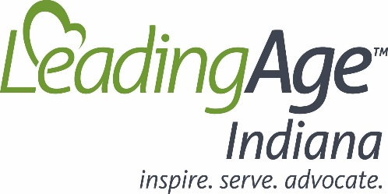

Long-Term Care and Aging Service Facilities – the Embodiment of Public Service
By Eric Essley, President/CEO, LeadingAge Indiana
April 24, 2020

Nearly every day, we are witness to heartbreaking scenes playing out in hospitals and long-term care communities as the coronavirus spreads across our state. We will never get used to seeing families talking through nursing home windows with relatives who can no longer receive visitors … final farewells exchanged via Facetime … funeral services attended from cars. As we consider those difficult events, I would like to take a moment to honor the long-term care professionals who provide advice, comfort, friendship, care, and love to these families – often at incredible risk to their own safety. These individuals are more than heroes – they are the embodiment of selfless public service.

Each individual, senior or not, included in the daily COVID-19 statistics announced by Governor Eric Holcomb and his tireless team of Agency leaders; Dr. Kristina Box, Dr. Jennifer Sullivan, Dr. Dan Rusyniak, and many others, represents a treasured person. These victims are husbands and wives, parents and grandparents, veterans, and community volunteers. Let us not forget – so too are our long-term care professionals. These nurses, aides, housekeepers, cooks, and other workers do not appear on camera or in newspapers - but they are hurting too. They grieve every time this virus takes away an aging individual whom they have served, and to whom they have grown close over many years.

The media tells stories of leadership exhibited by Governor Holcomb and his team, and the exhaustion and anguish on the faces of hospital staff. To be sure, we can never thank and applaud these individuals enough. Sadly, long-term care professionals are too often simply forgotten. Worse, they are condemned for outcomes that are beyond anyone’s control or did not occur at their community. These caregivers put their lives, and those of their families, at risk because they love their work. They feel called to help residents fight this virus so they can continue living meaningful lives long after this pandemic becomes a distant memory.

In light of this dedication, it is disappointing to see news reports blaming America’s nursing homes for coronavirus deaths. That attribution is misplaced and unfair. Hospitals are viewed as a place for treatment and recovery. Conversely, long term communities are portrayed as places where folks go to die. It is no wonder that COVID-19 cases and the sometime resulting deaths, are rarely, if ever, assigned to a hospital. Let us be clear, the point of this piece is not to place misguided fault on hospitals – not at all. We praise and admire the great works performed there. However, the media does not seem to focus on COVID-19 cases or deaths that occur at hospitals. Rather, such unfortunate events are routinely tied back to the long-term care community where these residents live and are considered family. This is often factually wrong and does not properly honor the dedication and caring of the long-term care professional. And – that is the point of this piece.

Nursing homes and their aging services counterparts need personal protective equipment (masks, gowns, and gloves to keep them (and other residents) safe. They need access to critical testing tools that would help identify and isolate residents and staff who have been exposed to the virus. They also need adequate funding that actually covers the true cost of the care they provide. But what they really need – is your support, understanding, and to be treated fairly.

You may or may not see these individuals as heroes (like I do), but what we should all agree on is that long-term care professionals are true public servants. Please join me in treating them with the respect and appreciation they so richly earn and deserve.

LeadingAge Indiana is an association that provides services and support to over 135 not for profit organizations that represent the continuum of long-term care, housing and community-based services for seniors in Indiana. Our members are committed to achieving the highest standards of care to protect the welfare and well-being of those they serve.

