SUFFOLK COUNTY BAR ASSOCIATION’S
PRO BONO PROJECT IS HOSTING
A FREE LEGAL CLINIC FOR VETERANS

THURSDAY, NOVEMBER 7th 10:00 A.M. — 2:00 P.M.

FREE LEGAL HELP WITH:

Veterans Rights General Disability Power of Attorney Health Care Proxy Guardianship Taxation
Divorce
Child Support Public Benefits Taxes Bankruptcy
...and more!

Suffolk County Bar Association 560 Wheeler Road
Hauppauge, NY 11788

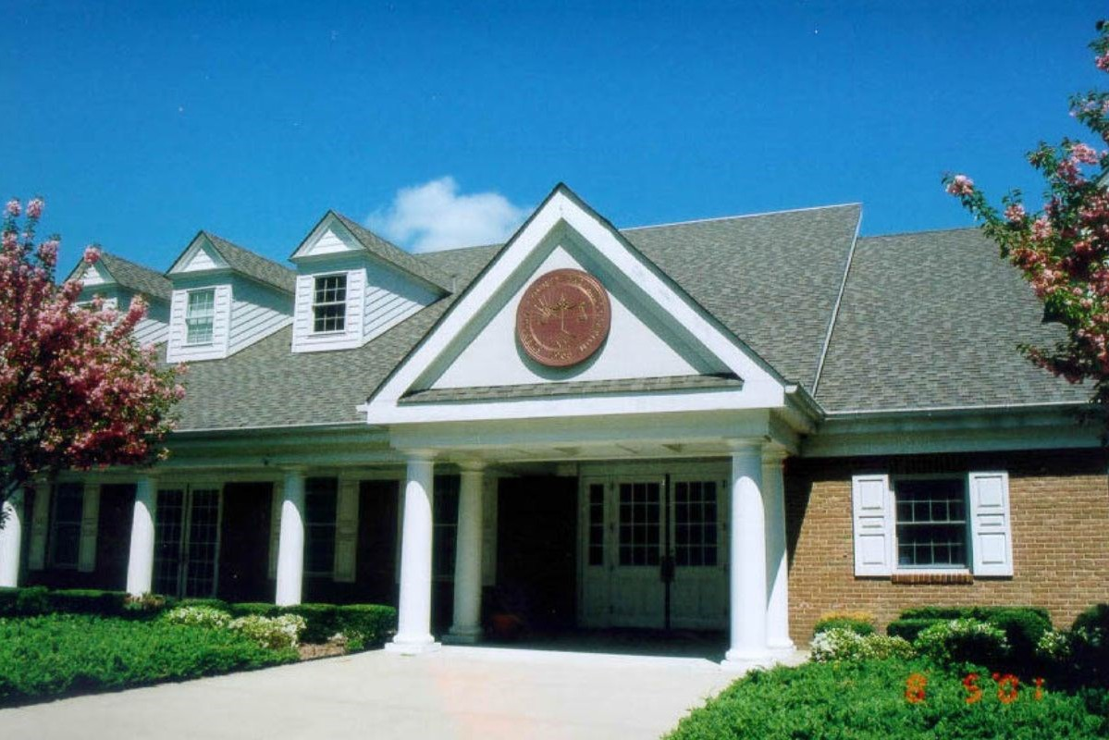
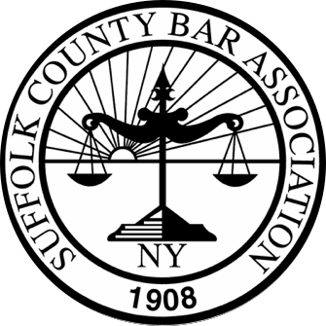
TO SCHEDULE AN APPOINTMENT WITH A LAWYER
ON NOVEMBER 7th: EMAIL VETS@SCBA.ORG

