

FCA Mental Health First Aid Class including Older Adult Module Details
Revised 11.12.2025
1. Eligibility
- Trainings are free for attendees who interact in ANY capacity with ANY Nassau County residents who are 55 yrs old and over (friends, family, colleagues, patients, clients, etc.). The class attendees must be 18 or over but do not need to live or work in Nassau, nor do the interactions need to take place in Nassau.
2. Training availability and scheduling options and duration
- I am flexible with scheduling options from now until the funding ends. Funding is scheduled through September 2026.
  - Individuals are welcome to join any of the sessions scheduled at our 377 Oak St FIFTH FLOOR Garden City Location
  - AMPLE PARKING, reachable by public transportation
  - I am available to come to external location(s) but ask for at least 10 confirmed attendees
    - WiFi and a monitor for use with HDMI cable needed or I can plug in a zip drive
    - Conference room preferably set up classroom style
  - Class can be offered in two 3 hours sessions or one 6 ½ hour session with a ½ hour break
  - Please advise the preferred day or days of the week, split sessions can be in same week or up to 4 weeks apart
3. Course content:
- Information re noticing signs/symptoms of emerging, worsening, and/or crisis mental health challenges including substance use misuse/addiction
- An exploration of Helpful/Unhelpful approaches and responses
- Stigma Reduction and how language impacts stigma
- Understanding the impact of trauma
- Discussion regarding the impact of cultural differences
- Learn suicide assessment skills and how to determine if it is a crisis and how to respond
- To help attendees understand how the above impacts the aging population and how psychiatric symptoms can be caused by physical illness vs mental health challenges
- To help attendees understand Dementia and Alzheimer’s Disease etc.
4. Costs associated with the training:
- Funding is provided by the Substance Abuse and Mental Health Services Administration (SAMHSA)
- There is 0 cost for attendees, they receive a manual that pertains to all adults 18+ and a handout fact sheet with older adult information and resource information
- There is an opportunity to receive a $30 gift card post course upon returning a survey (3 quick questions) about the use of mental health education/referrals with the attendees’ networks
5. Certification/pre and post requisite details for participants
- Attendees wishing to receive the 3 year MHFA certification:
  - Need to complete online pre-course work (should only take 10-15 mins)
    - Attendees are not expected to know all the information in the pre-course work
  - Attend the full in-person class
  - Need to complete online post-course work (should only take 15-20 mins)
6. Any materials needed
- All materials are provided including the MHFA comprehensive manual that is used for all adults age 18+
- Attendees receive a hand-out with facts about aging topics specific to older adults:
  - Dementia, Alzheimer's, medical induced psychosis vs. mental illness and more
- Attendees need to bring or purchase lunch (there are local merchants near our location)
- Water, coffee, soft drinks, snacks, microwave and fridge are available to those attending our location
  - I can provide a snack, (cookies, chips) when coming to an external location

Contact: Jeanne Cacciatore, LMSW, Program Director – Work Cell (516) 619-6786 Email: jcacciatore@fcali.org
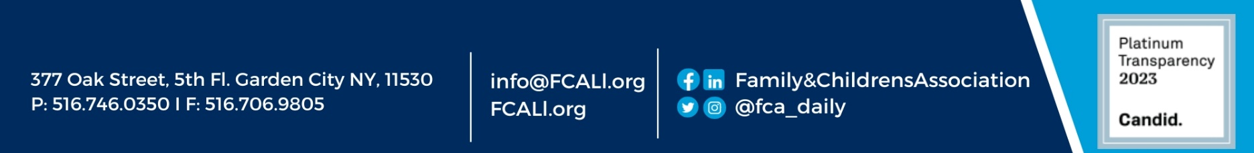
Senior Mental Health Awareness Training Program & Safe Observant Senior (SOS) Program

